**ERP System Implementation**

**using Business One v9.2**

Detailed Design Document (DDD)

|  |  |  |
| --- | --- | --- |
| **VERSION** | **:** | **1.0** |
| **PROJECT NAME** | **:** | **ERP Application to Brunei Shell Marketing Company Sdn. Bhd.** |
| **PROJECT REFERENCE** | **:** | **C170025/BMF** |

**Approval and Sign-Off**

| **Name** | **Job Title** | **Signature** | **Date** |
| --- | --- | --- | --- |
|  |  |  |  |
|  |  |  |  |

**Revision History**

| **Revision No.** | **Revision Details** | **Revised By** | **Date** |
| --- | --- | --- | --- |
|  |  |  |  |

Contents

**No table of contents entries found.**

1. **Introduction**

Detail Design Document (DDD) is the configuration detail document of SAP Business One (SAP B1) for Brunei Shell Marketing Company Sdn Bhd (BSM). It included both functional and technical designs which designed according to BSM requirement after go through business requirement study and design walk-through.

The purpose of this document is to specify the detailed-level of configuration and also the scope to make sure that every configuration made is matched with the requirement of BSM. This document will be used as a guideline to ensure that the configuration is not running out of scope.

1. **System Initialization**
   1. **Database Definition**

Total 8 databases will be implemented for BSM. The database lists are as below:

|  |  |  |
| --- | --- | --- |
| **Database Code** | **Database Name** | **Description** |
| BSM | Brunei Shell Marketing | This is SAP Business One productive database that developed specifically for BSM |
| ZBSM | (Test) Brunei Shell Marketing | This is SAP Business One testing database that developed specifically for BSM |
| FA_BSM | FA – Brunei Shell Marketing | This is fixed asset productive database that developed specifically for BSM |
| ZFA_BSM | (Test) FA – Brunei Shell Marketing | This is fixed asset testing database that developed specifically for BSM |
| ASM_BSM | ASM – Brunei Shell Marketing | This is asset management system productive database that developed specifically for BSM |
| ZASM_BSM | (TEST) ASM – Brunei Shell Marketing | This is asset management system testing database that developed specifically for BSM |
| ROXANA | Roxana Shell Service Station | This is SAP Business One productive database that developed specifically for Roxana database |
| ZROXANA | (TEST)- Roxana Shell Service Station | This is SAP Business One testing database that developed specifically for Roxana database |

Note that all the testing database start with alphabet “Z”. This is to segregate the coding structure of testing and live database to reduce the chances of user access to the wrong database.

For every unsure transaction that need to be test or training, testing database will be utilized to prevent any issue happened to the productive database in the midst of testing or training.

* 1. **Posting Period**

There will be 12 periods each financial year for BSM. Starting from period 01 (January) – period 12 (December). Please refer table below:

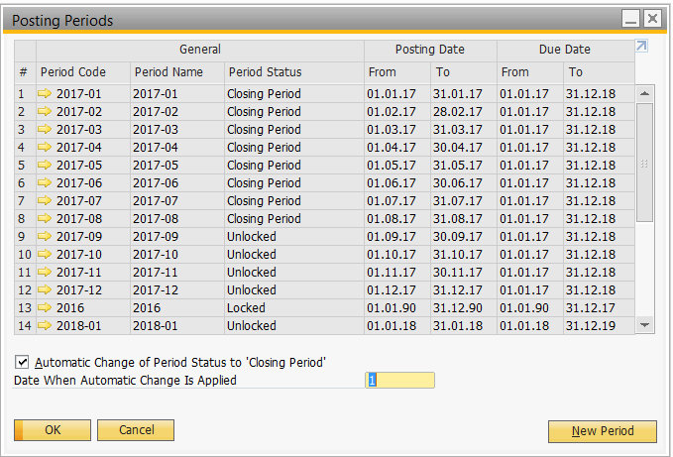

3 financial periods will be created initially for BSM as table below:

|  |  |  |  |  |
| --- | --- | --- | --- | --- |
| **Period Code** | **Purpose** | **Sub-Period** | **Period From** | **Period To** |
| 2016 | To import TB as at 31st Dec 2016 | Year | 01.01.1990 | 31.12.2016 |
| 2017 | To import monthly TB for each month of 2017 (for monthly comparison of TB between 2017 and 2018) | Months | 01.01.2017 | 31.12.2017 |
| 2018 | For data entry in productive environment | Months | 01.01.2018 | 31.12.2018 |

For the detail of each financial periods including the sub-period created for BSM initially as below:

|  |  |  |  |  |  |  |  |  |  |
| --- | --- | --- | --- | --- | --- | --- | --- | --- | --- |
|  |  |  |  |  |  | **Posting Date** | | **Due/Document Date** | |
| **#** | **Code** | **Name** | **Sub-Periods** | **Period Indicator** | **Period Status** | **From** | **To** | **From** | **To** |
| 1 | 2016 | 2016 | Year | Default | Locked | 01.01.1990 | 31.12.2016 | 01.01.1990 | 31.12.2017 |
| 2 | 2017-01 | 2017-01 | Month | Default | Locked | 01.01.2017 | 31.01.2017 | 01.01.2017 | 31.12.2018 |
| 3 | 2017-02 | 2017-02 | Month | Default | Locked | 01.02.2017 | 28.02.2017 | 01.02.2017 | 31.12.2018 |
| 4 | 2017-03 | 2017-03 | Month | Default | Locked | 01.03.2017 | 31.03.2017 | 01.03.2017 | 31.12.2018 |
| 5 | 2017-04 | 2017-04 | Month | Default | Locked | 01.04.2017 | 30.04.2017 | 01.04.2017 | 31.12.2018 |
| 6 | 2017-05 | 2017-05 | Month | Default | Locked | 01.05.2017 | 31.05.2017 | 01.05.2017 | 31.12.2018 |
| 7 | 2017-06 | 2017-06 | Month | Default | Locked | 01.06.2017 | 30.06.2017 | 01.06.2017 | 31.12.2018 |
| 8 | 2017-07 | 2017-07 | Month | Default | Locked | 01.07.2017 | 31.07.2017 | 01.07.2017 | 31.12.2018 |
| 9 | 2017-08 | 2017-08 | Month | Default | Locked | 01.08.2017 | 31.08.2017 | 01.08.2017 | 31.12.2018 |
| 10 | 2017-09 | 2017-09 | Month | Default | Locked | 01.09.2017 | 30.09.2017 | 01.09.2017 | 31.12.2018 |
| 11 | 2017-10 | 2017-10 | Month | Default | Locked | 01.10.2017 | 31.10.2017 | 01.10.2017 | 31.12.2018 |
| 12 | 2017-11 | 2017-11 | Month | Default | Locked | 01.11.2017 | 30.11.2017 | 01.11.2017 | 31.12.2018 |
| 13 | 2017-12 | 2017-12 | Month | Default | Closing Period | 01.12.2017 | 31.12.2017 | 01.12.2017 | 31.12.2018 |
| 14 | 2018-01 | 2018-01 | Month | Default | Unlocked | 01.01.2018 | 31.01.2018 | 01.01.2018 | 31.12.2019 |
| 15 | 2018-02 | 2018-02 | Month | Default | Locked | 01.02.2018 | 28.02.2018 | 01.02.2018 | 31.12.2019 |
| 16 | 2018-03 | 2018-03 | Month | Default | Locked | 01.03.2018 | 31.03.2018 | 01.03.2018 | 31.12.2019 |
| 17 | 2018-04 | 2018-04 | Month | Default | Locked | 01.04.2018 | 30.04.2018 | 01.04.2018 | 31.12.2019 |
| 18 | 2018-05 | 2018-05 | Month | Default | Locked | 01.05.2018 | 31.05.2018 | 01.05.2018 | 31.12.2019 |
| 19 | 2018-06 | 2018-06 | Month | Default | Locked | 01.06.2018 | 30.06.2018 | 01.06.2018 | 31.12.2019 |
| 20 | 2018-07 | 2018-07 | Month | Default | Locked | 01.07.2018 | 31.07.2018 | 01.07.2018 | 31.12.2019 |
| 21 | 2018-08 | 2018-08 | Month | Default | Locked | 01.08.2018 | 31.08.2018 | 01.08.2018 | 31.12.2019 |
| 22 | 2018-09 | 2018-09 | Month | Default | Locked | 01.09.2018 | 30.09.2018 | 01.09.2018 | 31.12.2019 |
| 23 | 2018-10 | 2018-10 | Month | Default | Locked | 01.10.2018 | 31.10.2018 | 01.10.2018 | 31.12.2019 |
| 24 | 2018-11 | 2018-11 | Month | Default | Locked | 01.11.2018 | 30.11.2018 | 01.11.2018 | 31.12.2019 |
| 25 | 2018-12 | 2018-12 | Month | Default | Locked | 01.12.2018 | 31.12.2018 | 01.12.2018 | 31.12.2019 |

For the new financial period such as 2019, 2020 and etc. can be create later using “New Period” function. Please refer screenshot below for the “New Period” screen in SAP B1:

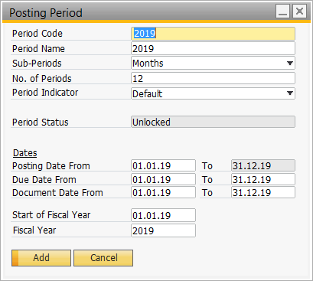

Period 13 will not be created in posting period, there is an option in journal entry “Adj. Trans. (Period 13)” that will be served as period 13. Further information please refer to ….

|  |  |  |
| --- | --- | --- |
| **Field Name** | **Description/Remarks** | **Mandatory/Optional** |
| Period Code | Unique code for each of the posting period. | Mandatory |
| Period Name | Description of the unique code assigned to each posting period. | Mandatory |
| Sub-Periods | Manage the sub-periods of the posting period. | Mandatory |
| No. of Periods | Number of periods based on the sub-period. | Mandatory |
| Period Indicator | The Period Indicator refers to each document series (row) that can be connected to one or more Accounting Periods. Each document series must be connected to an indicator, to enable document numbering starting with 1 for each fiscal year.  BSM decided to set to default as continuous document numbering will apply to the Business One system. | Optional |
| Period Status | Assign to the posting period the required status:  Unlocked – all users, with respect to their authorizations, can post all types of transactions and documents to this period. This status is assigned by default to new posting periods.  Unlocked Except Sales – all users with respect to their authorizations, can post to this period all types of transactions and documents, except for documents of the Sales – A/R module.  Period Closing – only users with full Period Closing authorization can post to this period all types of documents and transactions. Only the year-end closing process is still to be performed. Period will auto close after 7 days on new month.  Locked – no documents neither transaction can be posted to the period. | Mandatory |
| Posting Date | This is the GL posting Date. Displays the date ranges available for this period. Any date used in a new Journal entry or document must match these date ranges. An error message is displayed if an incorrect date is entered. | Mandatory |
| Due Date | This is document due date, for ageing purposes. Displays the date ranges available for this period. Any date used in a new Journal entry or document must match these date ranges. An error message is displayed if an incorrect date is entered. | Mandatory |
| Document Date | This is document date, capture for information purposes. Displays the date ranges available for this period. Any date used in a new Journal entry or document must match these date ranges. An error message is displayed if an incorrect date is entered. | Mandatory |
| Start of Fiscal Year | Starting date of the financial period that the posting period created. | Mandatory |
| Fiscal Year | Specify the financial year of the created period. | Mandatory |

* 1. **Authorization**

Authorizations allow users to view, create, and update documents that assigned to them, according to data ownership definitions. There are 2 types of user which are regular user and superuser. These 2 users have different rights in authorization as below:

1. Regular User:
   * Cannot assign authorization to other users.
2. Superuser can:
   * Define permissions for other users.
   * Automatically have full authorization for all functions in the system.

There will be 3 types of authorization that can be set for user in each document as below:

|  |  |
| --- | --- |
| **Authorization** | **Description** |
| Full Authorization | Choose to grant full authorization to a user for all functions in all applications. |
| Read Only | Choose to grant read-only authorization to a user for all functions in all applications. The user can then display all data but cannot make any changes. |
| No Authorization | Choose to grant no authorizations for any functions in any application. The user will be unable to display or change any data. |

Please refer below for the screenshot of Authorization screen in SAP B1:

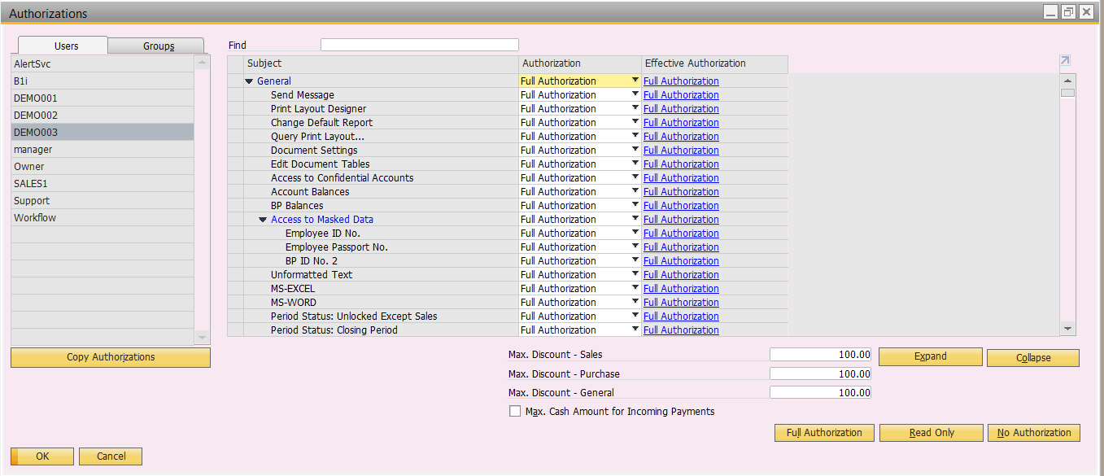

The authorization for each of the user in BSM will based on the role mapping document. If user without authorization and not a superuser, he or she will not able to access to any screen of SAP B1.

* 1. **User Setup**

All user setup according to the list of users provided by BSM. Superuser is a user that has full authorization to all modules in SAP B1. Superuser will be assigned to those authorized personnel only.

User Setup screen are as below:

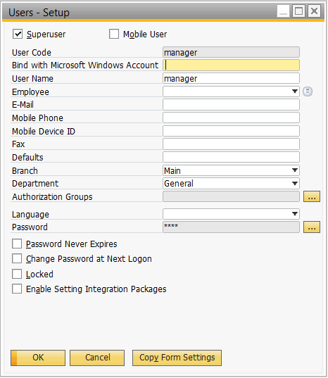

All user will be setup to allow login SAP B1 using Single Sign-On (SSO). Each of the user created need to assign authorization if he or she not a superuser. Please refer to 2.3 Authorization for further information.

| **Field Name** | **Description/Remarks** | **Mandatory/Optional** |
| --- | --- | --- |
| Superuser | User that has full authorization for all the modules in SAP B1. | Optional |
| Mobile User | User that will be using SAP B1 mobile application. | Optional |
| User Code | User Code to login SAP B1 for the user. | Mandatory |
| Bind with Microsoft Windows Account | Active directory of the user for Single Sign-On (SSO). | Optional |
| User Name | User Name of the user. | Mandatory |
| Employee | Specify an employee who is not yet linked to any user. | Optional |
| E-Mail | User’s email. | Optional |
| Mobile Phone | User’s mobile number. It’s mandatory if user use SAP B1 mobile application. | Optional |
| Mobile Device ID | ID of user’s mobile device. It’s mandatory if user use SAP B1 mobile application. | Optional |
| Fax | User’s fax number. | Optional |
| Defaults | Default parameters such as language, font size and etc. for individual users or groups of users. | Optional |
| Branch | Use these fields to specify a user’s branch. | Optional |
| Department | Use these fields to specify a user’s department. | Optional |
| Authorization Groups | Specify the permission group that assigned to the user. | Optional |
| Language | Specify user’s language when login to SAP B1. | Optional |
| Password | Specify the password of user. | Mandatory |
| Password Never Expires | The user password will never expire regardless what’s the setting defined in password administration. | Optional |
| Change Password at Next Logon | The user need to change password during next login. | Optional |
| Locked | Lock specific user to prevent them from login into SAP B1. | Optional |

* 1. **Password Administration**

Password Administration is to specify the requirements for user password. By default, SAP B1 has 3 predefined security level as below:

1. Low – Selected by default

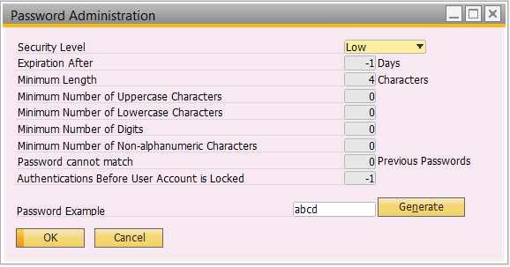

1. Medium

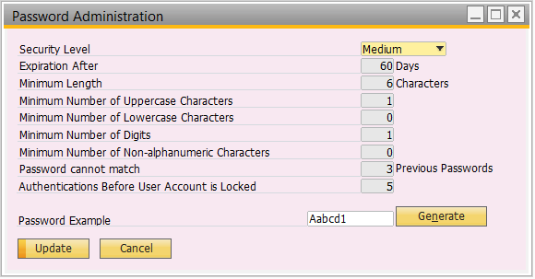

1. High

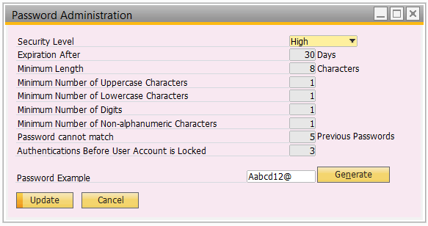

BSM will be using IRM standard guideline provided by BSM for password policy and SAP B1 has the ability to allow customization on the security level as below:

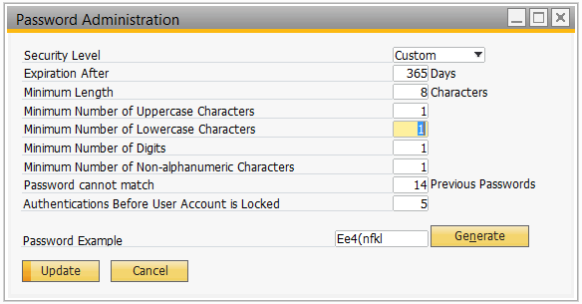

**Please refer below for the guideline provided by Natrah from BSM:**

**1.1      General Password Construction Guidelines**

All users at Brunei Shell Petroleum should be aware of how to select strong passwords. Strong passwords have the following characteristics:

* Contain at least three of the five following character classes:
* Lower case characters
* Upper case characters
* Numbers
* Punctuation
* “Special”characters (e.g. @#$%^&*()_+|~-=\`{}[]:";'<>/ etc)
* Contain at least 8 alphanumeric characters
* Weak passwords have the following characteristics:
* The password contains less than 8 characters
* The password is a word found in a dictionary (English or foreign)
* The password is a common usage word such as:
  + - Names of family, pets, friends, co-workers, fantasy characters, etc.
    - Computer terms and names, commands, sites, companies, hardware, software.
    - The words "Brunei Shell Petroleum", "sanjose", "sanfran" or any derivation.
    - Birthdays and other personal information such as addresses and phone numbers.
    - Word or number patterns like aaabbb, qwerty, zyxwvuts, 123321, etc.
    - Any of the above spelled backwards.
    - Any of the above preceded or followed by a digit (e.g., secret1, 1secret)

Try to create passwords that can be easily remembered. One way to do this is create a password based on a song title, affirmation, or other phrase. For example, the phrase might be: "This May Be One Way To Remember" and the password could be: "TmB1w2R!" or "Tmb1W>r~" or some other variation.

(NOTE: Do not use either of these examples as passwords!)

**1.2      Password Maintenance**

* A history of at least 14 passwords is kept;
* Password must be refreshed regularly, according to agreed intervals. Where technically possible, password expiration must be implemented
* Service account passwords should be renewed yearly.

**1.3      Number of failed Log-In attempts allowed**

* Password should be lock after a maximum number of failed five invalid logon to mitigate the risks of password guessing activity such as brute force attack
* Error page is displayed to the user immediately following the maximum number of failed login attempts, or at the following login attempt
* the user's account should be disabled for the penalty lockout time an administrator reset is required

**1.4      Logging of failed Log-In attempt**

System logging facilities should be checked for unusual error messages from system & software. For example, a large number of failed login attempts in a short period of time may indicate someone trying to guess passwords.

**1.5       Change of Password upon initial Log-on**

* Technically enforce user to change the initial password immediately upon receiving the new password.
* Change all system or vendor-supplied default passwords, including service accounts after installation of a new system.

**1.6      Application Development**

Application developers must ensure their programs contain the following security precautions.

Applications:

* Shall support authentication of individual users, not groups.
* Shall not store passwords in clear text or in any easily reversible form.
* Shall provide for some sort of role management, such that one user can take over the functions of another without having to know the other's password.
* Shall support TACACS+, RADIUS and/or X.509 with LDAP security retrieval wherever possible.

**1.7      Password Communicating guideline**

Passwords must be allocated to users in a secure manner, for example:

* User names and passwords are communicated via separate channels (e.g. via SMS)
* User names and passwords are communicated only after verification of the user identity
* The application to enforce the (temporary) password to be changed after first time use.
  1. **Approval Procedure**

In BSM, approval from Finance or MOA is required for certain documents, for example, for sales order to customer that exceed credit limit. Therefore, approval procedures are setup in SAP B1 to handle the approval needed for these documents.

Below are the lists of approval procedures setup for BSM:

|  |  |  |  |  |  |
| --- | --- | --- | --- | --- | --- |
| **No.** | **Approval Name** | **Trigger Condition** | **Purpose** | **Creator** | **Approver** |
| 1 | Credit Limit Extension | Sales order amount exceeded customer’s credit limit. | To ensure that customer has valid reason for exceeding credit limit. | CSC/BMD | BMF |
| 2 | Purchase Request | Purchase request created. | To ensure purchase amount within the budget. | Everyone | Budget Holder |
| 3 | Purchase Order | Purchase order created. | To ensure purchase amount within the contract ACV. | Everyone | Contract Holder |
| 4 | Diversion SO | Sales order created by BMD due to diversion. | To ensure SO validity. | BMD | CSC |

Whenever an approval is triggered while adding/updating certain documents, the screen below will appear:

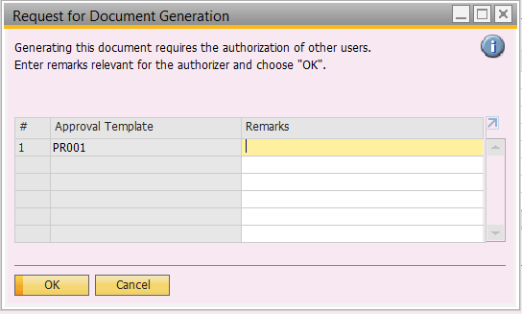

User can insert remarks if necessary and the remarks will reflect to approver while approving the document.

The approver will then receive an internal alert in SAP B1 to notify him or her there’s pending approval document as screen below:

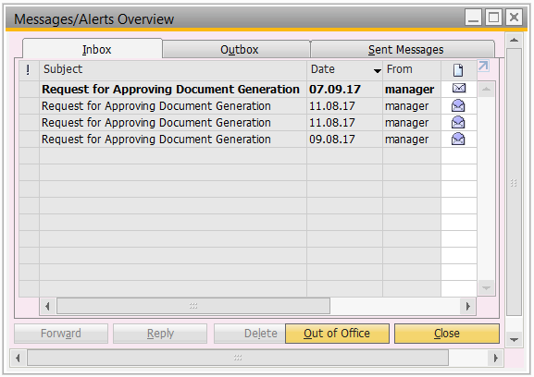

Approver can review the document and then decide whether to approve or not by changing the decision.

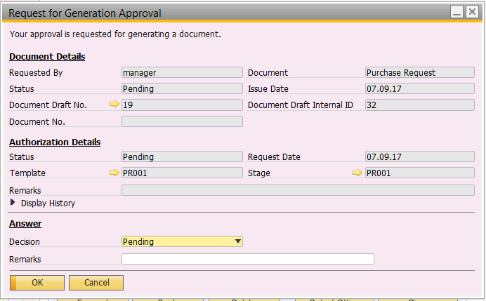

Doesn’t matter the document get approved or rejected, creator receive an internal alert as well.

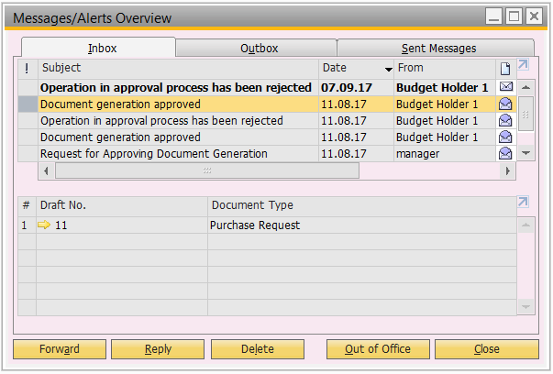

If it’s approved, creator can proceed to add the approval document.

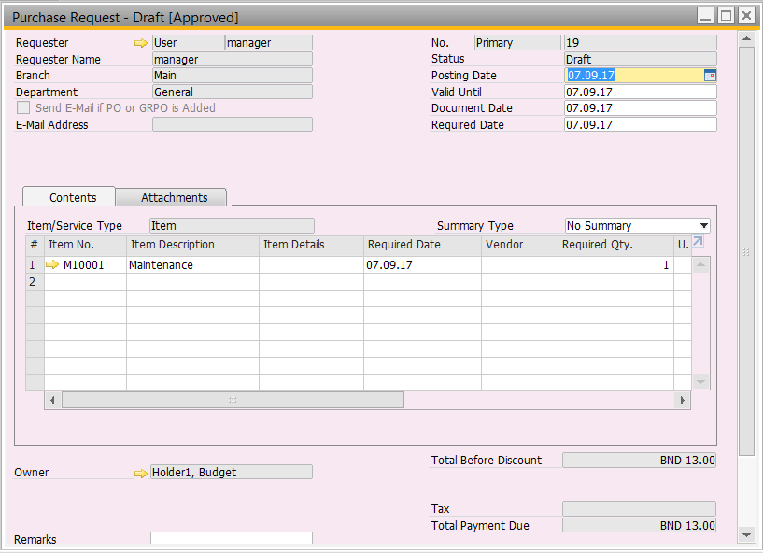

If approver missed out or accidentally delete the internal alert for the pending approval document, he or she can access to Approval Status Report to find back the pending approval document and change the answer.

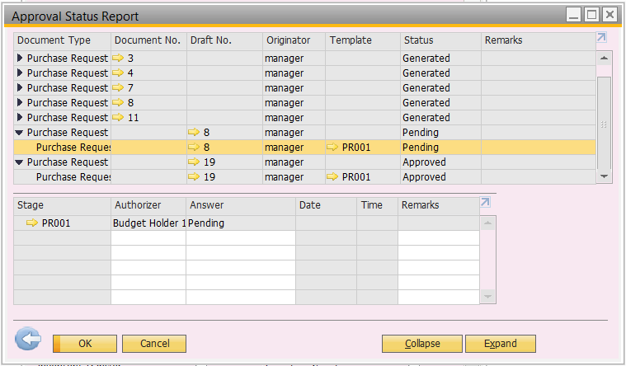

If approver would like to change their decision on the document that yet to generate, he or she can access to Approval Decision Report to do so by changing the answer.

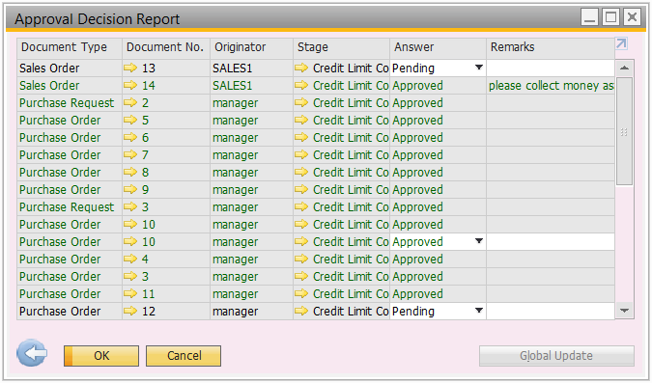

* 1. **Alerts**

Alert is use to notify selected users in SAP B1 whenever certain conditions are met in the predefined frequency. In BSM, there will be a few alerts setup to notify user as below:

|  |  |  |
| --- | --- | --- |
| **Alert Name** | **Condition** | **Frequency** |
| Contract expiry date < 6 months | Whenever the contract expiry date was less than 6 months. | Weekly, on Monday 8am |
| Contract ACV used > 80% | Whenever the contract ACV used up more than 80%. | Daily, 8am |
| Customer agreement expiry date < 6 months | Whenever the Customer Agreement expiry date was less than 6 months. | Weekly, on Monday 8am |
| Sales agreement expiry date < 6 months | Whenever the Sales Agreement expiry date was less than 6 months. | Weekly, on Monday 8am |
| Banker guarantee expiry date < 3 months | Whenever the Banker Guarantee expiry date was less than 6 months. | Weekly, on Monday 8am |

Below is the alert setup screen in SAP B1:

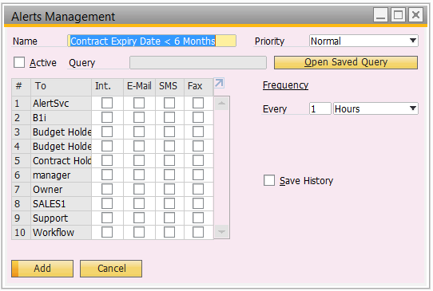

Whenever an alert was triggered, the selected user will receive an internal alert in SAP B1 just like pending approval document mentioned previously as below:

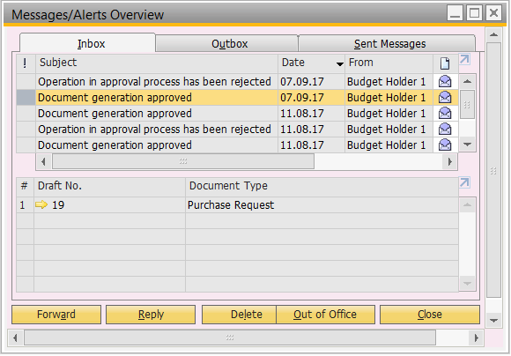

* 1. **Document Numbering**

When creating a document, a number will be assigned to each document in SAP B1. Document numbering is where to set the number that assigned to each document. One document, for eg. Sales order can have more than one numbering for the purpose of segregating the order or different filing.

Please refer below for document numbering screen in SAP B1:

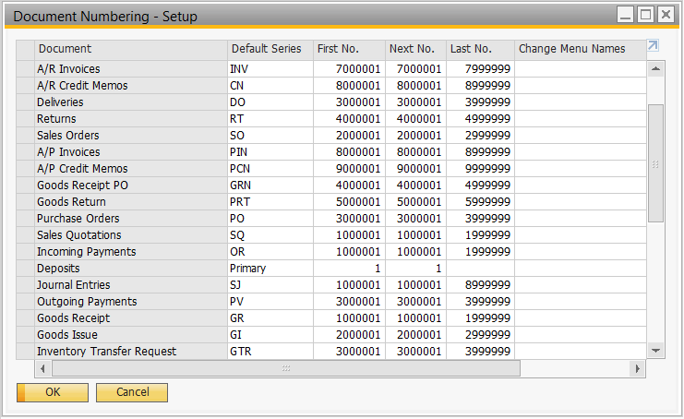

User can always double click on the first column of desire document to drill down to the numbering details of that document.

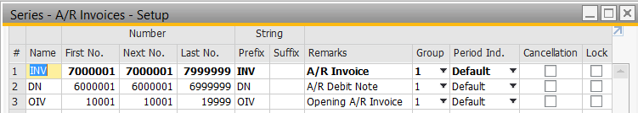

In detail, the document numbering will be setup for BSM as below by module:

|  |  |  |  |  |  |  |  |  |  |  |
| --- | --- | --- | --- | --- | --- | --- | --- | --- | --- | --- |
| **#** | **Name** | **First** | **Next** | **Last** | **Prefix** | **Suffix** | **Remarks** | **Group** | **Period Ind.** | **Lock** |
| **Sales Module** | | | | | | | | | | |
| 1 | SQ | 1000001 | 1000001 | 1999999 | SQ |  | Sakes Quotation | 1 | Default | N |
| 2 | SO | 2000001 | 2000001 | 2999999 | SO |  | Sales Order | 1 | Default | N |
| 3 | DO | 3000001 | 3000001 | 3999999 | DO |  | Delivery Order | 1 | Default | N |
| 4 | RT | 4000001 | 4000001 | 4999999 | RT |  | Return | 1 | Default | N |
| 5 | DP | 5000001 | 5000001 | 5999999 | DP |  | A/R Down Payment | 1 | Default | N |
| 6 | OIV | 10001 | 10001 | 19999 | OIV |  | Opening A/R Invoice | 1 | Default | N |
| 7 | DN | 6000001 | 6000001 | 6999999 | DN |  | A/R Debit Note | 1 | Default | N |
| 8 | INV | 7000001 | 7000001 | 7999999 | INV |  | A/R Invoice | 1 | Default | N |
| 9 | OCN | 20001 | 20002 | 29999 | OCN |  | Opening A/R Credit Note | 1 | Default | N |
| 10 | CN | 8000001 | 8000001 | 8999999 | CN |  | A/R Credit Note | 1 | Default | N |
| **Purchasing Module** | | | | | | | | | | |
| 11 | PR | 1000001 | 1000001 | 1999999 | PR |  | Purchase Request | 1 | Default | N |
| 12 | PQ | 2000001 | 2000001 | 2999999 | PQ |  | Purchase Quotation | 1 | Default | N |
| 13 | PO | 3000001 | 3000001 | 3999999 | PO |  | Purchase Order | 1 | Default | N |
| 14 | GRN | 4000001 | 4000001 | 4999999 | GRN |  | Goods Receipt Note | 1 | Default | N |
| 15 | LC | 30001 | 30001 | 39999 | LC |  | Landed Cost | 1 | Default | N |
| 16 | PRT | 5000001 | 5000001 | 5999999 | PRT |  | Goods Return Note | 1 | Default | N |
| 17 | PDP | 6000001 | 6000001 | 6999999 | PDP |  | A/P Down Payment | 1 | Default | N |
| 18 | OPI | 10001 | 10001 | 19999 | OPI |  | Opening A/P Invoice | 1 | Default | N |
| 19 | PDN | 7000001 | 7000001 | 7999999 | PDN |  | A/P Debit Note | 1 | Default | N |
| 20 | PIN | 8000001 | 8000001 | 8999999 | PIN |  | A/P Invoice | 1 | Default | N |
| 21 | OPC | 20001 | 20002 | 29999 | OPC |  | Opening A/P Credit Note | 1 | Default | N |
| 22 | PCN | 9000001 | 9000001 | 9999999 | PCN |  | A/P Credit Note | 1 | Default | N |
| **Inventory Module** | | | | | | | | | | |
| 23 | GR | 1000001 | 1000001 | 1999999 | GR |  | Goods Receipt | 1 | Default | N |
| 24 | GI | 2000001 | 2000001 | 2999999 | GI |  | Goods Issue | 1 | Default | N |
| 25 | GTR | 3000001 | 3000001 | 3999999 | GTR |  | Inventory Transfer Request | 1 | Default | N |
| 26 | GT | 4000001 | 4000001 | 4999999 | GT |  | Inventory Transfer | 1 | Default | N |
| 27 | IC | 5000001 | 5000001 | 5999999 | IC |  | Inventory Counting | 1 | Default | N |
| 28 | IP | 6000001 | 6000001 | 6999999 | IP |  | Inventory Posting | 1 | Default | N |
| 29 | IR | 7000001 | 7000001 | 7999999 | IR |  | Inventory Revaluation | 1 | Default | N |
| **Banking Module** | | | | | | | | | | |
| 30 | OR | 1000001 | 1000001 | 1999999 | OR |  | Official Receipt | 1 | Default | N |
| 31 | PCV | 2000001 | 2000001 | 2999999 | PCV |  | Petty Cash Voucher | 1 | Default | N |
| 32 | PV | 3000001 | 3000001 | 3999999 | PV |  | Payment Voucher | 1 | Default | N |
| **Finance Module** | | | | | | | | | | |
| 33 | SJ | 1000001 | 1000001 | 8999999 | SJ |  | System Journal | 1 | Default | N |
| 34 | MJ | 9000001 | 9000001 | 9999999 | MJ |  | Manual Journal | 1 | Default | N |
| **Production Order** | | | | | | | | | | |
| 35 | PO | 1000001 | 1000001 | 1999999 | PO |  | Production Order | 1 | Default | N |
| **Sales Blanket Agreement** | | | | | | | | | | |
| 36 | SBA | 1000001 | 1000001 | 1999999 | SBA |  | Sales Blanket Agreement | 1 | Default | N |
| **Purchase Blanket Agreement** | | | | | | | | | | |
| 37 | PBA | 1000001 | 1000001 | 1999999 | PBA |  | Purchase Blanket Agreement | 1 | Default | N |

| **Field Name** | **Description/Remarks** | **Mandatory/Optional** |
| --- | --- | --- |
| Name | Specify the name of the numbering. | Mandatory |
| First No. | Specify the first number of the numbering. | Mandatory |
| Next No. | Automatically start from First No. and increment whenever new document added. | Mandatory |
| Last No. | Specify the last number of the numbering. | Mandatory |
| Prefix | Specify prefix for the numbering for additional identification of the numbering. | Optional |
| Suffix | Specify suffix for the numbering for additional identification of the numbering. | Optional |
| Remarks | Specify any additional information in free text format regarding this numbering. | Optional |
| Group | Specify group which this numbering assigned to. Authorization can set based on the grouping assigned. | Mandatory |
| Period Ind. | Specify period indicator to limit the numbering for certain period. | Mandatory |
| Lock | Select to disable the selection of numbering in the document. | Optional |

* 1. **Logs**
     1. **Access Log**

Access log is to displays a list of actions and details related to a specific user's access activity in SAP Business One.

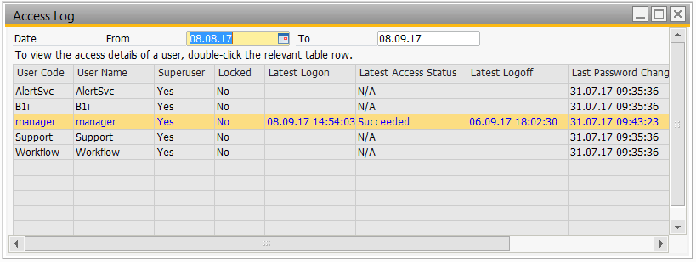

If user would like to drill down into the details of the access log for specific user, just double click on that user and screen as below:

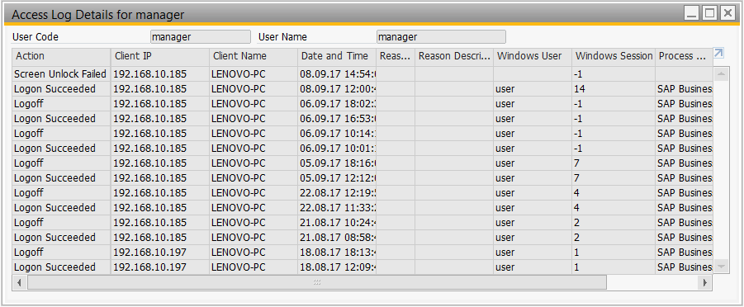

* + 1. **Change Log**

Change log is to gain an overview of changes in most windows of SAP B1. Each time user updates a document or master data, SAP B1 record the changes and show it as required in change log window.

Please refer below for the change log window in SAP B1:

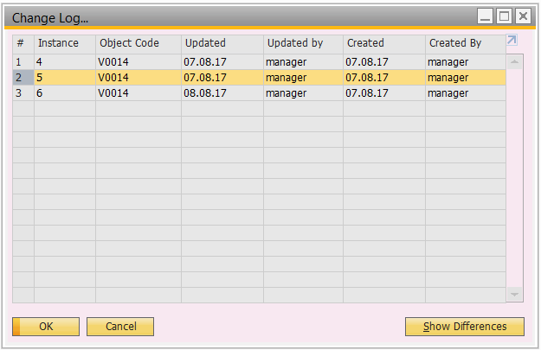

Each instance of the change log is equivalent to numbers of time(s) the document/master data been updated. User can compare the differences between the 2 instances by highlighting the instance and click on the “Show Differences” button:

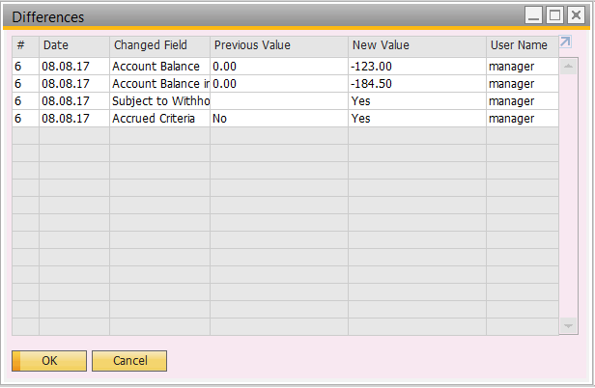

* 1. **Print Layout Designer**

Print layout designer is a form designer in SAP B1 to allow customization to be done on document layout. Each document in SAP B1 (such as PO, SO, Invoice, etc.) can have more than one layouts to serve for different purposes.

Please refer below for the layout that customized for BSM:

|  |  |  |  |
| --- | --- | --- | --- |
| **#** | **Layout Name** | **Module** | **Sub-Module** |
| 1 | Sales Quotation (BSM) | Sales A/R | Sales Quotation |
| 2 | Sales Order (BSM) | Sales A/R | Sales Order |
| 3 | Delivery (BSM) | Sales A/R | Delivery |
| 4 | Return (BSM) | Sales A/R | Return |
| 5 | A/R Invoice (BSM) | Sales A/R | A/R Invoice |
| 6 | A/R Credit Note (BSM) | Sales A/R | A/R Credit Note |
| 7 | Purchase Quotation (BSM) | Purchasing – A/P | Purchase Quotation |
| 8 | Purchase Order (BSM) | Purchasing – A/P | Purchase Order |
| 9 | Goods Receipt (BSM) | Inventory | Goods Receipt |
| 10 | Goods Issue (BSM) | Inventory | Goods Issue |
| 11 | Inventory Transfer (BSM) | Inventory | Inventory Transfer |
| 12 | Inventory Counting (BSM) | Inventory | Inventory Counting |
| 13 | Official Receipt (BSM) | Banking | Incoming Payment |
| 14 | Payment Voucher (BSM) | Banking | Outgoing Payment |
| 15 | Journal Entry (BSM) | Financials | Journal Entry |

For the document layout that does not include in the list above, if user wish to print out, there will still be standard SAP B1 document layout available in the system. However, if the standard layout doesn’t suit the requirement of BSM, customization of document layout can be done.

Please refer below for the layout and sequence window in SAP B1:

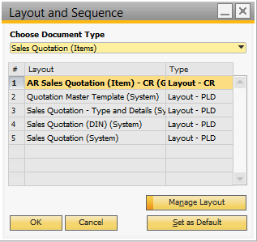

This window displays the available layouts of a document in SAP B1.

* 1. **Query Manager**

Query manager is a tool that designed for retrieval/selection of data from SAP B1. It can be used as an ad-hoc reporting tools because it can create nearly any query yourself that can quickly answer the question arising in your company.

After defining a query, it can be saved and use over again in the User Queries library. Authorization of the saved query can also be set under Authorization window to prevent unauthorized user to run the query and exposed the data that shouldn’t viewed by them.

Please refer below for the list of queries that created for BSM:

|  |  |  |  |
| --- | --- | --- | --- |
| **#** | **Query Name** | **Description** | **Group** |
| 1 | Listing - Purchase Request | Summary listing of Purchase Request created in SAP B1. | Purchasing A/P |
| 2 | Listing - Purchase Request Detail | Detail listing of Purchase Request created in SAP B1. | Purchasing A/P |
| 3 | Listing - Purchase Quotation | Summary listing of Purchase Quotation created in SAP B1. | Purchasing A/P |
| 4 | Listing - Purchase Quotation Detail | Detail listing of Purchase Quotation created in SAP B1. | Purchasing A/P |
| 5 | Listing - Purchase Order | Summary listing of Purchase Order created in SAP B1. | Purchasing A/P |
| 6 | Listing - Purchase Order Detail | Detail listing of Purchase Order created in SAP B1. | Purchasing A/P |
| 7 | Listing – Goods Receipt PO | Summary listing of Goods Receipt PO created in SAP B1. | Purchasing A/P |
| 8 | Listing – Goods Receipt PO Detail | Detail listing of Goods Receipt PO created in SAP B1. | Purchasing A/P |
| 9 | Listing – Goods Return | Summary listing of Goods Return created in SAP B1. | Purchasing A/P |
| 10 | Listing – Goods Return Detail | Detail listing of Goods Return created in SAP B1. | Purchasing A/P |
| 11 | Listing – A/P Invoice | Summary listing of A/P Invoice created in SAP B1. | Purchasing A/P |
| 12 | Listing – A/P Invoice Detail | Detail listing of A/P Invoice created in SAP B1. | Purchasing A/P |
| 13 | Listing – A/P Credit Note | Summary listing of A/P Credit Note created in SAP B1. | Purchasing A/P |
| 14 | Listing – A/P Credit Note Detail | Detail listing of A/P Credit Note created in SAP B1. | Purchasing A/P |
| 15 | Listing - Sales Quotation | Summary listing of Sales Quotation created in SAP B1. | Sales A/R |
| 16 | Listing - Sales Quotation Detail | Detail listing of Sales Quotation created in SAP B1. | Sales A/R |
| 17 | Listing - Sales Order | Summary listing of Sales Order created in SAP B1. | Sales A/R |
| 18 | Listing - Sales Order Detail | Detail listing of Sales Order created in SAP B1. | Sales A/R |
| 19 | Listing - Return | Summary listing of Return created in SAP B1. | Sales A/R |
| 20 | Listing - Return Detail | Detail listing of Return created in SAP B1. | Sales A/R |
| 21 | Listing - Delivery | Summary listing of Delivery created in SAP B1. | Sales A/R |
| 22 | Listing - Delivery Detail | Detail listing of Delivery created in SAP B1. | Sales A/R |
| 23 | Listing - A/R Invoice | Summary listing of A/R Invoice created in SAP B1. | Sales A/R |
| 24 | Listing - A/R Invoice Detail | Detail listing of A/R Invoice created in SAP B1. | Sales A/R |
| 25 | Listing - A/R Credit Note | Summary listing of A/R Credit Note created in SAP B1. | Sales A/R |
| 26 | Listing - A/R Credit Note Detail | Detail listing of A/R Credit Note created in SAP B1. | Sales A/R |
| 27 | Listing - Journal Entry | Detail listing of Journal Entry created in SAP B1. | Financials |
| 28 | Listing - Journal Voucher | Detail listing of open Journal Voucher created in SAP B1. | Financials |
| 29 | Listing – Incoming Payment Details | Detail listing of Incoming Payment created in SAP B1. | Banking |
| 30 | Listing – Incoming Payment Details (Cancel) | Detail listing of Cancelled Incoming Payment created in SAP B1. | Banking |
| 31 | Listing - Incoming Payment Summary (Total Daily Collection) | Summary listing of Daily Incoming Payment created in SAP B1. | Banking |
| 32 | Listing - Incoming Payment Summary (Total Daily Collection) (Cancel) | Summary listing of Daily Cancelled Incoming Payment in SAP B1. | Banking |
| 33 | Listing - Outgoing Payment Details | Detail listing of Outgoing Payment created in SAP B1. | Banking |
| 34 | Listing - Outgoing Payment Summary (Total Daily Paid) | Summary listing of Daily Outgoing Payment created in SAP B1. | Banking |
| 35 | Listing - Goods Issue | Detail listing of Goods Issue created in SAP B1. | Inventory |
| 36 | Listing - Goods Receipt | Detail listing of Goods Receipt created in SAP B1. | Inventory |
| 37 | Listing - Inventory Transfer | Detail listing of Inventory Transfer created in SAP B1. | Inventory |
| 38 | Listing - Inventory Transfer Request | Detail listing of Inventory Transfer Request created in SAP B1. | Inventory |

Please refer below for the Query Manager window in SAP B1 that stored the created query that can be reused over and over again:

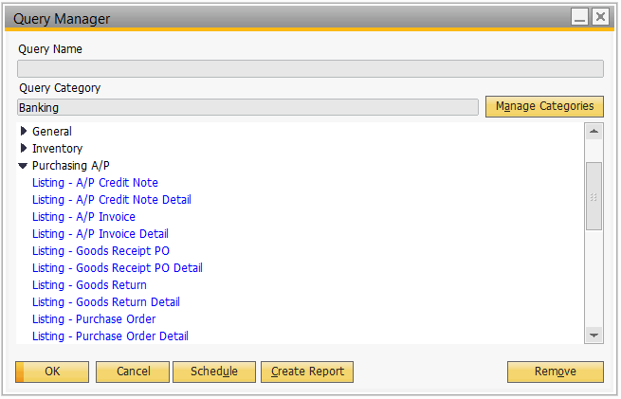

Whenever user access the query, the query selection window will appear, this is where user input the parameter for the created query as well.

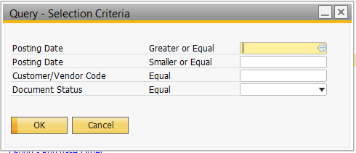

The result will appear after the selection screen as below:

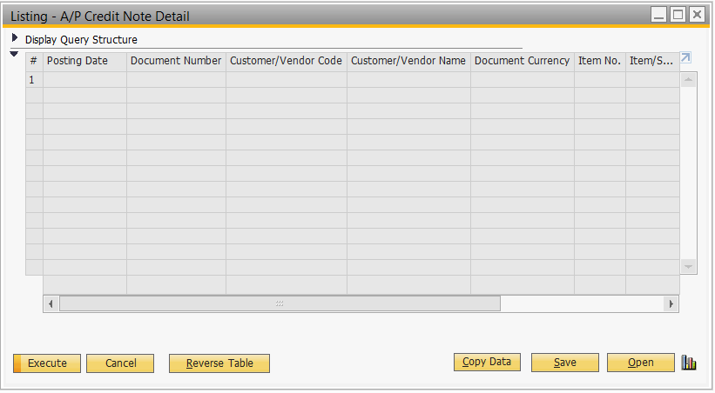

1. **Master Data**
   1. **Chart of Account**

SAP B1 support two types of chart of account as below:

* Segmented Account - A matrix of natural account codes (e.g., types of expenses) and analysis codes (e.g., products, departments, divisions, etc.).
* User Defined Account - Natural account codes where only pure account code will enter.

BSM will use User Defined Account. Below is the Chart of Account window in SAP B1 with BSM’s Chart of Account imported:

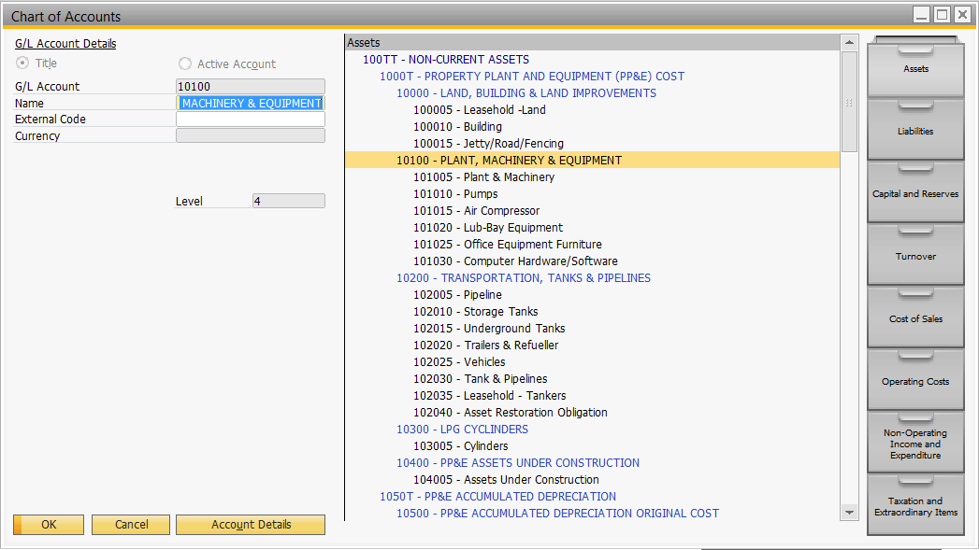

All the title account (account that is not postable, for grouping purpose) will be in capital letter and blue color. However, the active account (account that is postable) will be in proper letter format in black or green color.

* 1. **House Bank**

House Bank is use to define bank in SAP B1 that used for daily operation (such as issue/receiving money from/to bank) when there are more than one branch or account for a single bank.

**BSM’s house bank list as below:**

|  |  |
| --- | --- |
| **Bank Name** | **Bank Account** |
| BAIDURI BANK BERHAD | 01-00-110-289889 |
| BAIDURI BANK BERHAD (USD) | 01-00-100-289889 |
| BANK ISLAM BRUNEI DARUSSALAM | 00-001-01-0039893 |
| BANK ISLAM BRUNEI DARUSSALAM (ROXANA) | 01-001-01-0016459 |
| BANK ISLAM BRUNEI DARUSSALAM (PAYABLE) | 01-001-01-0052050 |

Please refer below for the House Bank Setup screen in SAP B1:

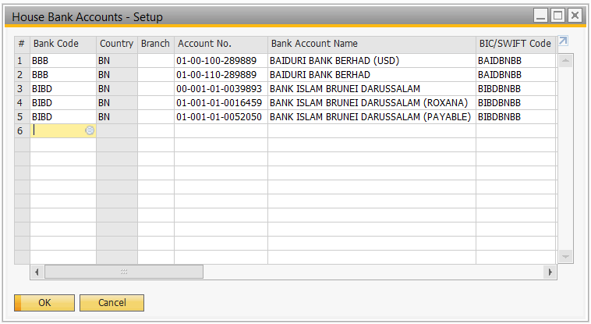

For any additional or new house bank that is not in the current list showed above, user can add in anytime in House Bank Accounts-Setup window.

* 1. **Currencies**

BSM uses multiple currencies in their company activity. The currencies are as below:

|  |  |  |  |
| --- | --- | --- | --- |
| **Currency Code** | **Currency Name** | **Hundredth Name** | **Currency Type** |
| BND | Brunei Dollar | cent | Local Currency |
| EUR | Euro | cent | Foreign Currency |
| GBP | United Kingdom, Pounds | cent | Foreign Currency |
| MYR | Malaysia Ringgit | sen | Foreign Currency |
| SGD | Singapore Dollar | cent | Foreign Currency |
| USD | US Dollar | cent | System Currency |
| IDR | Indo Rupiah | sen | Foreign Currency |
| AUD | Australian Dollar | cent | Foreign Currency |
| CNY | Chinese Yuan Renminbi | Jiao | Foreign Currency |
| RUB | Russian Ruble | Kopek | Foreign Currency |
| THB | Thai Baht | Satang | Foreign Currency |
| JPY | Japanese Yen | Sen | Foreign Currency |
| PHP | Philippines Peso | [Sentimo](https://en.wikipedia.org/wiki/C%C3%A9ntimo) | Foreign Currency |

Please refer below for the currencies setup window in SAP B1:

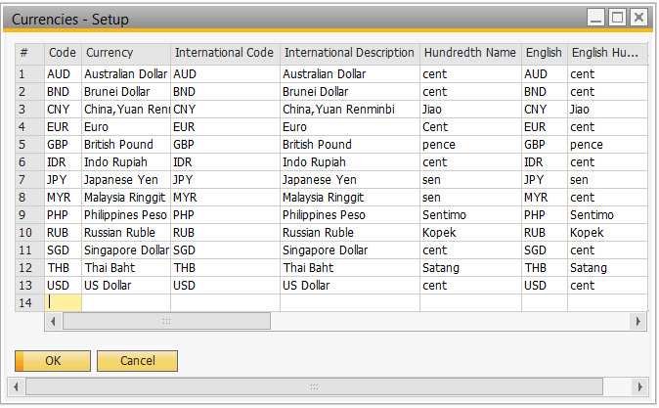

For any new currency, user can add in anytime in this currency setup window.

* 1. **Transaction Analysis**
     1. **Cost Center**

This analysis code allowed the cost allocate clearly to which cost center. This allow to churn out Profit & Loss Report by cost center.

The list of cost center for BSM as below:

|  |  |  |
| --- | --- | --- |
| Cost Center Code | Cost Center Name | Group |
| BMA01N | Cmptce & Admin NRoutine OPEX | BMA |
| BMA01R | Cmptce & Admin Routine OPEX | BMA |
| BMB01N | Branding & Comm NRoutine OPEX | BMB |
| BMB01R | Branding & Comm Routine OPEX | BMB |
| BMC01N | Commercial Non Routine OPEX | BMC |
| BMC01R | Commercial Routine OPEX | BMC |
| BMCBIT | Bitumen | BMC |
| BMCDBSP | Diesel BSP | BMC |
| BMCDBUN | Diesel Bunker | BMC |
| BMCJBSP | Jet A1 BSP | BMC |
| BMCLBSP | Lubricants BSP | BMC |
| BMCLUBE | Lubricants | BMC |
| BMCSAR | Saraline | BMC |
| BMD00N | S&D Non Routine OPEX | BMD |
| BMD00R | S&D Routine OPEX | BMD |
| BMD01N | Operations Non Routine OPEX | BMD |
| BMD01R | Operations Routine OPEX | BMD |
| BMD02N | Logistics Non Routine OPEX | BMD |
| BMD02R | Logistics Routine OPEX | BMD |
| BMD03N | Engineering Non Routine OPEX | BMD |
| BMD03R | Engineering Routine OPEX | BMD |
| BMF00N | Finance Non Routine Opex | BMF |
| BMF00R | Finance Routine Opex | BMF |
| BMF01R | Fin Ops. and Ctrl Routine Opex | BMF |
| BMF03N | IT Non Routine Opex | BMF |
| BMF03R | IT Routine Opex | BMF |
| BMR01N | Retail Routine Opex | BMR |
| BMR01R | Retail Non Routine Opex | BMR |
| BMRNDIE | Diesel (non sub) | BMR |
| BMRNR97 | Ron 97 (non sub) | BMR |
| BMRSDIE | Diesel (sub) | BMR |
| BMRSKER | Kerosene (sub) | BMR |
| BMRSR85 | Ron 85 (sub) | BMR |
| BMRSR92 | Ron 92 (sub) | BMR |
| BMRSR95 | Ron 95 (sub) | BMR |
| BMRSR97 | Ron 97 (sub) | BMR |
| BMS01N | HSSE Routine Opex | BMS |
| BMS01R | HSSE Non Routine Opex | BMS |
| MD01N | Corporate Non Routine OPEX | CORP |
| MD01R | Corporate Routine OPEX | CORP |
| PBMA001C | Project Capex | BMA |
| PBMA001O | Project Opex | BMA |
| PBMB001C | Project Capex | BMB |
| PBMB001O | Project Opex | BMB |
| PBMC001C | Project Capex | BMC |
| PBMC001O | Project Opex | BMC |
| PBMD001C | Project Capex | BMD |
| PBMD001O | Project Opex | BMD |
| PBMF001C | Project Capex | BMF |
| PBMF001O | Project Opex | BMF |
| PBMR001C | Project Capex | BMR |
| PBMR001O | Project Opex | BMR |
| PBMS001C | Project Capex | BMS |
| PBMS001O | Project Opex | BMS |
| PMD001C | Project Capex | CORP |
| PMD001O | Project Opex | CORP |

Please refer below for Cost Centers Setup window in SAP B1 :

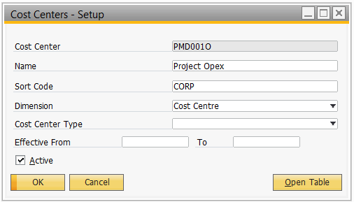

For any new cost center that is yet to be added into SAP B1, user can add anytime in the system provided he or she having the appropriate authority.

* + 1. **Project**

Project in SAP B1 allow BSM to track the financial status of each project by linking each transaction with the appropriate project by using the project code as a selection criterion in various report.

Please refer for the table below for the list of projects that currently valid in BSM:

|  |  |  |  |  |
| --- | --- | --- | --- | --- |
| **Project Code** | **Project Name** | **Main Project** | **Valid From** | **Valid To** |
| PRJBMC0001 | COMMERCIAL LIFTERS REPLACEMENT 2017 |  |  |  |
| PRJBMC0002 | HELIX BRAND VISUAL IDENTITY 2017 |  |  |  |
| PRJBMC0003 | COMMERCIAL LIFTERS REPLACEMENT (5YRS PLAN) |  |  |  |
| PRJBMC0004 | HELIX BRANDED WORKSHOP (5YRS PLAN) |  |  |  |
| PRJBMD0001 | MUARA TERMINAL IMPROVEMENT |  |  |  |
| PRJBMD0002 | REFUELLING BOWSER |  |  |  |
| PRJBMD0003 | FIREWATER PUMPS AND ENGINES |  |  |  |
| PRJBMD0004 | AVIATION NEW TRANSFER PUMP |  |  |  |
| PRJBMD0005 | AVIATION NEW HYDRANT PUMP |  |  |  |
| PRJBMD0006 | NEW LPG CYLINDERS |  |  |  |
| PRJBMD0007 | MUARA NEW FENCING 2016 |  |  |  |
| PRJBMD0008 | AVIATION DEPOT FIREFIGHTING EQUIPMENT UPGRADE DETAILED DESIGN |  |  |  |
| PRJBMD0009 | JETTY FENDERS 2016 |  |  |  |
| PRJBMD0010 | NEW PRV INSTALLATION |  |  |  |
| PRJBMD0011 | CATHODIC PROTECTION RECTIFIER - PROCUREMENT & INSTALLATION |  |  |  |
| PRJBMD0012 | (FIREFIGHTING & PRODUCT PIPELINE) SUPPORT UPGRADE |  |  |  |
| PRJBMD0013 | LOADING GANTRY 2014 |  |  |  |
| PRJBMD0014 | IND HI LEVEL ALARM SYS AVIATION 2015 | IHLA |  |  |
| PRJBMD0015 | IND HI LEVEL ALARM SYS MUARA 2014 | IHLA |  |  |
| PRJBMD0016 | IND HI LEVEL ALARM SYS BITUMEN 2015 | IHLA |  |  |
| PRJBMD0017 | MU TERMINAL PRETIUM PROJECT |  |  |  |
| PRJBMD0018 | NEW ATG (TANKFARM) |  |  |  |
| PRJBMD0019 | SARALINE PROJECT MUARA JETTY TO STL |  |  |  |
| PRJBMD0020 | UPGRADE OF TERMINAL OFFICE BUILDING |  |  |  |
| PRJBMD0021 | NEW LOCATION FOR LUBRICANTS, DRUM & LPG |  |  |  |
| PRJBMD0022 | MUARA TERMINAL FIREFIGHTING EQUIPMENT UPGRADE - DETAILED DESIGN |  |  |  |
| PRJBMD0023 | NEW PRODUCT METER INSTALLATION & UPGRADING OF LOADING ARM FOR AVIATION |  |  |  |
| PRJBMD0024 | PRODUCT QUALITY TESTING ROOM |  |  |  |
| PRJBMD0025 | NEW PUMP CONTROLLER (EXISTING LOAD G) |  |  |  |
| PRJBMD0026 | AS-BUILDING (MU PLANT CHANGES) |  |  |  |
| PRJBMD0027 | JETTY STRUCTURE UPGRADE |  |  |  |
| PRJBMD0028 | CATHODIC PROTECTION TEST FACILITIES |  |  |  |
| PRJBMD0029 | AVIATION OFFICE FIREWALL PROTECTION |  |  |  |
| PRJBMD0030 | NEW JETA1 DISPENSER & HYDRANT PIT EQUIPMENT |  |  |  |
| PRJBMD0031 | BITUMEN TERMINAL IMPROVEMENT |  |  |  |
| PRJBMD0032 | AVIATION TERMINAL IMPROVEMENT 2017 |  |  |  |
| PRJBMD0033 | AVIATION ATG UPGRADE |  |  |  |
| PRJBMD0034 | TAS SYSTEM FOR AVIATION |  |  |  |
| PRJBMD0035 | DRIVER CONTROL DELIVERY |  |  |  |
| PRJBMD0036 | CROSS UPGRADE |  |  |  |
| PRJBMD0037 | LPG STORAGE AND LUBRICANT WAREHOUSE |  |  |  |
| PRJBMD0038 | LPG BOTTLING PLANT |  |  |  |
| PRJBMD0039 | LPG SATEILLITE PROJECT |  |  |  |
| PRJBMD0040 | NEW TEMPERATURE PROBE (BIA/MUARA) |  |  |  |
| PRJBMD0041 | ENGINEERING OFFICE BUILDING |  |  |  |
| PRJBMR0001 | RETAIL AUTOMATION CONTROL ROOM |  |  |  |
| PRJBMR0002 | RIVERINE SKID TANK |  |  |  |
| PRJBMR0003 | DISPENSING PUMP REPLACEMENT PROGRAM 2017 |  |  |  |
| PRJBMR0004 | FUEL POS |  |  |  |
| PRJBMR0005 | RETAIL REFURBISHMENT 2017 |  |  |  |
| PRJBMR0006 | DISPENSING PUMP REPLACEMENT PROGRAM 2018-2022 |  |  |  |
| PRJBMR0007 | PROJECT SHINE |  |  |  |
| PRJBMR0008 | TYRE INFLATOR & COMPRESSOR |  |  |  |
| PRJBMR0009 | NTI - COCO JKR FILLING STATION |  |  |  |
| PRJBMR0010 | NTI - CODO BUANG SAKAR |  |  |  |
| PRJBMR0011 | KDR - DODO HJH BADARIAH |  |  |  |
| PRJBMR0012 | RETAIL REFURBISHMENT 2018 |  |  |  |
| PRJBMR0013 | CODO CONVERT KMMBT TEMBURONG |  |  |  |
| PRJBMR0014 | KDR - DODO DELIMA |  |  |  |
| PRJBMR0015 | NTI PLAN RETAIL STATION |  |  |  |
| PRJBMR0016 | KDR PLAN RETAIL STATION |  |  |  |
| PRJBMR0017 | RETAIL FUEL IMPROVEMENTS - AUDRIUS EMAIL 4TH AUGUST 2017 |  |  |  |
| PRJBMR0018 | RETAIL STATION DECOMISSIONING - SEPARATE ABEX (ABANDONMENT) |  |  |  |
| PRJBMR0019 | LPG SATEILLITE PROJECT |  |  |  |
| PRJBMF0001 | BUSINESS ERP SYSTEM REPLACEMENT |  |  |  |
| PRJBMF0002 | CARD MANAGEMENT SYSTEM |  |  |  |
| PRJBMF0003 | CLIENT ASSET REFERSH (CAR) LAPTOP/DESKTOP |  |  |  |
| PRJBMF0004 | ANPR |  |  |  |
| PRJBMA0001 | OFFICE RENOVATION |  |  |  |
| PRJBMA0002 | PABX SYSTEM |  |  |  |
| PRJBMA0003 | NEW OFFICE / OFFICE EXPANSION |  |  |  |

Please refer to the project setup windows in SAP B1 as below:

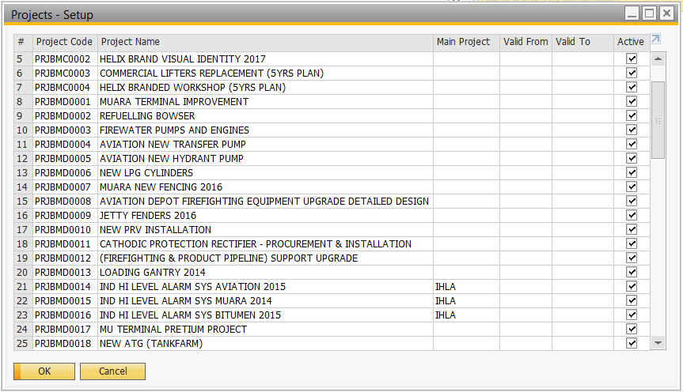

For every active project maintained in the project master data, it is allowed to select while creating transaction. By selecting the appropriate project in each transaction, report can be easily generated to track the financial status of the project accurately.

|  |  |  |
| --- | --- | --- |
| **Field Name** | **Description/Remarks** | **Mandatory/Optional** |
| Project Code | Specify the unique code for the project. | Mandatory |
| Project Name | Specify the name/description of the project. | Mandatory |
| Main Project | Specify the main project that group up the related project for reporting purpose. | Optional |
| Valid From | Specify the valid from date of the project. | Optional |
| Valid To | Specify the valid to date of the project. | Optional |
| Active | Specify whether the project is active, active project can be selected in transaction. | Mandatory |

* + 1. **Contract**

Contract in SAP B1 can be purchase contract, known as Purchase Blanket Agreement or sales contract, known as Sales Blanket Agreement. A contract can be maintained in two ways, item method and monetary method:

|  |  |
| --- | --- |
| **Contract Type** | **Description** |
| Item Method | Agreement to sell or purchase specific items within a predefined time frame. This method lets you define a planned item quantity and a price for the item that will be valid when the blanket agreement is linked to marketing documents. |
| Monetary Method | Agreement to sell or purchase goods at a predefined amount and within a predefined  time frame. This method lets you define a planned amount and a discount to be applied on the price from the BP's pricelist when the blanket agreement is linked to marketing documents. |

Whenever a document linked to a contract, the contract master will appear the document for easy tracking. Please refer below for the valid contracts of BSM setup in SAP B1:

|  |  |  |  |  |  |
| --- | --- | --- | --- | --- | --- |
| **Contract Code** | **Contract Name** | **Contractor** | **Contract Amount** | **Valid From** | **Valid To** |
| C100064 | Provision of Road Tanker Car Services | Aziz Latif Transport Sdn Bhd | 21,320,000 | 01/03/2015 | 28/02/2024 |
| C140428 | Provision of Fuel Tanker Car Services | PTT Enginering Sdn Bhd | 9,700,000 | 01/09/2017 | 31/08/2026 |
| C107108 | Importation of Fuel (core) | SIETCO |  |  |  |
| C107109 | Importation of Fuel (call off 1) | Vitol Pte Ltd |  |  |  |
| C107110 | Importation of Fuel (call off 2) | Astra Oil Sdn Bhd |  |  |  |
| C130322 | Provision of Material Handling Equipment & Personnel | Teamone Environmental Technologies | 2,952,000 | 01/05/2015 | 30/04/2020 |
| C120255 | International freight forwarding services | Schenker Singapore pte ltd | 11,397,000 | 01/09/2013 | 31/08/2018 |
| C140404 | Provision of Heavy Vehicles | Liftco Sdn Bhd | 3,648,000 | 04/01/2015 | 31/03/2020 |
| C100058 | BSM General Asset Maintenance Services [Scope 1] | Aziz Latif & Co. | 6,551,000 | 01/04/2012 | 31/12/2017 |
| C120001 | BSM Asset Maintenace Services at Retail Stations [Scope 2] | Dandy Jaya Sdn Bhd | 3,500,000 | 01/04/2012 | 31/12/2017 |
| C120005 | Provision of E-Banking Services | Bank Islam Brunei Berhad | 155,000 | 01/07/2017 | 01/04/2023 |
| C170118 | BSM External Audit Services | Ernst and Young |  |  |  |
| C140402 | Provision of BSM Fuel Pos Maintenance (Scope 1) | OPW Malaysia Sdn Bhd | 654,000 | 30/11/2016 | 29/11/2019 |
| C161172 | Provision of BSM Fuel Pos Maintenance (Scope 2) | Falahtek Sdn Bhd | 380,000 | 30/11/2016 | 29/11/2019 |
| C170025 | BSP ERP Implementation | Data Clicks Solution | 1,242,400 | 02/06/2017 | 04/01/2023 |
| C151011 | BSM Muara New Loading Gantry Construction | Sahid Sdn Bhd |  | 09/06/2017 |  |
| C140976 | BSM Muara New Loading Arms & Skid | Diamond Key International | 2,900,000 | 15/03/2017 | 14/03/2019 |

Please note that Project and Contract is NOT interchangeable. For example, a contract can be part of a project but project may have other elements which is not part of the contract.

Moreover, a generic contract may serve many projects

* 1. **Business Partner Master Data**
     1. **Vendor Code**

BSM will be using different vendor code comparing with the one maintained in SunSystems. The vendor coding structure in SAP B1 will start with alphabet “V”, follow by 6 running number. For example, V331540, V310829,etc.

Please refer below for the Business Partner Master Data window for one of the BSM’s vendor in SAP B1:

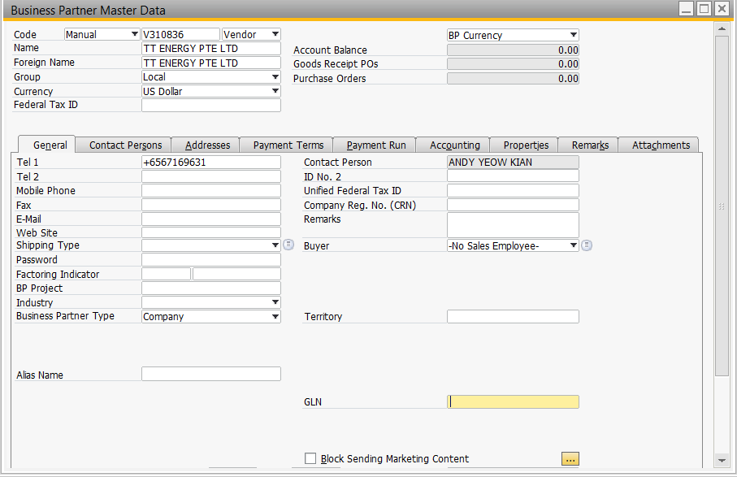

* + 1. **Vendor Group**

Vendor Group is use to classified the vendor by their group, for example, according to the sector, size or etc. Each vendor in SAP B1 can be assigned to one group only.

Vendor Group can be utilized to:

* format reports and evaluations
* sort data and make selections such as evaluating your purchase figures for each sector.

For BSM, vendor group in SAP B1 maintained as below:

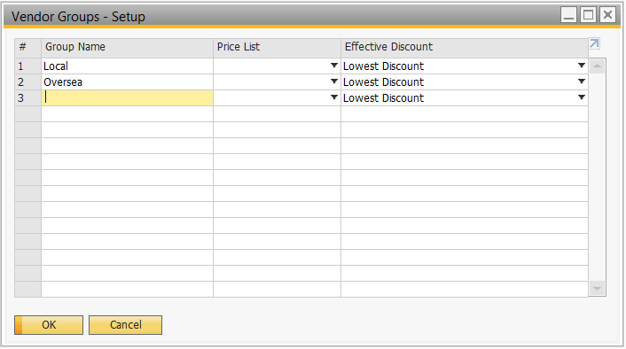

* + 1. **Customer Code**

Customer code in SAP B1 will start from alphabet “C” follow by 3 alphabets of customer group abbreviation, then 3 running number. For example, CIND001, CAVI002, etc.

Please refer below for the Business Partner Master Data window for one of the BSM’s customer in SAP B1:

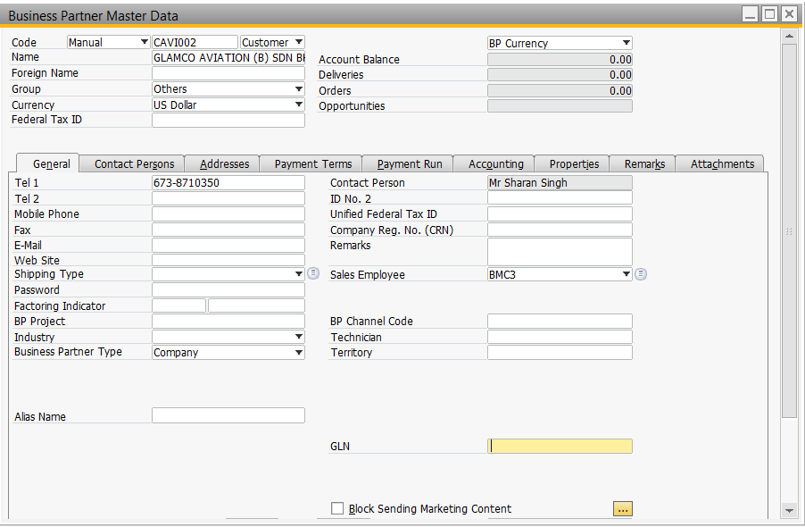

* + 1. **Customer Group**

Customer Group is use to classified the customer by their group, for example, according to the sector, size or etc. Each customer in SAP B1 can be assigned to one group only.

Customer Group can be utilized to:

* format reports and evaluations
* sort data and make selections such as evaluating your sales figures for each sector.

For BSM, customer group in SAP B1 maintained as below:

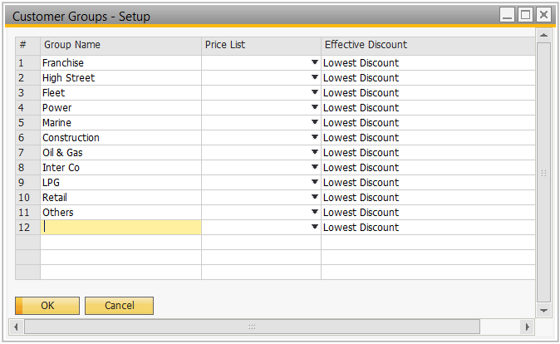

* + 1. **Payment Term**

This function is to define the payment terms that apply to transactions with customers and vendors. Whenever a purchasing or sales document is entered for a customer or vendor, SAP B1 will automatically copies the information of payment term. This information is used to calculate the due date of an invoice.

The payment term tagged to that specific customer or vendor master record can still be changed manually in the transaction.

In BSM, the payment term in SAP B1 setup as below:

|  |  |
| --- | --- |
| **Payment Term Code** | **Due Date After (Day(s))** |
| CBD | 0 |
| COD | 0 |
| 1 Day | 1 |
| 2 Days | 2 |
| 3 Days | 3 |
| 15 Days | 15 |
| 30 Days | 30 |

Please refer below for the payment term setup window in SAP B1:

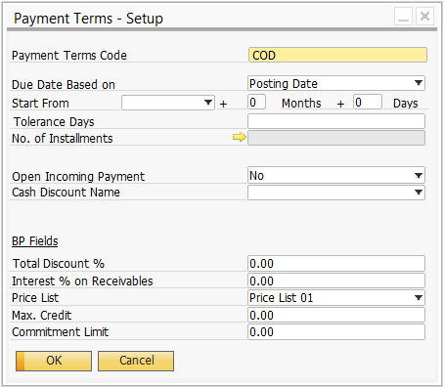

* + 1. **Price List**

SAP B1 allow creation of different price lists for items, giving the flexibility to offer customers customized prices.

During the creation of sales and purchasing documents, SAP B1 derives item prices directly from a price list that is linked to a customer or vendor.

Price list setup for BSM is according to available customer group and status. All these price list is not interlinked as each different price list will have their own pricing.

Please refer below for the price list created for BSM in SAP B1:

|  |  |  |  |
| --- | --- | --- | --- |
| **Price Group** | **Price Group Description** | **Base Price Group** | **Factor** |
| 1 | List Price | List Price | 1 |
| 2 | Industrial - Distributor | Industrial - Distributor | 1 |
| 3 | Industrial - Platium | Industrial - Platium | 1 |
| 4 | Industrial - Gold | Industrial - Gold | 1 |
| 5 | Industrial - Silver | Industrial - Silver | 1 |
| 6 | IWS - Distributor | IWS - Distributor | 1 |
| 7 | IWS - Platium | IWS - Platium | 1 |
| 8 | IWS - Gold | IWS - Gold | 1 |
| 9 | IWS - Silver | IWS - Silver | 1 |
| 10 | FWS - Distributor | FWS - Distributor | 1 |
| 11 | FWS - Platium | FWS - Platium | 1 |
| 12 | FWS - Gold | FWS - Gold | 1 |
| 13 | FWS - Silver | FWS - Silver | 1 |
| 14 | Government - Distributor | Government - Distributor | 1 |
| 15 | Government - Platium | Government - Platium | 1 |
| 16 | Government - Gold | Government - Gold | 1 |
| 17 | Government - Silver | Government - Silver | 1 |
| 18 | Retail - Platium | Retail - Platium | 1 |
| 19 | Retail - Gold | Retail - Gold | 1 |
| 20 | Retail - Silver | Retail - Silver | 1 |

Please refer below for the Price Lists window in SAP B1:

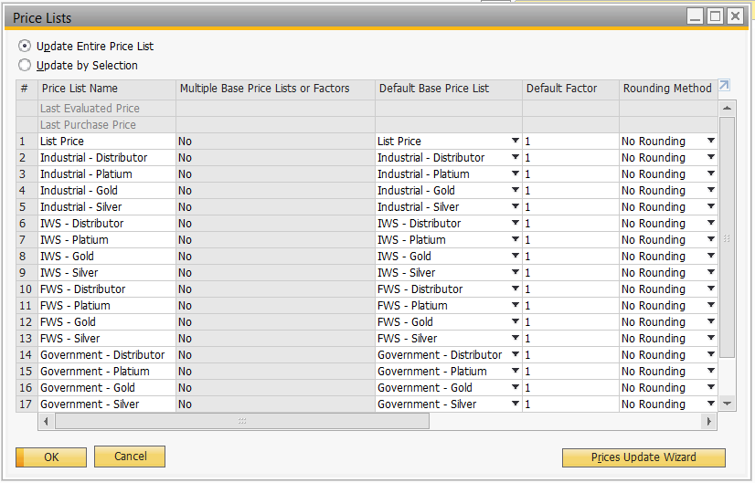

* 1. **Item Master Data**
     1. **Item Code**

Item code will start from product brand and follow by 3 running number. For example, TURBO009, ADVAC001, etc.

Please refer below for the Item Master Data window in SAP B1:

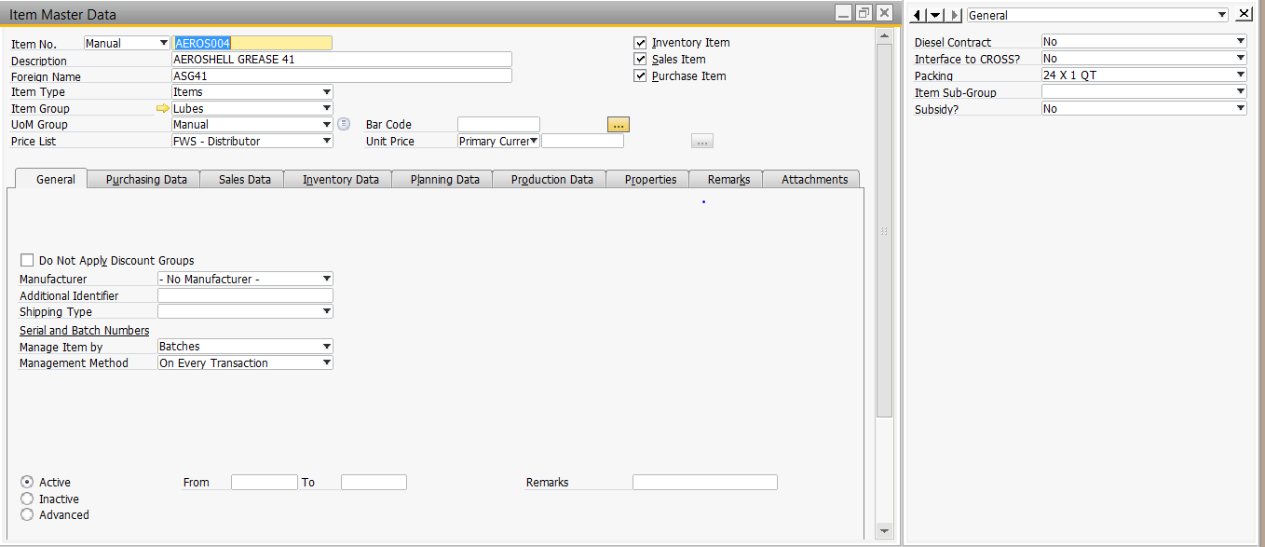

* + 1. **Item Group**

Item Group is use to differentiate the item by the group its’ belongs to for further analysis purpose that required by BSM. Each item can be assigned to only one item group.

BSM’s Item Group are as below:

* Bulk
* Lubes
* LPG

Please refer below for the Item Group Setup window in SAP B1:

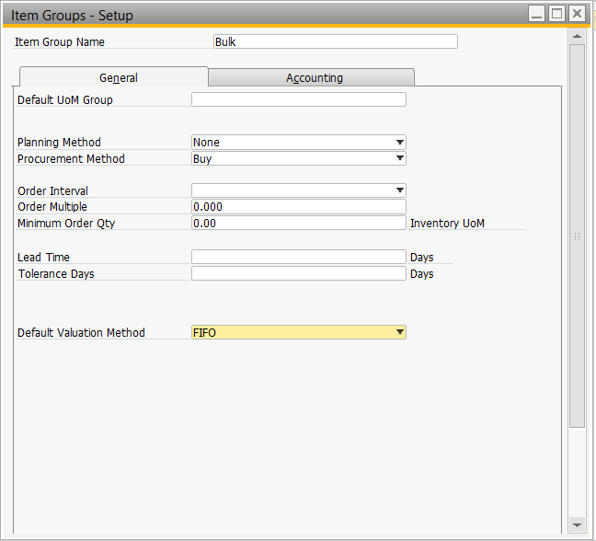

Each of the item group need to be linked to G/L account as below:

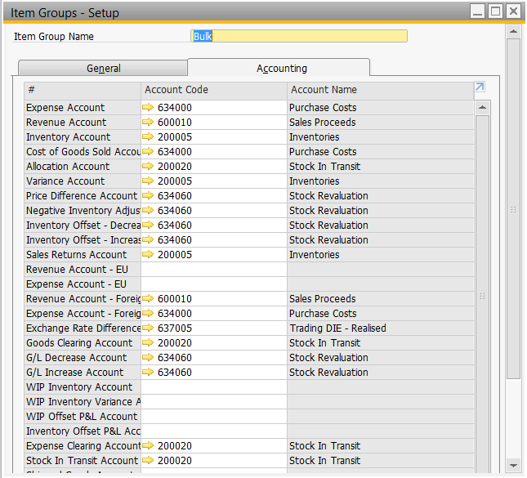

Whenever there’s transaction in SAP B1 that will utilized any of the G/L account that belongs to the item in this item group, it will retrieve the G/L account linked here to the transaction itself. However, user still allowed to change the G/L account in the transaction itself.

* + 1. **Item Sub-Group**

Item Sub-Group is to breakdown the item group into more detail for further analysis purpose that required by BSM. It is maintained in a user defined field (UDF) where located in Item Master Data window.

BSM’s Item Sub-Group lists are as below:

* PCMO
* DEO (Diesel Engine Oil)
* AVIATION
* GREASE
* AGT (Axle, Gear, Transmission)
* EEO (Electrical Engine Oil)
* SPCIALITIES PRODUCTS
* MEO (Manne Engine Oil)
* GO (Gear Oil)

Please refer below for the Item Sub-Group maintained in SAP B1:

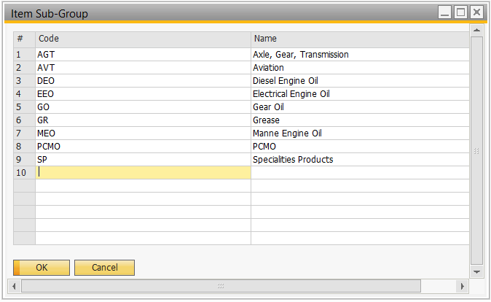

User can add in any additional/new item sub-group which is not in the list at any point of time in SAP B1.

* + 1. **Packing**

Packing is use to categorized the item’s packing for analysis purpose required by BSM. It is maintained in a user defined field (UDF) where located in Item Master Data window.

BSM’s Item Packing lists are as below:

* 1L
* 4L
* 20L
* 208L
* 209L
* 1000L
* 12 X 1L
* 4 X 4L
* 3 X 5L
* 5kg
* 18kg

Please refer below for the Item Packing maintained in SAP B1:

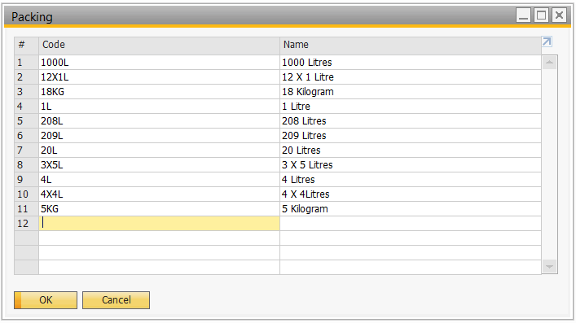

User can add in any additional/new item sub-group which is not in the list at any point of time in SAP B1.

* + 1. **Warehouse**

Warehouse represents the physical / logical location where the item stored. BSM has multiple different warehouses that serve for different purposes. The warehouse list of BSM setup in SAP B1 as below:

|  |  |  |
| --- | --- | --- |
| **Warehouse Code** | **Warehouse Name** | **Physical/Logical** |
| WHS1 | Muara Whs 1 | Physical |
| WHS8 | Muara Damage Whs | Physical |
| WHS9 | Muara Repacking Whs | Physical |
| MUA | BSM Muara Terminal | Physical |
| BSR | Brunei Shell Refinery | Logical |
| BIT1 | BSM Bitumen Depot | Physical |
| BIT2 | Diesel Tank (Own Use) | Physical |
| LPG1 | LPG BSM Muara | Physical |
| LPG2 | LPG BSM Muara Damaged | Physical |
| LPG3 | LPG Lumut Bottling Plant | Physical |
| MTBE | MTBE Tank | Logical |
| BIA1 | JET A1 | Physical |
| BIA2 | Diesel Tank (Own Use) | Physical |
| OPL | Off-Port Location | Physical |
| BIT3 | PG 76 | Physical |

Please refer below for the Warehouse Setup window in SAP B1:

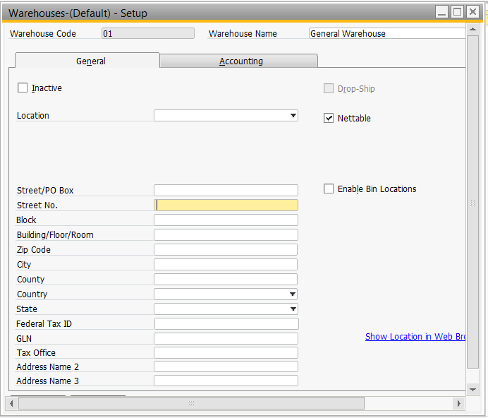

User can add in any additional/new warehouse which is not in the list at any point of time in SAP B1.

1. **User Defined Table & Fields**
   1. **User Defined Table (UDT)**

User Defined Table (UDT) is use to define any other information that companies would like to maintain but it doesn’t exist within the standard setup of SAP B1 in tabulate format. This table can later be reference by user defined field which will be mentioned in (4.2 User Defined Field (UDF)).

The UDT list for BSM in SAP B1 as below:

|  |  |  |  |
| --- | --- | --- | --- |
| **#** | **Table Code** | **Table Name** | **Description** |
| 1 | ITMSGROUP | Item Sub-Group | A list of available item sub-group in BSM which will be referenced by user defined field in item master data to categorized the item by its’ sub-group for reporting purpose. |
| 2 | PACKING | Packing | A list of available item packing in BSM which will be referenced by user defined field in item master data to categorized the item by its’ packing for reporting purpose. |
| 3 | DENSITY | Density | Use to store the density of the fuel each day to calculate the actual mass of the liter delivered in DO, because whenever density changed, it will affect the liter as well, the only thing wouldn’t change is the mass. |
| 4 | RTNREASON | Return Reason | A list of available return reason in BSM that will be selected when creating return document for analysis purpose. |
| 5 | TRANSPORTER | Transporter | A list of available transporters, this will be referenced by user defined field in delivery document for information purpose. |
| 6 | TRUCK | Truck | A list of available truck under each transporter, this will be referenced by user defined field in delivery document for information purpose. |
| 7 | COUNTRY | Country | A list of countries that requested by CSC to keep track as additional information in sales document. |

The initial content for each UDT as below:

1. Item Sub-Group

|  |  |
| --- | --- |
| **Code** | **Description** |
| PCMO | PCMO |
| DEO | Diesel Engine Oil |
| AVT | Aviation |
| GR | Grease |
| AGT | Axle, Gear, Transmission |
| EEO | Electrical Engine Oil |
| SP | Specialities Products |
| MEO | Manne Engine Oil |
| GO | Gear Oil |

1. Packing

|  |  |
| --- | --- |
| **Code** | **Description** |
| 1L | 1 Liter |
| 4L | 4 Liters |
| 20L | 20 Liters |
| 208L | 208 Liters |
| 209L | 209 Liters |
| 1000L | 1000 Liters |
| 12X1L | 12 X 1 Liter |
| 4X4L | 4 X 4 Liters |
| 3X5L | 3 X 5 Liters |
| 5kg | 5 Kilogram |
| 18kg | 18 Kilogram |
| 180kg | 180 Kilogram |

1. Density

|  |  |  |  |
| --- | --- | --- | --- |
| **Code** | **Description** | **Date** | **Density** |
| 1 | 20170913 | 13/9/2017 | 0.543 |

1. Return Reason

|  |  |
| --- | --- |
| **Code** | **Description** |
| 1 | Long Pending |
| 2 | Customer Not Allege |
| 3 | Product Quality Issue |
| 4 | Wrong Product |
| 5 | Wrong Quantity |
| 6 | Others |

1. Transporter

|  |  |  |  |
| --- | --- | --- | --- |
| **Code** | **Description** | **Contact Person** | **Contact No.** |
| 1 | Aziz Latif Transport | Mervin | 8720376 |
| 2 | Zainal Daud | Jimmy | 8744855 |
| 3 | Liftco | Khairi | 8312138 |

1. Truck

|  |  |  |  |  |
| --- | --- | --- | --- | --- |
| **Code** | **Description** | **Transporter Code** | **Type of Vehicle** | **Product** |
| KP9052 | KP9052 | 1 | Rigid | Mogas |
| KP9035 | KP9035 | 1 | Rigid | Mogas |
| BAQ1531 | BAQ1531 | 1 | Rigid | Mogas |
| BAQ1532 | BAQ1532 | 1 | Rigid | Mogas |
| BAQ1534 | BAQ1534 | 1 | Rigid | Mogas |
| BAQ2512 | BAQ2512 | 1 | Rigid | Mogas |
| BAQ2513 | BAQ2513 | 1 | Rigid | Mogas |
| BAQ2514 | BAQ2514 | 1 | Rigid | Mogas |
| BAP9349 | BAP9349 | 1 | Single Axle | Mogas |
| BAP9348 | BAP9348 | 1 | Single Axle | Mogas |
| BAP9351 | BAP9351 | 1 | Single Axle | Mogas |
| BAP9354 | BAP9354 | 1 | Single Axle | Mogas |
| BAQ1537 | BAQ1537 | 1 | Double Axle | Mogas |
| BAQ1538 | BAQ1538 | 1 | Double Axle | Jet A1 |
| BAP9358 | BAP9358 | 1 | Double Axle | Jet A1 |
| KJ5306 | KJ5306 | 2 | Rigid | Mogas |
| KJ5307 | KJ5307 | 2 | Rigid | Mogas |
| BAE5311 | BAE5311 | 2 | Double Axle | Jet A1 |
| KJ5313 | KJ5313 | 2 | Double Axle | Mogas |
| KJ5315 | KJ5315 | 2 | Double Axle | Mogas |
| KJ5317 | KJ5317 | 2 | Double Axle | Mogas |
| KJ5319 | KJ5319 | 2 | Double Axle | Mogas |
| KJ5321 | KJ5321 | 2 | Double Axle | Mogas |
| KJ5323 | KJ5323 | 2 | Double Axle | Mogas |
| BAQ2593/2703 | BAQ2593/2703 | 3 | Trailer | LPG |
| BAQ2586/2596 | BAQ2586/2596 | 3 | Trailer | LPG |
| BAQ2591/2701 | BAQ2591/2701 | 3 | Trailer | LPG |
| BAQ2590/2598 | BAQ2590/2598 | 3 | Trailer | LPG |
| BAQ2594/2704 | BAQ2594/2704 | 3 | Trailer | LPG |
| BAQ2587/2597 | BAQ2587/2597 | 3 | Trailer | LPG |
| BAQ8203 | BAQ8203 | 3 | Box Truck | Pack |
| BAQ8204 | BAQ8204 | 3 | Box Truck | Pack |

1. Country

|  |  |
| --- | --- |
| **Code** | **Description** |
| TH | Thailand |
| SG | Singapore |
| MY | Malaysia |

Please refer below for the UDT setup window in SAP B1:

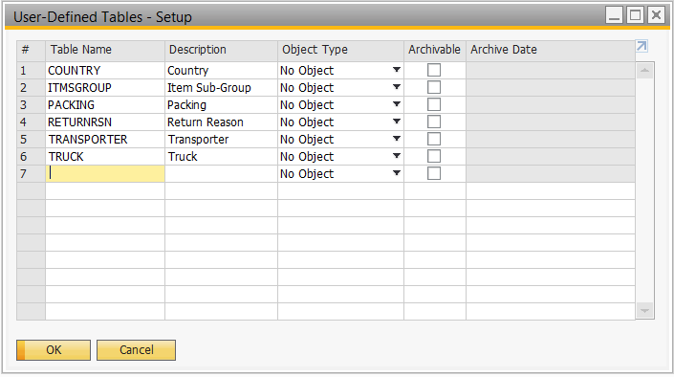

Please refer below for one of the example, Item Sub-Group UDT windows, use to maintain (add/edit/delete) the value content in UDT in SAP B1:

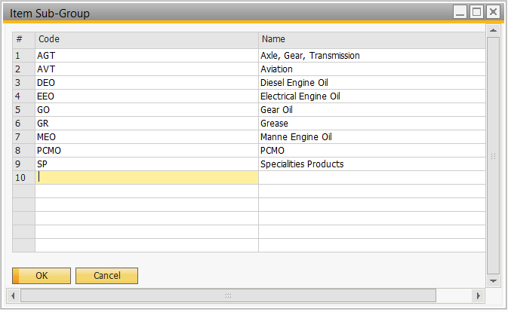

* 1. **User Defined Fields (UDF)**

User Defined Fields (UDF) is use to define any other extra fields in document/master data in SAP B1 that does not exist in the standard SAP B1 for additional information.

User defined field can be in drop down selection or free text and it also support different data types such as Alphanumeric, Numeric, Date/Time, Units and Total and General. General Types can be defined to Attach Documents and Images.

For the user defined field created, it can be included in the document layout as well. We will create user defined field for BSM as the table below:

|  |  |  |  |
| --- | --- | --- | --- |
| **#** | **UDF Name** | **Screen** | **Description** |
| 1 | Fuel Quota Check | Business Partner | Indicate whether this customer need to have fuel quota check. |
| 2 | Fuel Quota | Business Partner | Indicate the fuel quota that approved by government for the customer. |
| 3 | Fuel Quota Duration | Business Partner | Indicate the duration of the fuel quota, for eg. Month/Year. |
| 4 | SunSystems Address ID | Business Partners - Addresses | Maintain the old address code maintained in SunSystems for the customer, to ensure interface over CROS |
| 4 | Item Sub Group | Items | Indicate the sub group of the item belongs to. For additional information and reporting purpose. |
| 5 | Packing | Items | Indicate the packing of the item belongs to. For additional information and reporting purpose. |
| 6 | Fuel Quota Check | Items | Indicate whether this item need to be included in the fuel quota check. |
| 7 | Interface to CROSS? | Items | Indicate whether this item need to interface to CROSS. It will automatically copy the value maintained in item master data to sales document when the item selected, but changes still allowed to made at the document itself. |
| 8 | RTC No. | Marketing Document Title | RTC number generated by CROSS. |
| 9 | Mileage | Marketing Document Title | Mileage of the delivery. |
| 10 | Truck Number | Marketing Document Title | Truck number that in charge for that delivery. Link to TRUCK UDT mentioned above. |
| 11 | Transporter Name | Marketing Document Title | Name of transporter that in charge for that delivery. Link to TRANSPORTER UDT mentioned above. |
| 12 | Driver Name | Marketing Document Title | Name of the driver that in charge for that delivery. |
| 13 | Warehouse | Marketing Document Title | To enable switching of all item’s warehouse in a DO at one go. |
| 14 | Country | Marketing Document Row | Indicate the country of the item from/to. |
| 15 | Tank No. | Marketing Document Row | Customer’s underground tank number that will be filled up on the delivery. |
| 16 | Compartment No. | Marketing Document Row | To indicate which compartment does the item load into the truck while delivery. |
| 17 | Interface to CROSS? | Marketing Document Row | To indicate whether that particular SO row will be interface to CROSS for scheduling or not. |
| 18 | Liter | Marketing Document Row | To store the liter sold for customer and use it to calculate the actual mass sold for fuel using the formula below:  Liter * Density |
| 19 | Density | Marketing Document Row | To store the density of the fuel sold for customer and use it to calculate the actual mass sold for fuel using the formula below:  Liter X Density |
| 20 | Trip No. | Marketing Document Row | Trip number for the item to be delivered on that day. |
| 21 | Return Reason | Marketing Document Row | To keep track the return reason for analysis purpose. It will link back to RTNREASON UDT to allow user select return reason instead of key in free text by themselves. |
| 22 | Cheque No. | Cheque | To store the cheque number of the cheque number as standard field in SAP B1 only accept numeric cheque number but not alphanumeric. |

1. **Financial**
   1. **G/L Account Determination**

G/L Account Determination is to define the default G/L Account for transactions created in SAP B1. Different financial year can have different set of default G/L Account. G/L Account Determination have six different window’s tabs that specific area of the business activity: Sales, Purchase, General and Inventory, Resources and WIP Mapping.

Resources and WIP Mapping is applicable only when production module is activated. BSM will be using production module as well for refill process of the LPG.

Please refer below for the G/L Account Determination windows in SAP B1 :

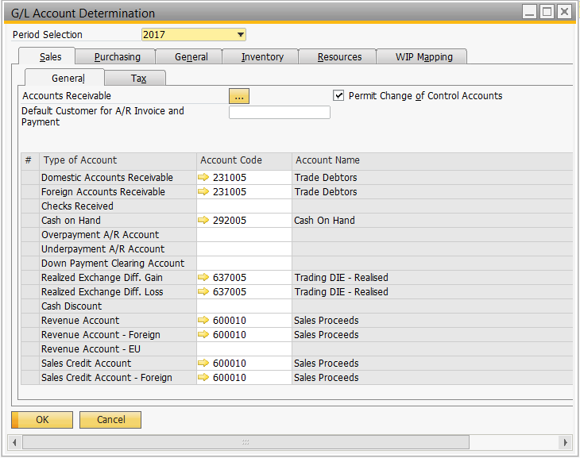

* 1. **Journal Entry**

This is the window where user able to enter manual journal in SAP B1. The manual records entered in SAP B1 cannot be deleted, if there’s any error found for the created manual journal, cancellation is needed. Cancelling manual journal will generate reserve double entry.

Please refer below for Journal Entry window in SAP B1:

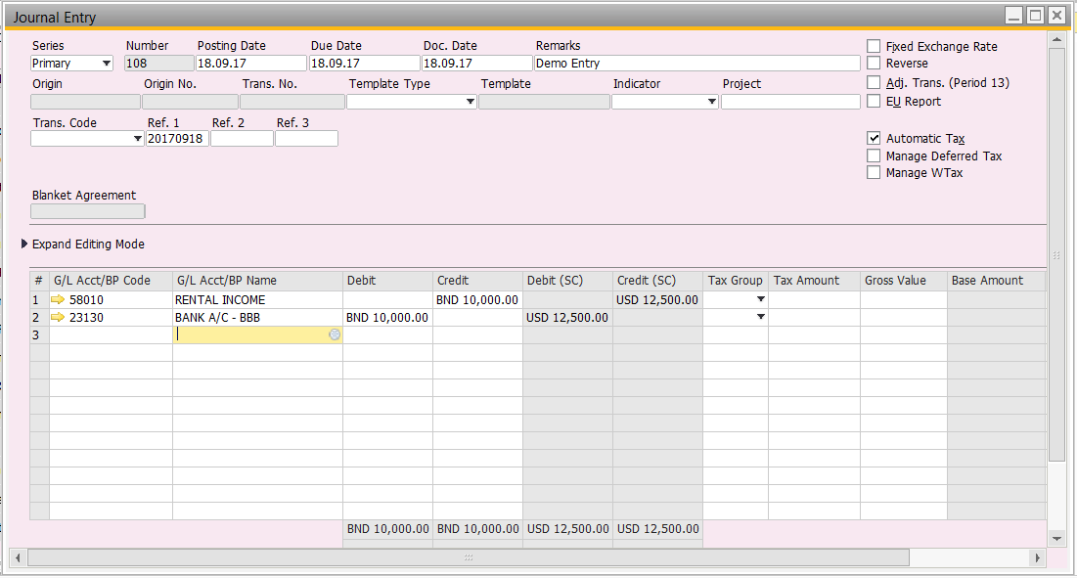

If user would like to duplicate or cancel this particular manual journal entry, they need to look for the manual journal entry, then right click on the window.

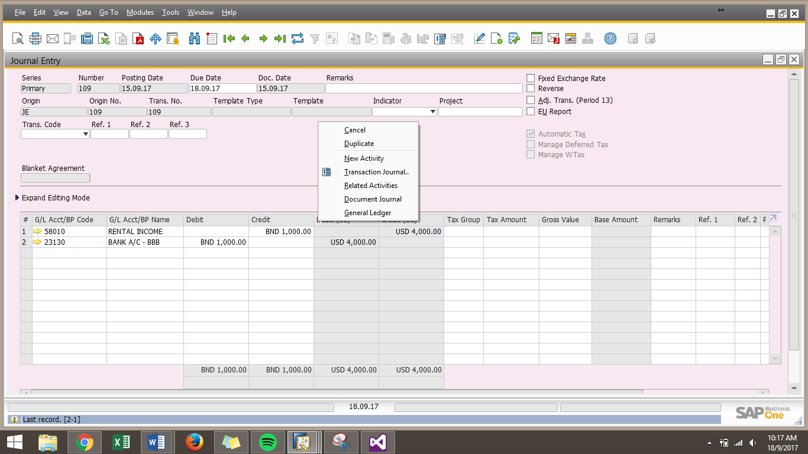

If the journal entry is system generated or pending for reverse, the Cancel option is not available.

For the period 13 adjustment, user can create the adjustment journal in Journal Entry window with selecting “Adj. Trans. (Period 13)” option which located on the top and rightmost of the window.



This period 13 adjustment can later be included or excluded from the management report based on management requirement. Please refer below for one of the SAP B1 report selection criteria:

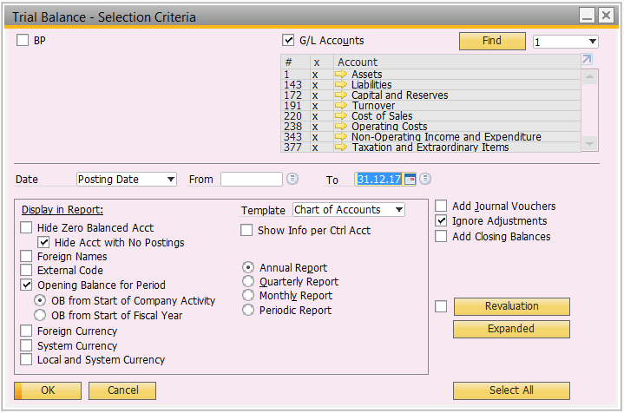

“Ignore Adjustments” option is to include or exclude the period 13 adjustment figure that have been added in SAP B1 for the report.

Besides, user can preset when to alert the reversal of Journal Entry at this screen as well by selecting “Reverse” option and fill up the desired reverse date which located above “Adj. Trans. (Period 13)” option.



Upon the reserve date arrived, when user login to the system with appropriate authorization, he or she will able to see the reversal alert/notification appear in their home page as below:

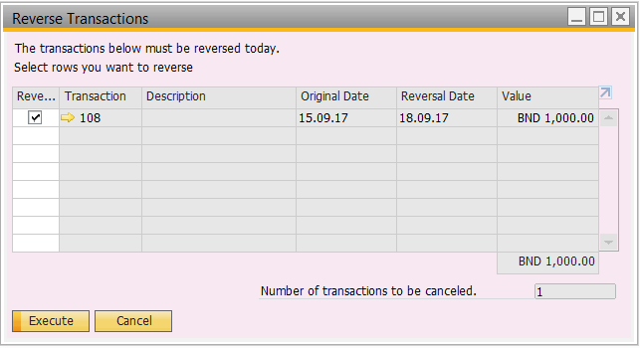

For further details regarding journal reverse, please refer to section 5.6 Reverse Transaction.

* 1. **Journal Voucher**

This is the window where user allowed to create draft version of journal entry. As for current, SAP B1 doesn’t support approval procedure for journal entry, this, Journal Voucher can be used as a form of approval where unauthorized user can only create journal voucher and the authorized user approved and convert it into journal entry.

One journal voucher can have more than one draft journal entry transaction. Please refer below for the Journal Voucher window in SAP B1:

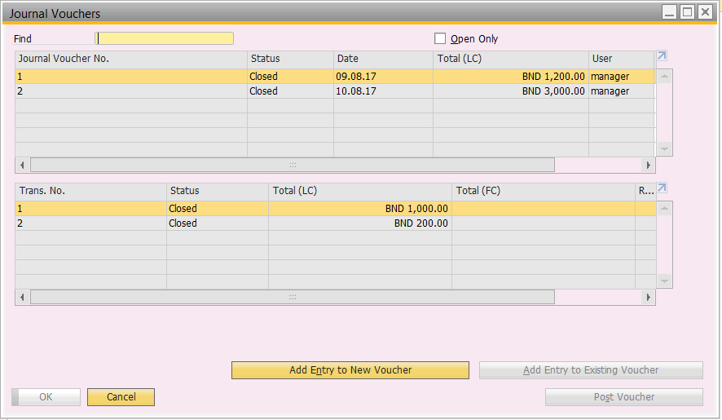

The draft journal entry (Journal Voucher Entry) window is basically similar with the journal entry window. Only one more extra field in Journal Voucher Entry window which is Voucher No. located at the top and leftmost of the Journal Voucher Entry window.

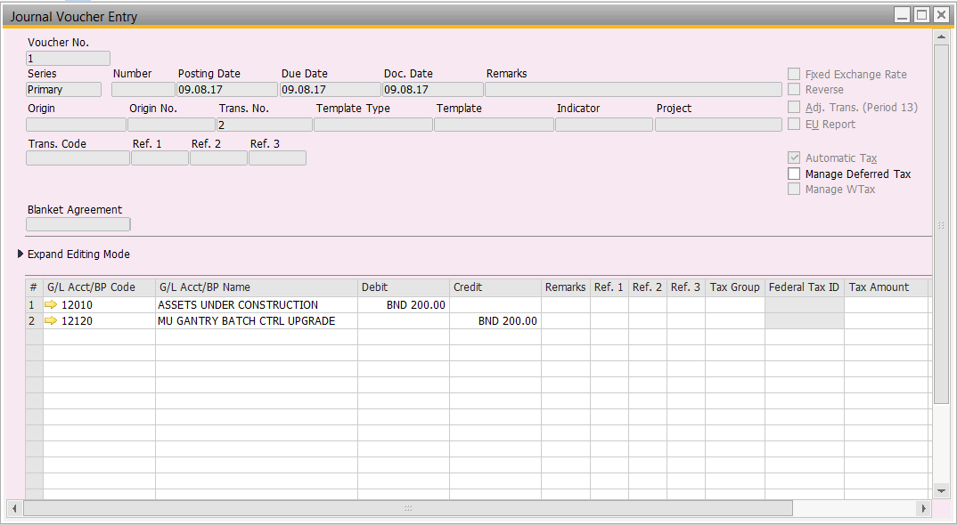

The voucher no. is use to indicate the uniqueness of each journal voucher created. Upon finish creating the journal voucher, the authorized user can go through the content of journal voucher and decide to convert journal voucher to journal entry by selecting the journal voucher and click on the “Post Voucher” button.

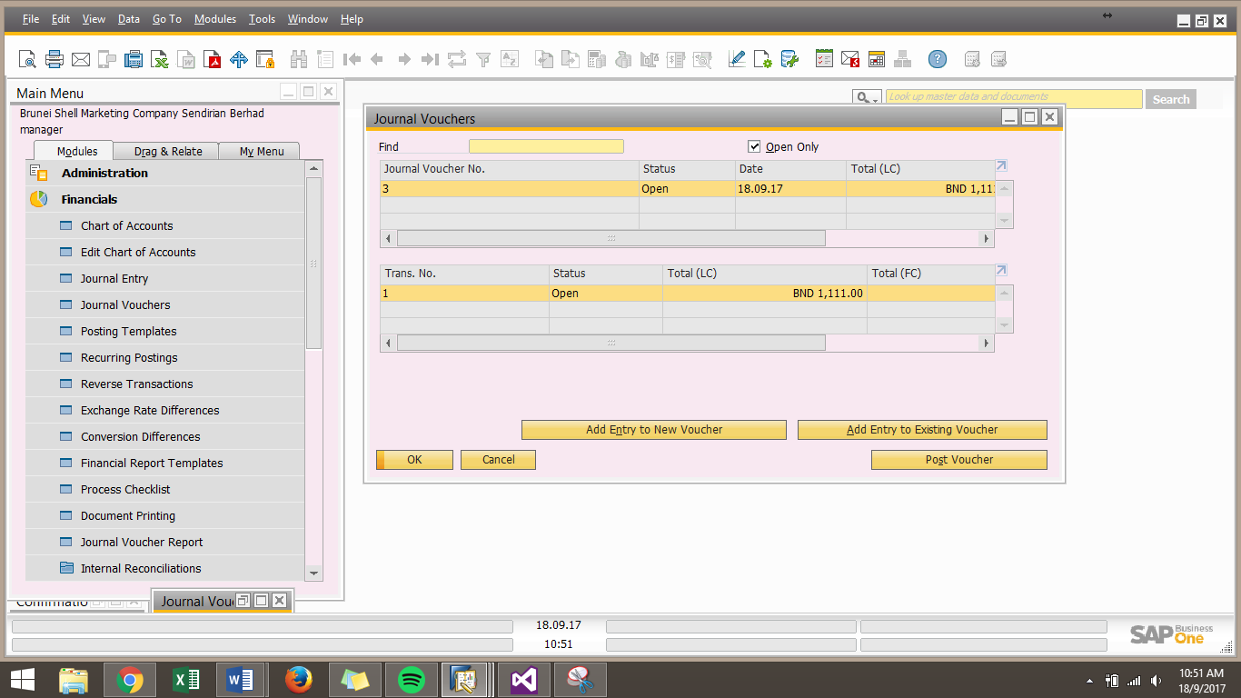

This action will close the journal voucher and convert the journal voucher to journal entry. Then only the figure of the journal voucher will be added into the G/L account.

However, SAP B1 allowed user to include or exclude the journal voucher figure in management report as well, please refer below for one of the SAP B1 report selection criteria:

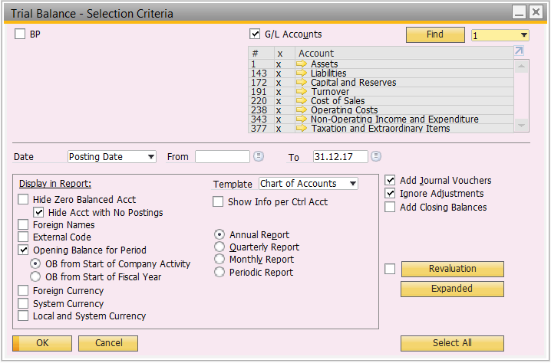

“Add Journal Vouchers” option is to include or exclude the journal voucher figure that have been added in SAP B1 for the report.

* 1. **Exchange Rate Differences**

This window allowed user to recalculate the local currency (LC) and foreign currency (FC) balances according to the exchange rate on the day the differences are calculated. This is due to daily fluctuations in FC exchange rates may cause mismatches between the balances in LC and FC.

For the differences calculated, it will be posted to the account selected, normally it will be unrealized gain/loss account. Please refer below for Exchange Rate Differences window in SAP B1:

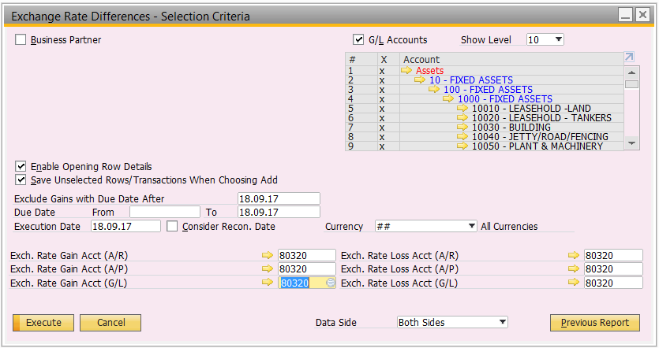

Upon all the selection criteria filled up and “Execute” button clicked, the available result will appear as below:

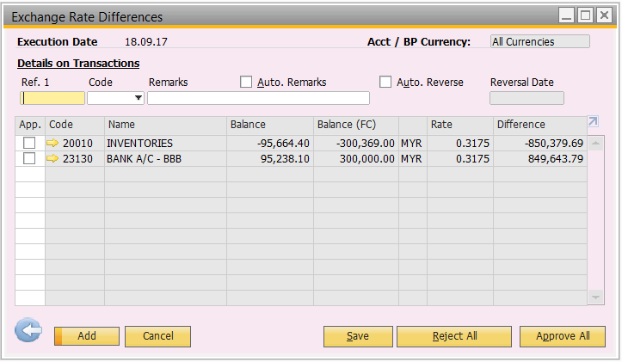

User can choose which transaction they like to post and click “Add” button to proceed, journal entry will automatically add in SAP B1 based on user selection.

* 1. **Recurring Transaction**

This window allow user to setup a predefined template for the business transactions that BSM recur monthly or weekly. For example, electricity utility, rental, payroll and etc. Although the transactions recur on predefined dates, and usually comprise the same objects, the transaction amounts are not necessarily the same each time, nor do the percentages have to be fixed. The recurring period can be daily, weekly, monthly, quarterly, semi-annually and annually based on a calendar date. It can also set the recurring end date.

Please refer below for the Recurring Transaction Setup window in SAP B1:

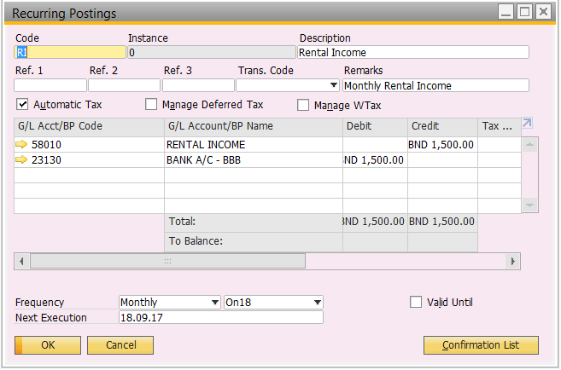

Upon the recurring posting setup complete, whenever the “Next Execution” date arrived, it will appear a window in main menu when user login to SAP B1 which showed all the available recurring transaction that pending to be post as below:

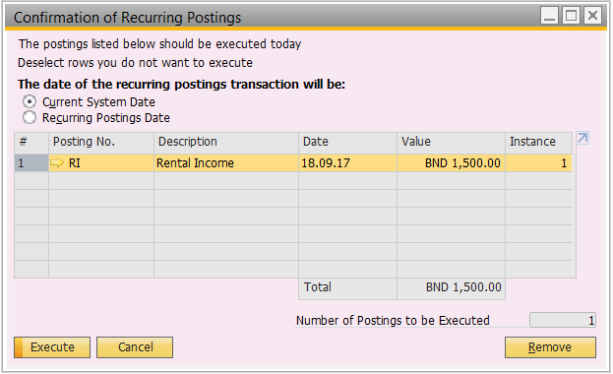

User can select recurring posting transaction from the list to execute and journal entry will automatically create in SAP B1 based on user selection. The posting date of the journal entry have the option of recurring template posting date or current system date. This only applies to those transaction that have fixed amount happened weekly or monthly.

For those recurring transaction with amount that not necessary to be the same, user can still setup the recurring template as an alert/reminder to themselves. Then user can go to journal entry window and create manual journal entry by selecting the recurring template as below:

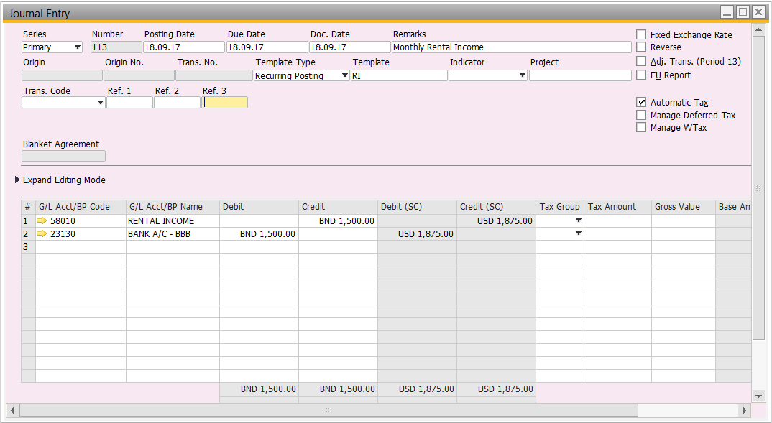

This shorten the time required to select all the G/L account again, amendment should be the amount only. After journal created, user must go back to the available recurring transaction window to remove that particular transaction. By removing the transaction, SAP B1 will assumed the transaction executed for that month/week, it will only appear again when the “Next Execution” date arrived.

* 1. **Reverse Transaction**

This allowed user to view a list of all manual journal entries scheduled for automatic reversal which can be execute. This feature can be utilized for accrual transaction that need to be reverse on the following month.

Please refer below for Reserve Transactions window in SAP B1:

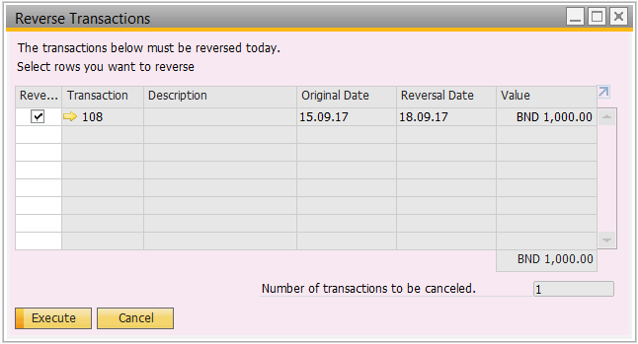

This window will appear to user with appropriate authorization when he or she login to SAP B1 and the reverse date for the manual journal entries arrived. If user accidentally closed this window and wanted to access this window again, he or she can access under Financials -> Reverse Transactions.

User can still select from the available reverse transaction list to decide whether to reserve which transaction, then execute. Upon execute, a reverse journal will be automatically created in SAP B1 with the reverse double entry of the original journal entry.

* 1. **Report**

There will be a list of financial report (yet to be finalized) in SAP B1 or BI360 as below:

1. Profit & Loss Report
2. Balance Sheet Report
3. Cash Flow Report
4. Trial Balance Report
5. Board Requirement Report
6. PSA Report
7. Credit Exposure (Aging) Report
8. Profit & Loss Report – Unit Operating Cost
9. Cost Reporting
10. Statement of Account
11. Stock Valuation Report
12. Net Realizable Value (NRV Report)
13. Tax Report
14. Manual Accrual Report
15. JPKE Report- Volume, Value and Sector
16. Subsidiary Reports
17. EIDPMO Reports
18. **Budget**
    1. **Budget**

The Budget function is used to manage tracking of corporate expenses, and includes the option to block, warning or ignore the creation of additional transactions if the budget is exceeded. The budget can only be control by G/L account, not by respective cost center or project for standard SAP B1 without any customization.

However, to fulfill BSM’s request, budget control by cost center, add-on is required. With this add-on, the budget can be control by cost center based on monthly or annual budget. The differences of monthly and annual budget as below:

|  |  |
| --- | --- |
| **Budget Period** | **Differences** |
| Monthly | If the budget of the month exceeded while creating transaction, it will block user from adding that particular transaction. |
| Annual | If the budget of the month exceeded while creating transaction but the amount still within the annual budget, the transaction allowed to add. Only when the annual budget exceeded, only it will block the transaction from adding to SAP B1. |

As provided by BSM, the budget scenario will be maintained in SAP B1 as below:

1. Opex
2. Non-Routine (Studies)
3. Capex

Please refer below for Budget Scenario Setup window in SAP B1:

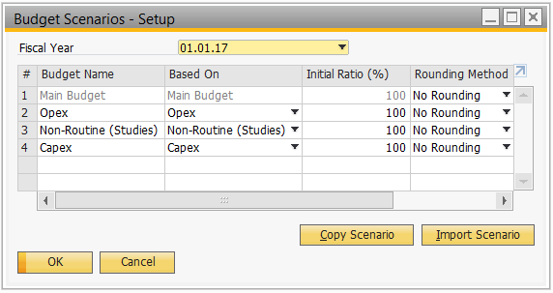

Every new fiscal (financial) year, there must be a “Main Budget” which cannot be overwrite.

* 1. **Report**

There will be a list of budget reports (yet to be finalized) in SAP B1 or BI360 as below:

1. Budget Report
2. Balance Sheet Budget Report
3. Trial Balance Budget Report
4. Profit and Loss Statement Budget Report
5. **Sales**
   1. **Sales Flow**
      1. **Order to Payment (Fuel/Non-VMI/Normal)**

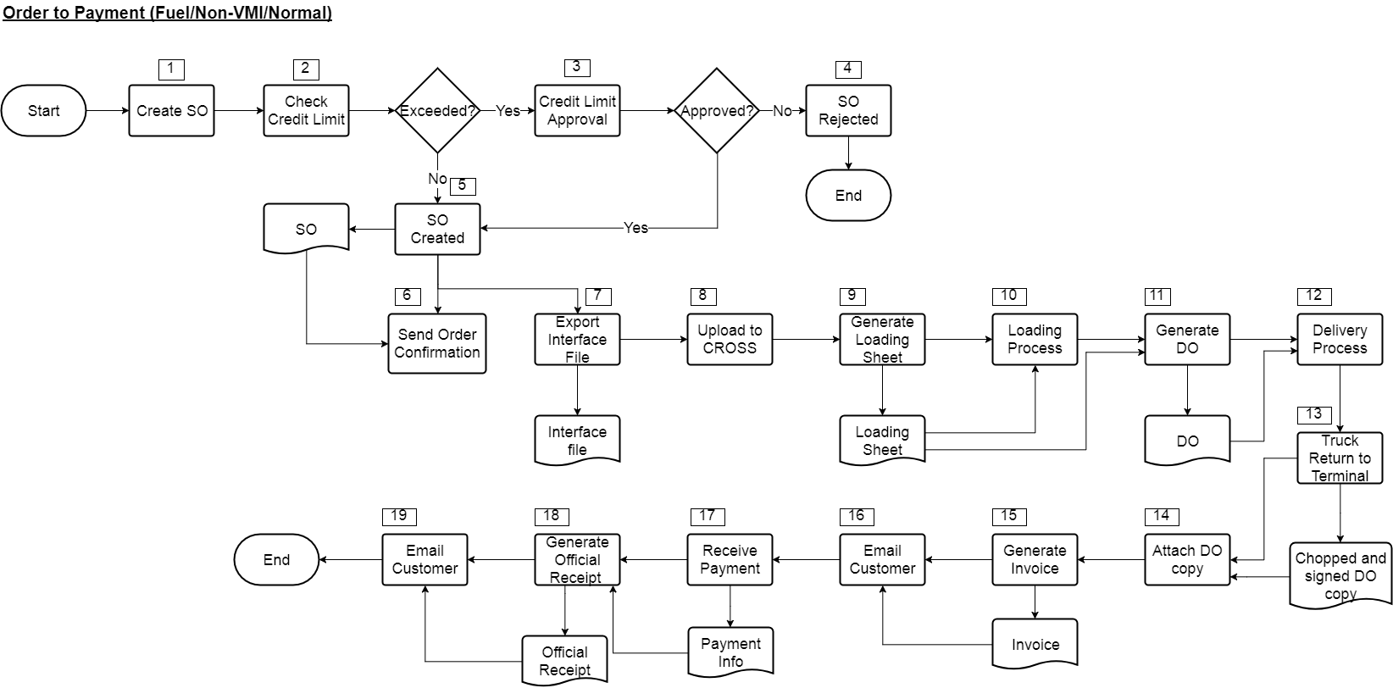

|  |  |  |  |
| --- | --- | --- | --- |
| **No.** | **Title** | **Description** | **Department/System** |
| 1 | Create SO | Create Sales Order in SAP B1 based on customer’s PO. If there’s no PO, user need to manually assign PO number for the order. | CSC |
| 2 | Check Credit Limit | Once the SO created, system will go through credit limit check automatically. | SAP B1 |
| 3 | Credit Limit Approval | If the credit limit exceeded, SO will forward to authorized approver based on approval setup for credit limit extension. | SAP B1 |
| 4 | SO Rejected | Reject credit limit approval for that SO after review customer’s profile in system. | BMF |
| 5 | SO Created | SO successfully add into SAP B1. | CSC |
| 6 | Send Order Confirmation | Sent email via email portal to customer with attach of order confirmation form. | BMR |
| 7 | Export Interface File | Extract sales order created via BI360 and save as (.csv) format. | BMD |
| 8 | Upload to CROSS | Upload extracted sales order to CROSS for scheduling. | BMD |
| 9 | Generate Loading Sheet | Generate loading sheet from CROSS after scheduling complete as a pick list for transporter. | BMD |
| 10 | Loading Process | Truck arrived at terminal and start loading process based on loading sheet. | - |
| 11 | Generate DO | Upon truck arrived at terminal gate for leaving, operation convert SO to DO using copy to feature based on the loading sheet and print out, then hand it over to driver. | BMD |
| 12 | Delivery Process | Truck leave the terminal and start delivery process. | - |
| 13 | Truck Return to Terminal | Truck returned to terminal after delivery together with the chopped and signed DO copy, then pass back to logistic staff. | - |
| 14 | Attach DO Copy | Logistic staff will browse back the created DO in SAP B1, then update information such as (ATA or others) and attach together with the chopped and signed DO copy | BMD |
| 15 | Generate Invoice | After DO updated, convert DO to Invoice in SAP B1 using copy to feature. | BMD |
| 16 | Email Customer | Upon all the creation of Invoice completed for the day, use email portal to send out the invoice in batch for the customer. | BMD |
| 17 | Receive Payment | Receiving payment from customer together with the payment information. | - |
| 18 | Generate Official Receipt | Create incoming payment in SAP B1 after verify the payment information. | BMF |
| 19 | Email Customer | Send out the created official receipt to customer in batch using email portal. | BMF |

* + 1. **Order to Payment (Fuel/Non-VMI/Return Fuel)**

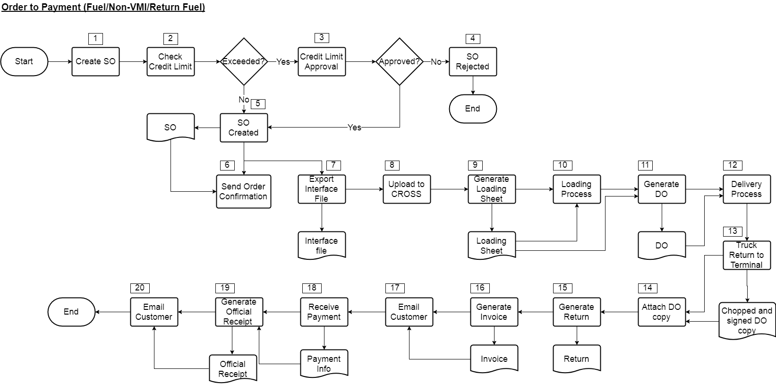

|  |  |  |  |
| --- | --- | --- | --- |
| **No.** | **Title** | **Description** | **Department/System** |
| 1 | Create SO | Create Sales Order in SAP B1 based on customer’s PO. If there’s no PO, user need to manually assign PO number for the order. | CSC |
| 2 | Check Credit Limit | Once the SO created, system will go through credit limit check automatically. | SAP B1 |
| 3 | Credit Limit Approval | If the credit limit exceeded, SO will forward to authorized approver based on approval setup for credit limit extension. | SAP B1 |
| 4 | SO Rejected | Reject credit limit approval for that SO after review customer’s profile in system. | BMF |
| 5 | SO Created | SO successfully add into SAP B1. | CSC |
| 6 | Send Order Confirmation | Sent email via email portal to customer with attach of order confirmation form. | BMR |
| 7 | Export Interface File | Extract sales order created via BI360 and save as (.csv) format. | BMD |
| 8 | Upload to CROSS | Upload extracted sales order to CROSS for scheduling. | BMD |
| 9 | Generate Loading Sheet | Generate loading sheet from CROSS after scheduling complete as a pick list for transporter. | BMD |
| 10 | Loading Process | Truck arrived at terminal and start loading process based on loading sheet. | - |
| 11 | Generate DO | Upon truck arrived at terminal gate for leaving, operation convert SO to DO using copy to feature based on the loading sheet and print out, then hand it over to driver. | BMD |
| 12 | Delivery Process | Truck leave the terminal and start delivery process. | - |
| 13 | Truck Return to Terminal | Truck returned to terminal after delivery together with the chopped and signed DO copy, then pass back to logistic staff. | - |
| 14 | Attach DO Copy | Logistic staff will browse back the created DO in SAP B1, then update information such as (ATA or others) and attach together with the chopped and signed DO copy | BMD |
| 15 | Generate Return | Logistic staff will browse back the updated DO and use copy to feature to copy DO to Return and amend return quantity. |  |
| 16 | Generate Invoice | After DO updated and Return created, convert DO to Invoice in SAP B1 using copy to feature, it will only copy over the remaining quantity in DO after return instead of full quantity. | BMD |
| 17 | Email Customer | Upon all the creation of Invoice completed for the day, use email portal to send out the invoice in batch for the customer. | BMD |
| 18 | Receive Payment | Receiving payment from customer together with the payment information. | - |
| 19 | Generate Official Receipt | Create incoming payment in SAP B1 after verify the payment information. | BMF |
| 20 | Email Customer | Send out the created official receipt to customer in batch using email portal. | BMF |

* + 1. **Order to Payment (Fuel/Non-VMI/Diversion)**

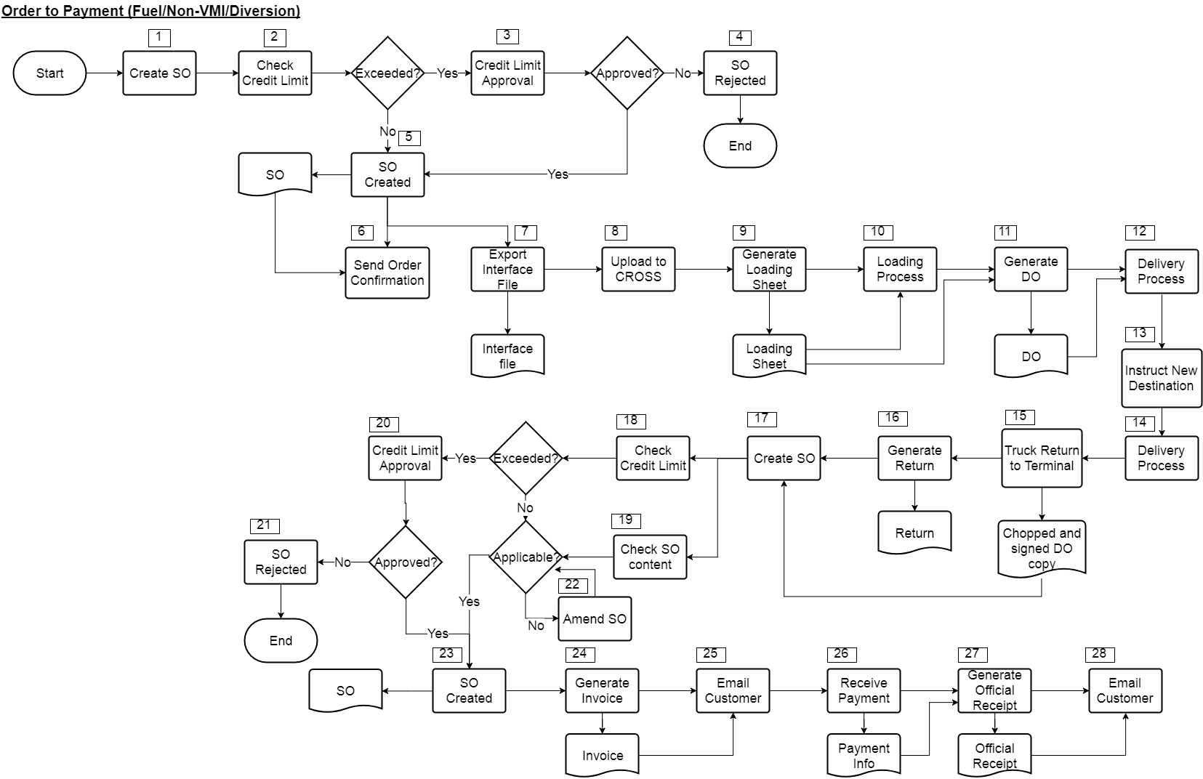

|  |  |  |  |
| --- | --- | --- | --- |
| **No.** | **Title** | **Description** | **Department/System** |
| 1 | Create SO | Create Sales Order in SAP B1 based on customer’s PO. If there’s no PO, user need to manually assign PO number for the order. | CSC |
| 2 | Check Credit Limit | Once the SO created, system will go through credit limit check automatically. | SAP B1 |
| 3 | Credit Limit Approval | If the credit limit exceeded, SO will forward to authorized approver based on approval setup for credit limit extension. | SAP B1 |
| 4 | SO Rejected | Reject credit limit approval for that SO after review customer’s profile in system. | BMF |
| 5 | SO Created | SO successfully add into SAP B1. | CSC |
| 6 | Send Order Confirmation | Sent email via email portal to customer with attach of order confirmation form. | BMR |
| 7 | Export Interface File | Extract sales order created via BI360 and save as (.csv) format. | BMD |
| 8 | Upload to CROSS | Upload extracted sales order to CROSS for scheduling. | BMD |
| 9 | Generate Loading Sheet | Generate loading sheet from CROSS after scheduling complete as a pick list for transporter. | BMD |
| 10 | Loading Process | Truck arrived at terminal and start loading process based on loading sheet. | - |
| 11 | Generate DO | Upon truck arrived at terminal gate for leaving, operation convert SO to DO using copy to feature based on the loading sheet and print out, then hand it over to driver. | BMD |
| 12 | Delivery Process | Truck leave the terminal and start delivery process. | - |
| 13 | Instruct New Destination | Logistic staff need to instruct a new destination for driver to deliver. | BMD |
| 14 | Delivery Process | Deliver to the newly instructed destination. | - |
| 15 | Truck Return to Terminal | Truck returned to terminal after delivery together with the chopped and signed DO copy, then pass back to logistic staff. | - |
| 16 | Generate Return | Logistic staff will browse back the diverted DO and use copy to feature to copy DO to Return. | BMD |
| 17 | Create SO | Logistic staff need to create SO for the diverted customer and attach the chopped and signed DO copy. | BMD |
| 18 | Check Credit Limit | Once the SO created, system will go through credit limit check automatically. | SAP B1 |
| 19 | Check SO Content | Forward the SO created by Logistic to CSC for content checking. | SAP B1 |
| 20 | Credit Limit Approval | If the credit limit exceeded, SO will forward to authorized approver based on approval setup for credit limit extension. | SAP B1 |
| 21 | SO Rejected | Reject credit limit approval for that SO after review customer’s profile in system. | BMF |
| 22 | Amend SO | CSC will amend the SO if there’s any missing or wrong information | CSC |
| 23 | SO Created | SO successfully add into SAP B1. | CSC |
| 24 | Generate Invoice | CSC will convert SO into invoice using copy to feature. | CSC |
| 25 | Email Customer | Upon all the creation of Invoice completed for the day, use email portal to send out the invoice in batch for the customer. | BMD |
| 26 | Receive Payment | Receiving payment from customer together with the payment information. | - |
| 27 | Generate Official Receipt | Create incoming payment in SAP B1 after verify the payment information. | BMF |
| 28 | Email Customer | Send out the created official receipt to customer in batch using email portal. | BMF |

* + 1. **Order to Payment (Fuel/VMI/Normal)**

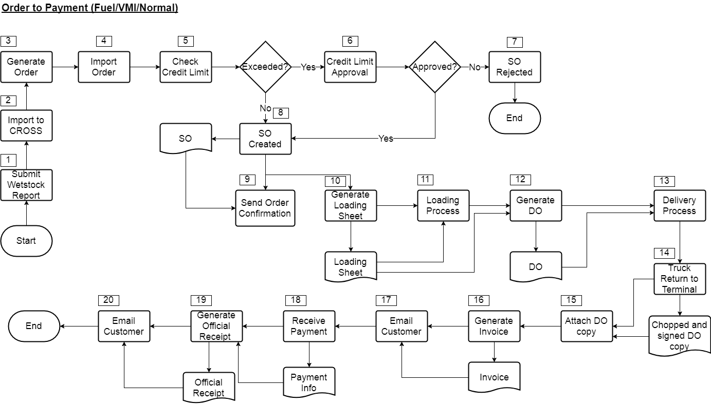

|  |  |  |  |
| --- | --- | --- | --- |
| **No.** | **Title** | **Description** | **Department/System** |
| 1 | Submit Wetstock Report | VMI customer will submit wetstock report daily. | - |
| 2 | Import to CROSS | Logistic staff will then upload the wetstock report into CROSS | BMD |
| 3 | Generate Order | CROSS will auto generate order. | CROSS |
| 4 | Import Order | Logistic can then extract the order generate by CROSS and import into SAP B1 via the addon tools to create SO in SAP B1. | BMD |
| 5 | Check Credit Limit | Once the SO created, system will go through credit limit check automatically. | SAP B1 |
| 6 | Credit Limit Approval | If the credit limit exceeded, SO will forward to authorized approver based on approval setup for credit limit extension. | SAP B1 |
| 7 | SO Rejected | Reject credit limit approval for that SO after review customer’s profile in system. | BMF |
| 8 | SO Created | SO successfully add into SAP B1. | CSC |
| 9 | Send Order Confirmation | Sent email via email portal to customer with attach of order confirmation form. | BMR |
| 10 | Generate Loading Sheet | Generate loading sheet from CROSS as a pick list for transporter. | BMD |
| 11 | Loading Process | Truck arrived at terminal and start loading process based on loading sheet. | - |
| 12 | Generate DO | Upon truck arrived at terminal gate for leaving, operation convert SO to DO using copy to feature based on the loading sheet and print out, then hand it over to driver. | BMD |
| 13 | Delivery Process | Truck leave the terminal and start delivery process. | - |
| 14 | Truck Return to Terminal | Truck returned to terminal after delivery together with the chopped and signed DO copy, then pass back to logistic staff. | - |
| 15 | Attach DO Copy | Logistic staff will browse back the created DO in SAP B1, then update information such as (ATA or others) and attach together with the chopped and signed DO copy | BMD |
| 16 | Generate Invoice | After DO updated, convert DO to Invoice in SAP B1 using copy to feature. | BMD |
| 17 | Email Customer | Upon all the creation of Invoice completed for the day, use email portal to send out the invoice in batch for the customer. | BMD |
| 18 | Receive Payment | Receiving payment from customer together with the payment information. | - |
| 19 | Generate Official Receipt | Create incoming payment in SAP B1 after verify the payment information. | BMF |
| 19 | Email Customer | Send out the created official receipt to customer in batch using email portal. | BMF |

* + 1. **Order to Payment (Fuel/VMI/Return Fuel)**

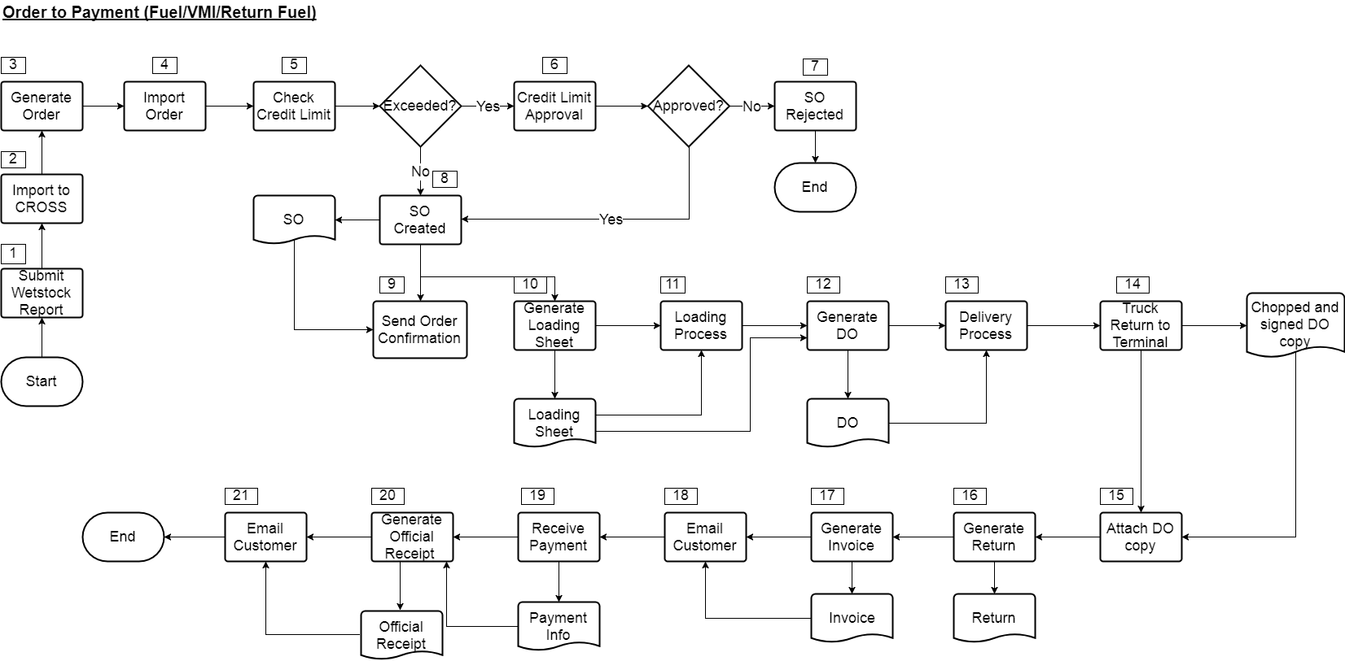

|  |  |  |  |
| --- | --- | --- | --- |
| **No.** | **Title** | **Description** | **Department/System** |
| 1 | Submit Wetstock Report | VMI customer will submit wetstock report daily. | - |
| 2 | Import to CROSS | Logistic staff will then upload the wetstock report into CROSS | BMD |
| 3 | Generate Order | CROSS will auto generate order. | CROSS |
| 4 | Import Order | Logistic can then extract the order generate by CROSS and import into SAP B1 via the addon tools to create SO in SAP B1. | BMD |
| 5 | Check Credit Limit | Once the SO created, system will go through credit limit check automatically. | SAP B1 |
| 6 | Credit Limit Approval | If the credit limit exceeded, SO will forward to authorized approver based on approval setup for credit limit extension. | SAP B1 |
| 7 | SO Rejected | Reject credit limit approval for that SO after review customer’s profile in system. | BMF |
| 8 | SO Created | SO successfully add into SAP B1. | CSC |
| 9 | Send Order Confirmation | Sent email via email portal to customer with attach of order confirmation form. | BMR |
| 10 | Generate Loading Sheet | Generate loading sheet from CROSS after scheduling complete as a pick list for transporter. | BMD |
| 11 | Loading Process | Truck arrived at terminal and start loading process based on loading sheet. | - |
| 12 | Generate DO | Upon truck arrived at terminal gate for leaving, operation convert SO to DO using copy to feature based on the loading sheet and print out, then hand it over to driver. | BMD |
| 13 | Delivery Process | Truck leave the terminal and start delivery process. | - |
| 14 | Truck Return to Terminal | Truck returned to terminal after delivery together with the chopped and signed DO copy, then pass back to logistic staff. | - |
| 15 | Attach DO Copy | Logistic staff will browse back the created DO in SAP B1, then update information such as (ATA or others) and attach together with the chopped and signed DO copy | BMD |
| 16 | Generate Return | Logistic staff will browse back the updated DO and use copy to feature to copy DO to Return and amend return quantity. | BMD |
| 17 | Generate Invoice | After DO updated and Return created, convert DO to Invoice in SAP B1 using copy to feature, it will only copy over the remaining quantity in DO after return instead of full quantity. | BMD |
| 18 | Email Customer | Upon all the creation of Invoice completed for the day, use email portal to send out the invoice in batch for the customer. | BMD |
| 19 | Receive Payment | Receiving payment from customer together with the payment information. | - |
| 20 | Generate Official Receipt | Create incoming payment in SAP B1 after verify the payment information. | BMF |
| 21 | Email Customer | Send out the created official receipt to customer in batch using email portal. | BMF |

* + 1. **Order to Payment (Fuel/VMI/Diversion)**

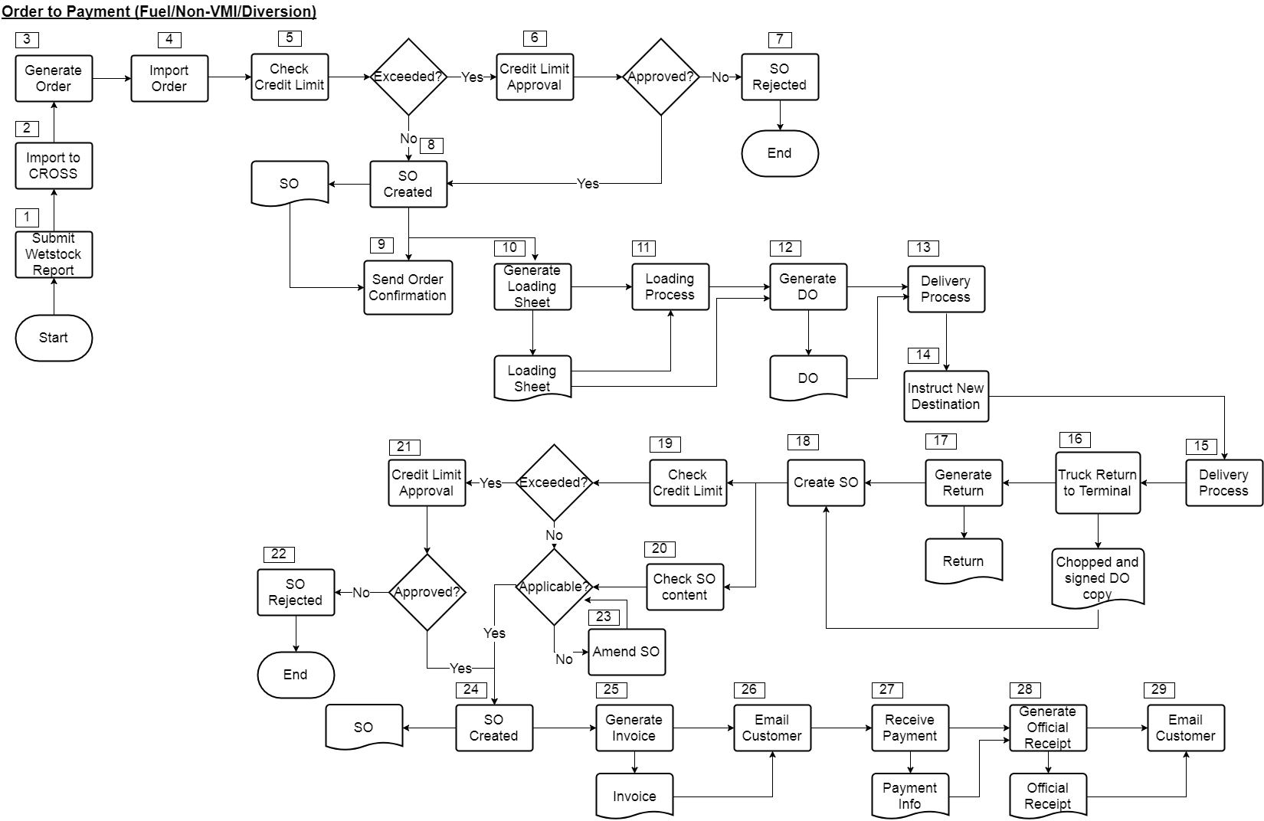

|  |  |  |  |
| --- | --- | --- | --- |
| **No.** | **Title** | **Description** | **Department/System** |
| 1 | Submit Wetstock Report | VMI customer will submit wetstock report daily. | - |
| 2 | Import to CROSS | Logistic staff will then upload the wetstock report into CROSS | BMD |
| 3 | Generate Order | CROSS will auto generate order. | CROSS |
| 4 | Import Order | Logistic can then extract the order generate by CROSS and import into SAP B1 via the addon tools to create SO in SAP B1. | BMD |
| 2 | Check Credit Limit | Once the SO created, system will go through credit limit check automatically. | SAP B1 |
| 3 | Credit Limit Approval | If the credit limit exceeded, SO will forward to authorized approver based on approval setup for credit limit extension. | SAP B1 |
| 4 | SO Rejected | Reject credit limit approval for that SO after review customer’s profile in system. | BMF |
| 5 | SO Created | SO successfully add into SAP B1. | CSC |
| 6 | Send Order Confirmation | Sent email via email portal to customer with attach of order confirmation form. | BMR |
| 9 | Generate Loading Sheet | Generate loading sheet from CROSS after scheduling complete as a pick list for transporter. | BMD |
| 10 | Loading Process | Truck arrived at terminal and start loading process based on loading sheet. | - |
| 11 | Generate DO | Upon truck arrived at terminal gate for leaving, operation convert SO to DO using copy to feature based on the loading sheet and print out, then hand it over to driver. | BMD |
| 12 | Delivery Process | Truck leave the terminal and start delivery process. | - |
| 13 | Instruct New Destination | Logistic staff need to instruct a new destination for driver to deliver. | BMD |
| 14 | Delivery Process | Deliver to the newly instructed destination. | - |
| 15 | Truck Return to Terminal | Truck returned to terminal after delivery together with the chopped and signed DO copy, then pass back to logistic staff. | - |
| 16 | Generate Return | Logistic staff will browse back the diverted DO and use copy to feature to copy DO to Return. | BMD |
| 17 | Create SO | Logistic staff need to create SO for the diverted customer and attach the chopped and signed DO copy. | BMD |
| 18 | Check Credit Limit | Once the SO created, system will go through credit limit check automatically. | SAP B1 |
| 19 | Check SO Content | Forward the SO created by Logistic to CSC for content checking. | SAP B1 |
| 20 | Credit Limit Approval | If the credit limit exceeded, SO will forward to authorized approver based on approval setup for credit limit extension. | SAP B1 |
| 21 | SO Rejected | Reject credit limit approval for that SO after review customer’s profile in system. | BMF |
| 22 | Amend SO | CSC will amend the SO if there’s any missing or wrong information | CSC |
| 23 | SO Created | SO successfully add into SAP B1. | CSC |
| 24 | Generate Invoice | CSC will convert SO into invoice using copy to feature. | CSC |
| 25 | Email Customer | Upon all the creation of Invoice completed for the day, use email portal to send out the invoice in batch for the customer. | BMD |
| 26 | Receive Payment | Receiving payment from customer together with the payment information. | - |
| 27 | Generate Official Receipt | Create incoming payment in SAP B1 after verify the payment information. | BMF |
| 28 | Email Customer | Send out the created official receipt to customer in batch using email portal. | BMF |

* + 1. **Order to Payment (Lubricant/Normal)**

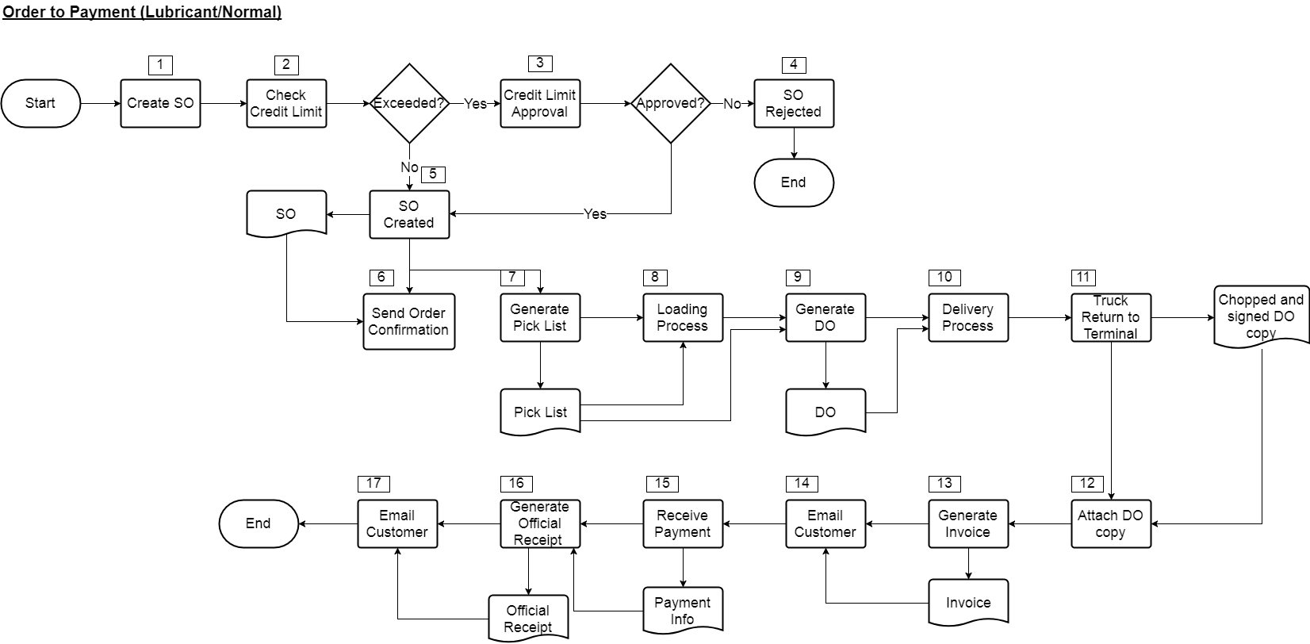

|  |  |  |  |
| --- | --- | --- | --- |
| **No.** | **Title** | **Description** | **Department/System** |
| 1 | Create SO | Create Sales Order in SAP B1 based on customer’s PO. If there’s no PO, user need to manually assign PO number for the order. | CSC |
| 2 | Check Credit Limit | Once the SO created, system will go through credit limit check automatically. | SAP B1 |
| 3 | Credit Limit Approval | If the credit limit exceeded, SO will forward to authorized approver based on approval setup for credit limit extension. | SAP B1 |
| 4 | SO Rejected | Reject credit limit approval for that SO after review customer’s profile in system. | BMF |
| 5 | SO Created | SO successfully add into SAP B1. | CSC |
| 6 | Send Order Confirmation | Sent email via email portal to customer with attach of order confirmation form. | BMR |
| 9 | Generate Pick List | Generate pick list in SAP B1 using Pick & Pack Manager and print it out to transporter as the loading sheet. | BMD |
| 10 | Loading Process | Truck arrived at terminal and start loading process based on loading sheet. | - |
| 11 | Generate DO | Upon truck arrived at terminal gate for leaving, operation convert SO to DO using copy to feature based on the pick list and print out, then hand it over to driver. | BMD |
| 12 | Delivery Process | Truck leave the terminal and start delivery process. | - |
| 13 | Truck Return to Terminal | Truck returned to terminal after delivery together with the chopped and signed DO copy, then pass back to logistic staff. | - |
| 14 | Attach DO Copy | Logistic staff will browse back the created DO in SAP B1, then update information such as (ATA or others) and attach together with the chopped and signed DO copy | BMD |
| 15 | Generate Invoice | After DO updated, convert DO to Invoice in SAP B1 using copy to feature. | BMD |
| 16 | Email Customer | Upon all the creation of Invoice completed for the day, use email portal to send out the invoice in batch for the customer. | BMD |
| 17 | Receive Payment | Receiving payment from customer together with the payment information. | - |
| 18 | Generate Official Receipt | Create incoming payment in SAP B1 after verify the payment information. | BMF |
| 19 | Email Customer | Send out the created official receipt to customer in batch using email portal. | BMF |

* + 1. **Order to Payment (Lubricant/Return)**

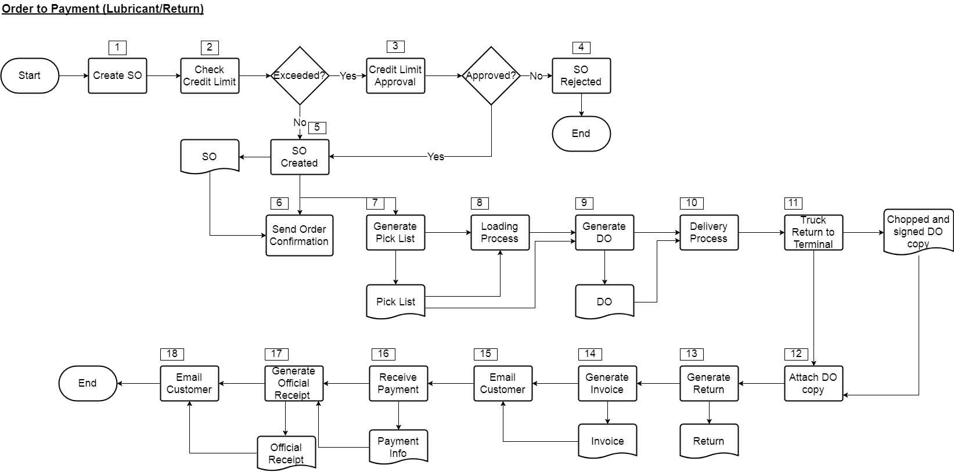

|  |  |  |  |
| --- | --- | --- | --- |
| **No.** | **Title** | **Description** | **Department/System** |
| 1 | Create SO | Create Sales Order in SAP B1 based on customer’s PO. If there’s no PO, user need to manually assign PO number for the order. | CSC |
| 2 | Check Credit Limit | Once the SO created, system will go through credit limit check automatically. | SAP B1 |
| 3 | Credit Limit Approval | If the credit limit exceeded, SO will forward to authorized approver based on approval setup for credit limit extension. | SAP B1 |
| 4 | SO Rejected | Reject credit limit approval for that SO after review customer’s profile in system. | BMF |
| 5 | SO Created | SO successfully add into SAP B1. | CSC |
| 6 | Send Order Confirmation | Sent email via email portal to customer with attach of order confirmation form. | BMR |
| 7 | Generate Pick List | Generate pick list in SAP B1 using Pick & Pack Manager and print it out to transporter as the loading sheet. | BMD |
| 8 | Loading Process | Truck arrived at terminal and start loading process based on loading sheet. | - |
| 9 | Generate DO | Upon truck arrived at terminal gate for leaving, operation convert SO to DO using copy to feature based on the pick list and print out, then hand it over to driver. | BMD |
| 10 | Delivery Process | Truck leave the terminal and start delivery process. | - |
| 11 | Truck Return to Terminal | Truck returned to terminal after delivery together with the chopped and signed DO copy, then pass back to logistic staff. | - |
| 12 | Attach DO Copy | Logistic staff will browse back the created DO in SAP B1, then update information such as (ATA or others) and attach together with the chopped and signed DO copy | BMD |
| 13 | Generate Return | Logistic staff will browse back the updated DO and use copy to feature to copy DO to Return and amend return quantity. | BMD |
| 14 | Generate Invoice | After DO updated, convert DO to Invoice in SAP B1 using copy to feature. | BMD |
| 15 | Email Customer | Upon all the creation of Invoice completed for the day, use email portal to send out the invoice in batch for the customer. | BMD |
| 16 | Receive Payment | Receiving payment from customer together with the payment information. | - |
| 17 | Generate Official Receipt | Create incoming payment in SAP B1 after verify the payment information. | BMF |
| 18 | Email Customer | Send out the created official receipt to customer in batch using email portal. | BMF |

* + 1. **Order to Payment (LPG/Normal)**

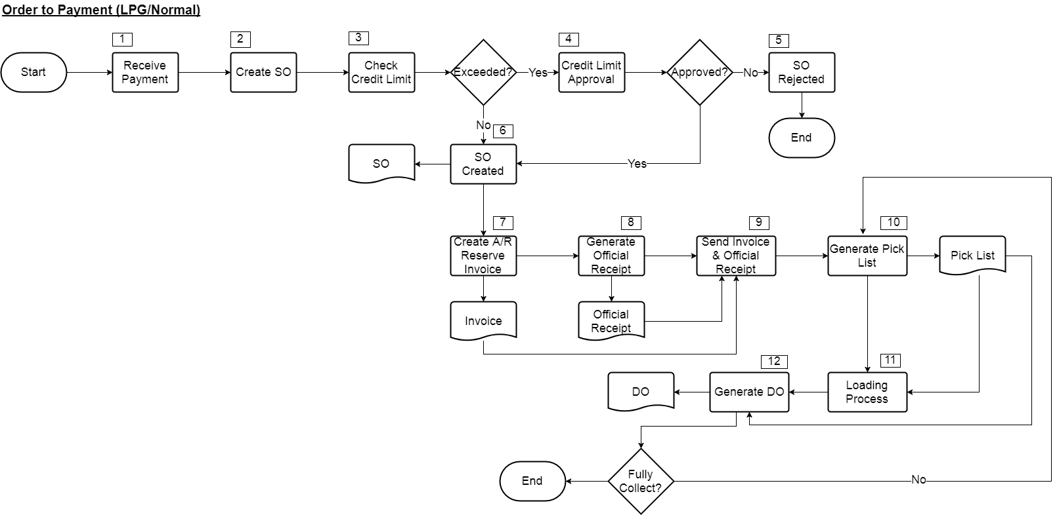

|  |  |  |  |
| --- | --- | --- | --- |
| **No.** | **Title** | **Description** | **Department/System** |
| 1 | Receive Payment | Receive payment information from customer | - |
| 2 | Create SO | Create Sales Order in SAP B1 based on customer’s PO. If there’s no PO, user need to manually assign PO number for the order. | CSC |
| 3 | Check Credit Limit | Once the SO created, system will go through credit limit check automatically. | SAP B1 |
| 4 | Credit Limit Approval | If the credit limit exceeded, SO will forward to authorized approver based on approval setup for credit limit extension. | SAP B1 |
| 5 | SO Rejected | Reject credit limit approval for that SO after review customer’s profile in system. | BMF |
| 6 | SO Created | SO successfully add into SAP B1. | CSC |
| 7 | Create A/R Reserve Invoice | Convert SO to A/R Reserve Invoice using copy to feature in SAP B1 to commit the sales without affecting the stock yet. | CSC |
| 8 | Generate Official Receipt | Create incoming payment applied to the reserve invoice based on the customer payment information after verified. | CSC |
| 9 | Send Invoice & Official Receipt | Send via email or by print out the physical copy of invoice and official receipt to customer | CSC |
| 10 | Generate Pick List | Generate pick list in SAP B1 using Pick & Pack Manager and print it out for customer to collect. | BMD |
| 11 | Loading Process | Customer start to load LPG based on the pick list in the terminal. | - |
| 12 | Generate DO | Convert pick list to DO based on the LPG collected, then print out DO to customer before they leave the terminal. If it’s not fully collected, customer can come to the terminal another round and steps 10 to 12 will be repeat over again until it’s fully collected. | BMD |

* + 1. **Order to Payment (LPG/Return)**

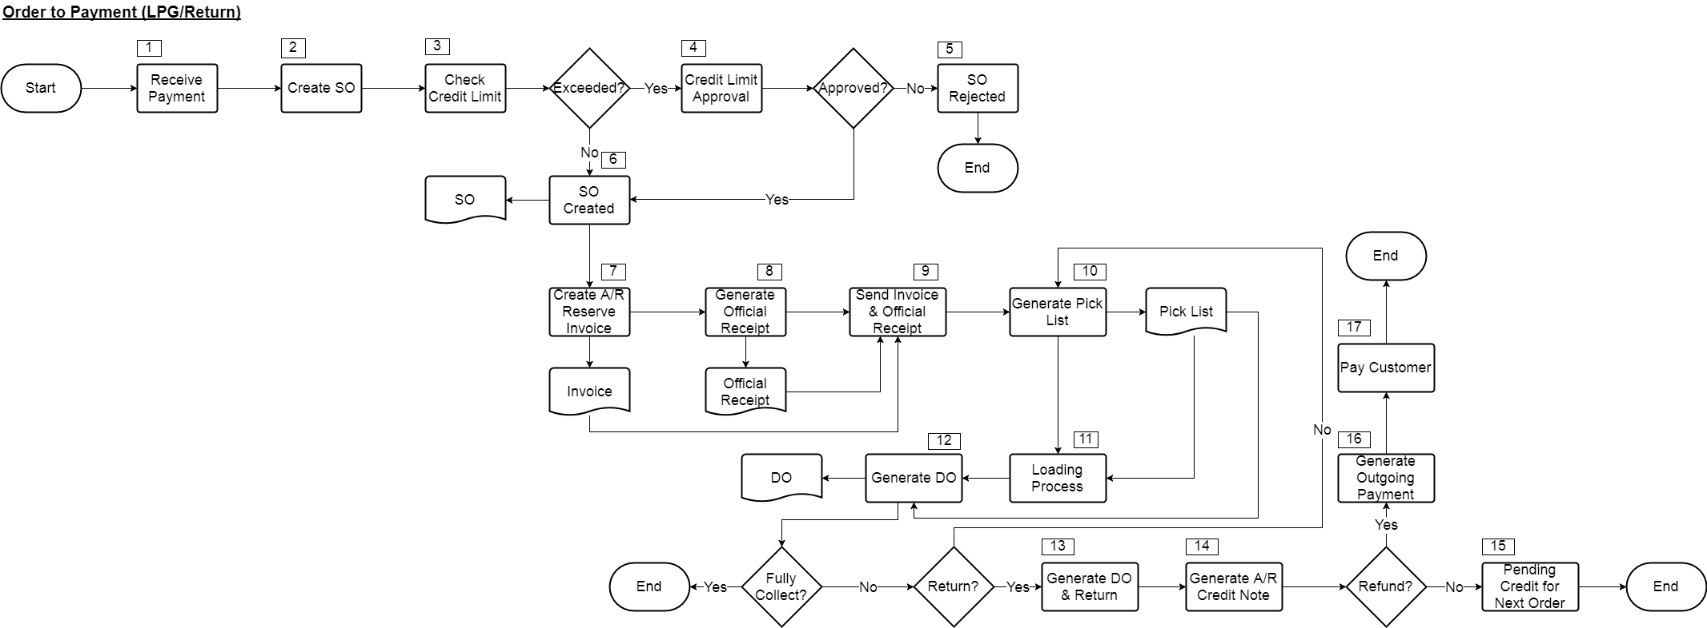

|  |  |  |  |
| --- | --- | --- | --- |
| **No.** | **Title** | **Description** | **Department/System** |
| 1 | Receive Payment | Receive payment information from customer | - |
| 2 | Create SO | Create Sales Order in SAP B1 based on customer’s PO. If there’s no PO, user need to manually assign PO number for the order. | CSC |
| 3 | Check Credit Limit | Once the SO created, system will go through credit limit check automatically. | SAP B1 |
| 4 | Credit Limit Approval | If the credit limit exceeded, SO will forward to authorized approver based on approval setup for credit limit extension. | SAP B1 |
| 5 | SO Rejected | Reject credit limit approval for that SO after review customer’s profile in system. | BMF |
| 6 | SO Created | SO successfully add into SAP B1. | CSC |
| 7 | Create A/R Reserve Invoice | Convert SO to A/R Reserve Invoice using copy to feature in SAP B1 to commit the sales without affecting the stock yet. | CSC |
| 8 | Generate Official Receipt | Create incoming payment applied to the reserve invoice based on the customer payment information after verified. | CSC |
| 9 | Send Invoice & Official Receipt | Send via email or by print out the physical copy of invoice and official receipt to customer | CSC |
| 10 | Generate Pick List | Generate pick list in SAP B1 using Pick & Pack Manager and print it out for customer to collect. | BMD |
| 11 | Loading Process | Customer start to load LPG based on the pick list in the terminal. | - |
| 12 | Generate DO | Convert pick list to DO based on the LPG collected, then print out DO to customer before they leave the terminal. If it’s not fully collected, customer can come to the terminal another round and steps 10 to 12 will be repeat over again until it’s fully collected. | BMD |
| 13 | Generate DO & Return | If customer wanted to return the ordered LPG, user need to create DO document first and then create Return document instantly in SAP B1. DO document is create to close the paid A/R Reserve Invoice and Return document is create to reverse the LPG depleted in DO. | BMD |
| 14 | Generate A/R Credit Note | Convert Return document into A/R Credit Memo by using the copy to feature in SAP B1. This action will actually credit that specific customer account. | BMD |
| 15 | Pending Credit for Next Order | If customer doesn’t request for refund, the credit will be pending in SAP B1, it can be utilized for the next order. | - |
| 16 | Generate Outgoing Payment | If customer request for refund, user need to create outgoing payment in SAP B1 by selecting customer option and select the A/R Credit Note created in step 14 for the payment. | BMF |
| 17 | Pay Customer | Make payment according to the outgoing payment created to the customer. | BMF |

* 1. **Report**

There will be a list of sales reports (yet to be finalized) in SAP B1 or BI360 as below:

1. Outstanding Sales Order
2. Sales by Marketing Executive Report
3. Monthly Sales Report by Volume
4. Monthly Sales Report by Amount
5. List of Sales Order per Customer
6. List of Collection per Customer
7. Sales Promotion Reports
8. Sales Forecast Reports
9. Outstanding Invoice per Product Report
10. Credit Monitoring Report
11. Product Costing
12. Trade Offer Cost Analysis
13. Daily Order Release Report
14. **Purchase**
    1. **Purchase Flow**
       1. **Purchase Request to Payment (<BND5000/Non-Contract/Local/Stock)**

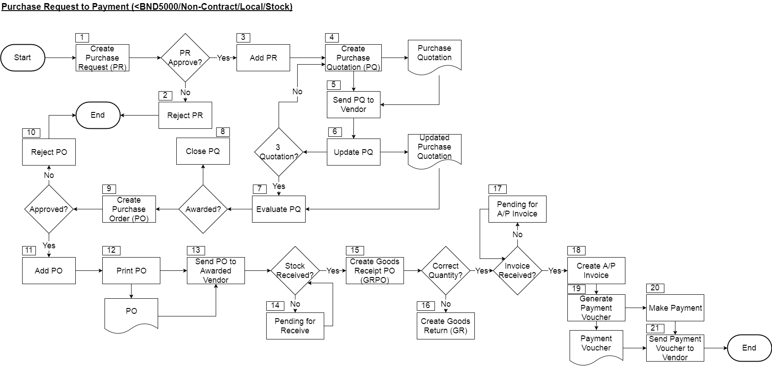

|  |  |  |  |
| --- | --- | --- | --- |
| **No.** | **Title** | **Description** | **Department/System** |
| 1 | Create Purchase Request (PR) | Requester create Purchase Request (PR) in SAP B1 and it will automatically forward for approval upon created. | Requester |
| 2 | Reject PR | If PR is rejected, the approver will change the PR status to reject, the originator (requester) will be notify in SAP B1. | Approver |
| 3 | Add PR | If PR is approved, originator (requester) will received notification in SAP B1 as well, then he or she can now add the PR into system. | Requester |
| 4 | Create Purchase Quotation (PQ) | Copy PR to Purchase Quotation (PQ) using copy to feature in SAP B1 and select the desire vendor in PQ. | Purchaser |
| 5 | Send PQ to Vendor | Without enter any quoted quantity or price in previous step, print out the PQ for the created PQ. Then, send PQ to the vendor. | Purchaser |
| 6 | Update PQ | After vendor reply with the quoted quantity and price, update back to the PQ created earlier in SAP B1. If it’s less than 3 quotations, user need to repeat step 4 to 6 until it fulfilled 3 quotations. | Purchaser |
| 7 | Evaluate PQ | Evaluate the 3 quotations received from different vendor. | Purchaser |
| 8 | Close PQ | If the PQ not awarded, close the PQ in SAP B1. | Purchaser |
| 9 | Create Purchase Order (PO) | When the PQ awarded, create Purchase Order (PO) by using copy to feature to copy PQ content to PO without rekeying again in SAP B1. | Purchaser |
| 10 | Reject PO | Approver will update the PO status to rejected if it’s over budget or any other reason. The originator (purchaser) will received notification in SAP B1. | Approver |
| 11 | Add PO | If it’s approved, user can receive the notification in SAP B1, then he or she can proceed to add the PO into the system. | Purchaser |
| 12 | Print PO | Print PO for the approved PO in previous steps. | Purchaser |
| 13 | Send PO to Awarded Vendor | Send the printed PO to vendor to inform them for the order confirmation. | Purchaser |
| 14 | Pending for Receive | If the stock is yet to received, it will be pending in SAP B1 as open PO until it was fully received. | - |
| 15 | Create Goods Receipt PO (GRPO) | When the stock arrived, after physically received and checked, create Goods Receipt PO (GRPO) according to the PO and amend quantity where necessary by using copy to feature in SAP B1. | BMD |
| 16 | Create Goods Return (GR) | If the stock received is damaged or wrong quantity, create Goods Return (GR) according to the GRPO created in previous step and amend quantity where necessary by using copy to feature in SAP B1. | BMD |
| 17 | Pending for Invoice | Upon the stock fully received, GRPO will pending in open status if it hasn’t convert into A/P Invoice. | - |
| 18 | Create A/P Invoice | When received invoice from vendor, create A/P Invoice according to the GRPO by using copy to feature in SAP B1. | BMF |
| 19 | Generate Payment Voucher | Create Outgoing Payment in SAP B1 by selecting the A/P Invoice created in previous step. Then, print the payment voucher from the outgoing payment created. | BMF |
| 20 | Make Payment | Make payment to the vendor. | BMF |
| 21 | Send Payment Voucher to Vendor | Send payment voucher generated in step 19 to vendor via email. | BMF |

* + 1. **Purchase Request to Payment (<BND5000/Non-Contract/Local/Services)**

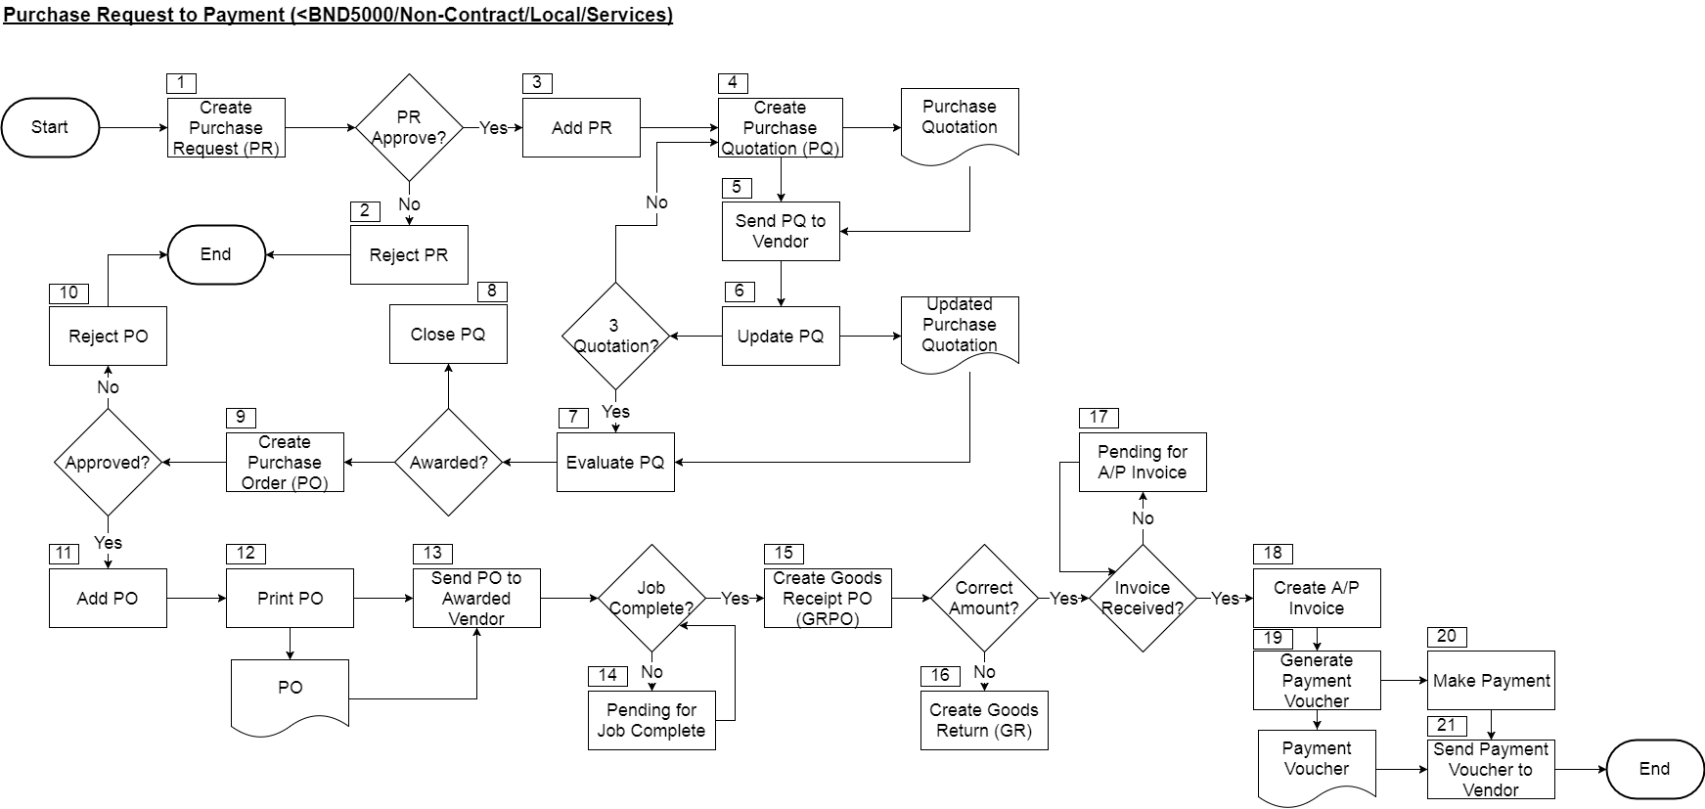

|  |  |  |  |
| --- | --- | --- | --- |
| **No.** | **Title** | **Description** | **Department/System** |
| 1 | Create Purchase Request (PR) | Requester create Purchase Request (PR) in SAP B1 and it will automatically forward for approval upon created. | Requester |
| 2 | Reject PR | If PR is rejected, the approver will change the PR status to reject, the originator (requester) will be notify in SAP B1. | Approver |
| 3 | Add PR | If PR is approved, originator (requester) will received notification in SAP B1 as well, then he or she can now add the PR into system. | Requester |
| 4 | Create Purchase Quotation (PQ) | Copy PR to Purchase Quotation (PQ) using copy to feature in SAP B1 and select the desire vendor in PQ. | Purchaser |
| 5 | Send PQ to Vendor | Without enter any quoted price in previous step, print out the PQ for the created PQ. Then, send PQ to the vendor. | Purchaser |
| 6 | Update PQ | After vendor reply with the quoted price, update back to the PQ created earlier in SAP B1. If it’s less than 3 quotations, user need to repeat step 4 to 6 until it fulfilled 3 quotations. | Purchaser |
| 7 | Evaluate PQ | Evaluate the 3 quotations received from different vendor. | Purchaser |
| 8 | Close PQ | If the PQ not awarded, close the PQ in SAP B1. | Purchaser |
| 9 | Create Purchase Order (PO) | When the PQ awarded, create Purchase Order (PO) by using copy to feature to copy PQ content to PO without rekeying again in SAP B1. | Purchaser |
| 10 | Reject PO | Approver will update the PO status to rejected if it’s over budget or any other reason. The originator (purchaser) will received notification in SAP B1. | Approver |
| 11 | Add PO | If it’s approved, user can receive the notification in SAP B1, then he or she can proceed to add the PO into the system. | Purchaser |
| 12 | Print PO | Print PO for the approved PO in previous steps. | Purchaser |
| 13 | Send PO to Awarded Vendor | Send the printed PO to vendor to inform them for the order confirmation. | Purchaser |
| 14 | Pending for Receive | If the job is yet to complete, it will be pending in SAP B1 as open PO until it was completed. | - |
| 15 | Create Goods Receipt PO (GRPO) | When the job completed, after verified, create Goods Receipt PO (GRPO) according to the PO and amend quantity where necessary by using copy to feature in SAP B1 as a proof of job completion. | BMD |
| 16 | Create Goods Return (GR) | If the job copied to GRPO as a job completion wrongly, create Goods Return (GR) according to the GRPO created in previous step and amend value/quantity where necessary by using copy to feature in SAP B1. | BMD |
| 17 | Pending for Invoice | Upon the job completed, GRPO will pending in open status if it hasn’t convert into A/P Invoice. | - |
| 18 | Create A/P Invoice | When received invoice from vendor, create A/P Invoice according to the GRPO by using copy to feature in SAP B1. | BMF |
| 19 | Generate Payment Voucher | Create Outgoing Payment in SAP B1 by selecting the A/P Invoice created in previous step. Then, print the payment voucher from the outgoing payment created. | BMF |
| 20 | Make Payment | Make payment to the vendor. | BMF |
| 21 | Send Payment Voucher to Vendor | Send payment voucher generated in step 19 to vendor via email. | BMF |

* + 1. **Purchase Request to Payment (>BND5000/Non-Contract/Local/Stock)**

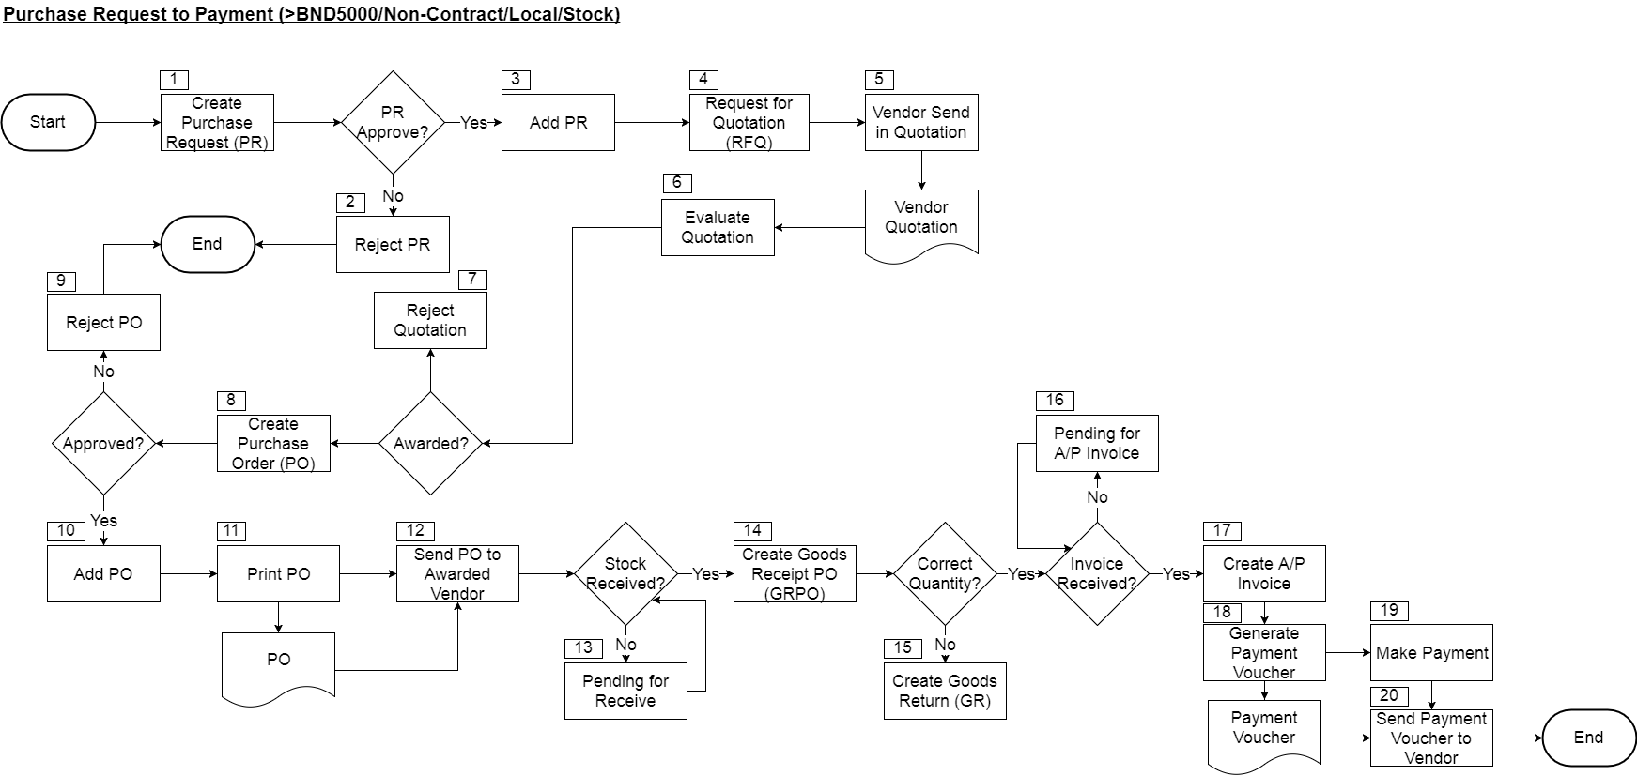

|  |  |  |  |
| --- | --- | --- | --- |
| **No.** | **Title** | **Description** | **Department/System** |
| 1 | Create Purchase Request (PR) | Requester create Purchase Request (PR) in SAP B1 and it will automatically forward for approval upon created. | Requester |
| 2 | Reject PR | If PR is rejected, the approver will change the PR status to reject, the originator (requester) will be notify in SAP B1. | Approver |
| 3 | Add PR | If PR is approved, originator (requester) will received notification in SAP B1 as well, then he or she can now add the PR into system. | Requester |
| 4 | Request for Quotation (RFQ) | Request quotation from the vendor in the desired list, this will be done outside SAP B1. | Purchaser |
| 5 | Vendor Send in Quotation | Vendor received the request and quoted according back to BSM. | - |
| 6 | Evaluate Quotation | Evaluate quotations received from all the vendors. | Purchaser |
| 7 | Reject Quotation | Reject the quotation if it’s not awarded. | Purchaser |
| 8 | Create Purchase Order (PO) | When the quotation awarded, create Purchase Order (PO) in SAP B1 according to the quotation. | Purchaser |
| 9 | Reject PO | Approver will update the PO status to rejected if it’s over budget or any other reason. The originator (purchaser) will received notification in SAP B1. | Approver |
| 10 | Add PO | If it’s approved, user can receive the notification in SAP B1, then he or she can proceed to add the PO into the system. | Purchaser |
| 11 | Print PO | Print PO for the approved PO in previous steps. | Purchaser |
| 12 | Send PO to Awarded Vendor | Send the printed PO to vendor to inform them for the order confirmation. | Purchaser |
| 13 | Pending for Receive | If the stock is yet to received, it will be pending in SAP B1 as open PO until it was fully received. | - |
| 14 | Create Goods Receipt PO (GRPO) | When the stock arrived, after physically received and checked, create Goods Receipt PO (GRPO) according to the PO and amend quantity where necessary by using copy to feature in SAP B1. | BMD |
| 15 | Create Goods Return (GR) | If the stock received is damaged or wrong quantity, create Goods Return (GR) according to the GRPO created in previous step and amend quantity where necessary by using copy to feature in SAP B1. | BMD |
| 16 | Pending for Invoice | Upon the stock fully received, GRPO will pending in open status if it hasn’t convert into A/P Invoice. | - |
| 17 | Create A/P Invoice | When received invoice from vendor, create A/P Invoice according to the GRPO by using copy to feature in SAP B1. | BMF |
| 18 | Generate Payment Voucher | Create Outgoing Payment in SAP B1 by selecting the A/P Invoice created in previous step. Then, print the payment voucher from the outgoing payment created. | BMF |
| 19 | Make Payment | Make payment to the vendor. | BMF |
| 20 | Send Payment Voucher to Vendor | Send payment voucher generated in step 18 to vendor via email. | BMF |

* + 1. **Purchase Request to Payment (>BND5000/Non-Contract/Local/Services)**

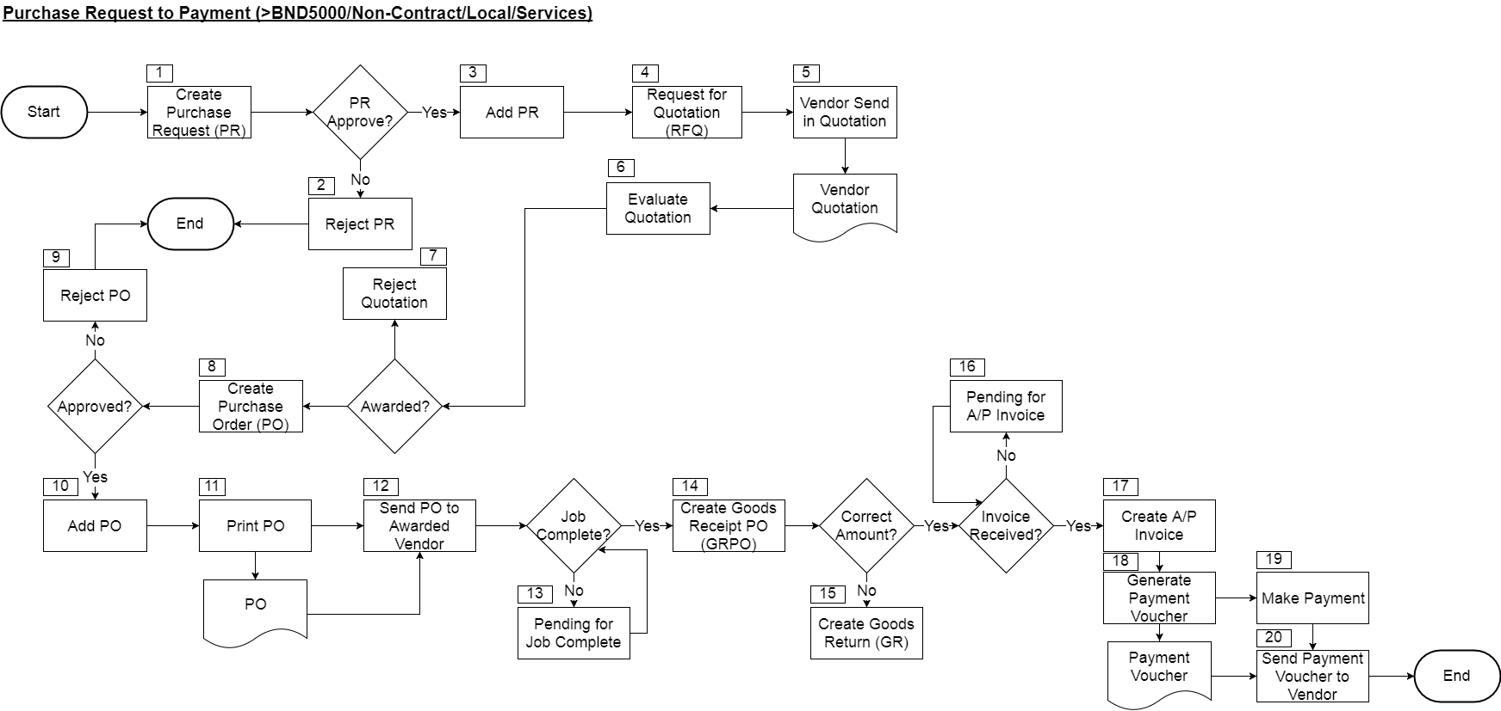

|  |  |  |  |
| --- | --- | --- | --- |
| **No.** | **Title** | **Description** | **Department/System** |
| 1 | Create Purchase Request (PR) | Requester create Purchase Request (PR) in SAP B1 and it will automatically forward for approval upon created. | Requester |
| 2 | Reject PR | If PR is rejected, the approver will change the PR status to reject, the originator (requester) will be notify in SAP B1. | Approver |
| 3 | Add PR | If PR is approved, originator (requester) will received notification in SAP B1 as well, then he or she can now add the PR into system. | Requester |
| 4 | Request for Quotation (RFQ) | Request quotation from the vendor in the desired list, this will be done outside SAP B1. | Purchaser |
| 5 | Vendor Send in Quotation | Vendor received the request and quoted according back to BSM. | - |
| 6 | Evaluate Quotation | Evaluate quotations received from all the vendors. | Purchaser |
| 7 | Reject Quotation | Reject the quotation if it’s not awarded. | Purchaser |
| 8 | Create Purchase Order (PO) | When the quotation awarded, create Purchase Order (PO) in SAP B1 according to the quotation. | Purchaser |
| 9 | Reject PO | Approver will update the PO status to rejected if it’s over budget or any other reason. The originator (purchaser) will received notification in SAP B1. | Approver |
| 10 | Add PO | If it’s approved, user can receive the notification in SAP B1, then he or she can proceed to add the PO into the system. | Purchaser |
| 11 | Print PO | Print PO for the approved PO in previous steps. | Purchaser |
| 12 | Send PO to Awarded Vendor | Send the printed PO to vendor to inform them for the order confirmation. | Purchaser |
| 13 | Pending for Receive | If the job is yet to complete, it will be pending in SAP B1 as open PO until it was completed. | - |
| 14 | Create Goods Receipt PO (GRPO) | When the job completed, after verified, create Goods Receipt PO (GRPO) according to the PO and amend quantity where necessary by using copy to feature in SAP B1 as a proof of job completion. | BMD |
| 15 | Create Goods Return (GR) | If the job copied to GRPO as a job completion wrongly, create Goods Return (GR) according to the GRPO created in previous step and amend value/quantity where necessary by using copy to feature in SAP B1. | BMD |
| 16 | Pending for Invoice | Upon the job completed, GRPO will pending in open status if it hasn’t convert into A/P Invoice. | - |
| 17 | Create A/P Invoice | When received invoice from vendor, create A/P Invoice according to the GRPO by using copy to feature in SAP B1. | BMF |
| 18 | Generate Payment Voucher | Create Outgoing Payment in SAP B1 by selecting the A/P Invoice created in previous step. Then, print the payment voucher from the outgoing payment created. | BMF |
| 19 | Make Payment | Make payment to the vendor. | BMF |
| 20 | Send Payment Voucher to Vendor | Send payment voucher generated in step 18 to vendor via email. | BMF |

* + 1. **Purchase Request to Payment (Contract/Local/Stock)**

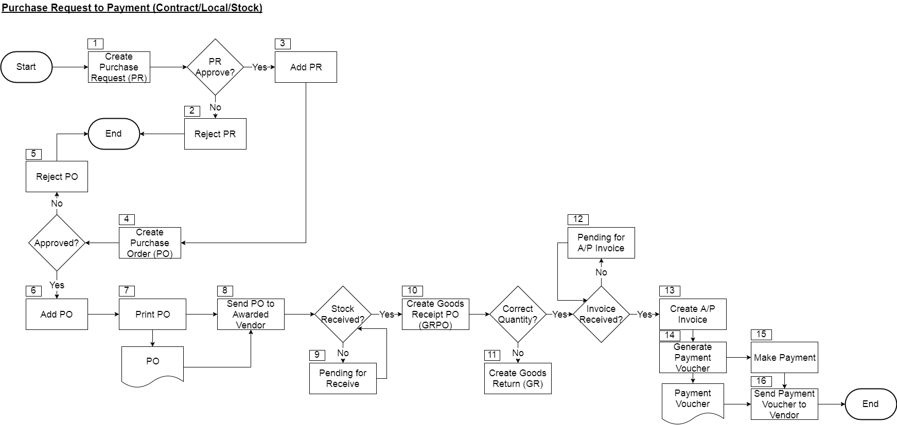

|  |  |  |  |
| --- | --- | --- | --- |
| **No.** | **Title** | **Description** | **Department/System** |
| 1 | Create Purchase Request (PR) | Requester create Purchase Request (PR) with the contract pricing in SAP B1 and it will automatically forward for approval upon created. | Requester |
| 2 | Reject PR | If PR is rejected, the approver will change the PR status to reject, the originator (requester) will be notify in SAP B1. | Approver |
| 3 | Add PR | If PR is approved, originator (requester) will received notification in SAP B1 as well, then he or she can now add the PR into system. | Requester |
| 4 | Create Purchase Order (PO) | Copy the purchase request to purchase order using the copy to feature and select the vendor. It will automatically link to the contract and forward to contract holder for approval. | Purchaser |
| 5 | Reject PO | Approver will update the PO status to rejected if it’s over contract ACV or any other reason. The originator (purchaser) will received notification in SAP B1. | Approver |
| 6 | Add PO | If it’s approved, user can receive the notification in SAP B1, then he or she can proceed to add the PO into the system. | Purchaser |
| 7 | Print PO | Print PO for the approved PO in previous steps. | Purchaser |
| 8 | Send PO to Awarded Vendor | Send the printed PO to vendor to inform them for the order confirmation. | Purchaser |
| 9 | Pending for Receive | If the stock is yet to received, it will be pending in SAP B1 as open PO until it was fully received. | - |
| 10 | Create Goods Receipt PO (GRPO) | When the stock arrived, after physically received and checked, create Goods Receipt PO (GRPO) according to the PO and amend quantity where necessary by using copy to feature in SAP B1. | BMD |
| 11 | Create Goods Return (GR) | If the stock received is damaged or wrong quantity, create Goods Return (GR) according to the GRPO created in previous step and amend quantity where necessary by using copy to feature in SAP B1. | BMD |
| 12 | Pending for Invoice | Upon the stock fully received, GRPO will pending in open status if it hasn’t convert into A/P Invoice. | - |
| 13 | Create A/P Invoice | When received invoice from vendor, create A/P Invoice according to the GRPO by using copy to feature in SAP B1. | BMF |
| 14 | Generate Payment Voucher | Create Outgoing Payment in SAP B1 by selecting the A/P Invoice created in previous step. Then, print the payment voucher from the outgoing payment created. | BMF |
| 15 | Make Payment | Make payment to the vendor. | BMF |
| 16 | Send Payment Voucher to Vendor | Send payment voucher generated in step 14 to vendor via email. | BMF |

* + 1. **Purchase Request to Payment (Contract/Local/Services)**

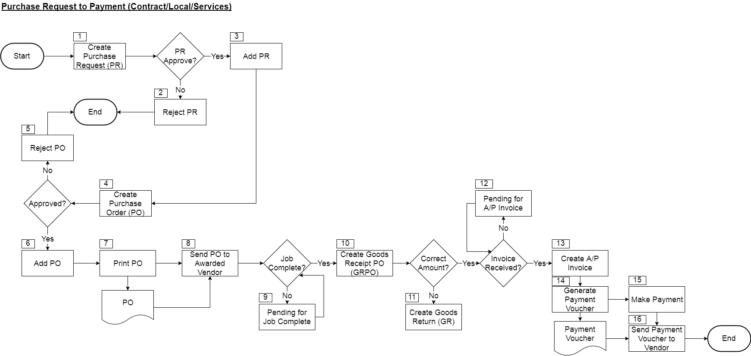

|  |  |  |  |
| --- | --- | --- | --- |
| **No.** | **Title** | **Description** | **Department/System** |
| 1 | Create Purchase Request (PR) | Requester create Purchase Request (PR) with the contract pricing in SAP B1 and it will automatically forward for approval upon created. | Requester |
| 2 | Reject PR | If PR is rejected, the approver will change the PR status to reject, the originator (requester) will be notify in SAP B1. | Approver |
| 3 | Add PR | If PR is approved, originator (requester) will received notification in SAP B1 as well, then he or she can now add the PR into system. | Requester |
| 4 | Create Purchase Order (PO) | Copy the purchase request to purchase order using the copy to feature and select the vendor. It will automatically link to the contract and forward to contract holder for approval. | Purchaser |
| 5 | Reject PO | Approver will update the PO status to rejected if it’s over contract ACV or any other reason. The originator (purchaser) will received notification in SAP B1. | Approver |
| 6 | Add PO | If it’s approved, user can receive the notification in SAP B1, then he or she can proceed to add the PO into the system. | Purchaser |
| 7 | Print PO | Print PO for the approved PO in previous steps. | Purchaser |
| 8 | Send PO to Awarded Vendor | Send the printed PO to vendor to inform them for the order confirmation. | Purchaser |
| 9 | Pending for Receive | If the job is yet to complete, it will be pending in SAP B1 as open PO until it was completed. | - |
| 10 | Create Goods Receipt PO (GRPO) | When the job completed, after verified, create Goods Receipt PO (GRPO) according to the PO and amend quantity where necessary by using copy to feature in SAP B1 as a proof of job completion. | BMD |
| 11 | Create Goods Return (GR) | If the job copied to GRPO as a job completion wrongly, create Goods Return (GR) according to the GRPO created in previous step and amend value/quantity where necessary by using copy to feature in SAP B1. | BMD |
| 12 | Pending for Invoice | Upon the job completed, GRPO will pending in open status if it hasn’t convert into A/P Invoice. | - |
| 13 | Create A/P Invoice | When received invoice from vendor, create A/P Invoice according to the GRPO by using copy to feature in SAP B1. | BMF |
| 14 | Generate Payment Voucher | Create Outgoing Payment in SAP B1 by selecting the A/P Invoice created in previous step. Then, print the payment voucher from the outgoing payment created. | BMF |
| 15 | Make Payment | Make payment to the vendor. | BMF |
| 16 | Send Payment Voucher to Vendor | Send payment voucher generated in step 14 to vendor via email. | BMF |

* + 1. **Purchase Request to Payment (Oversea/Stocks)**

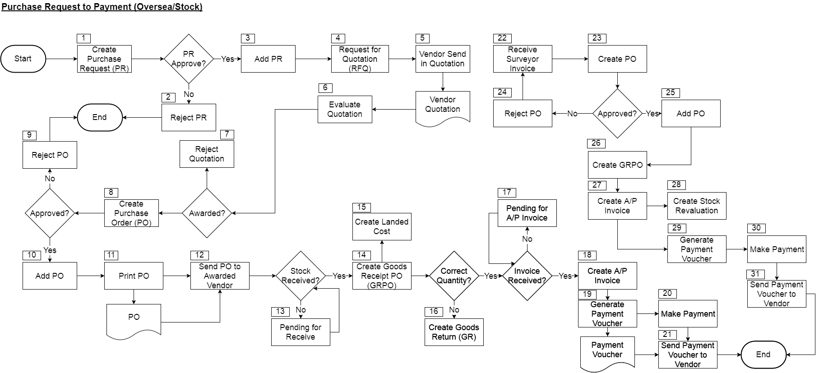

|  |  |  |  |
| --- | --- | --- | --- |
| **No.** | **Title** | **Description** | **Department/System** |
| 1 | Create Purchase Request (PR) | Requester create Purchase Request (PR) in SAP B1 and it will automatically forward for approval upon created. | Requester |
| 2 | Reject PR | If PR is rejected, the approver will change the PR status to reject, the originator (requester) will be notify in SAP B1. | Approver |
| 3 | Add PR | If PR is approved, originator (requester) will received notification in SAP B1 as well, then he or she can now add the PR into system. | Requester |
| 4 | Request for Quotation (RFQ) | Request quotation from the vendor in the desired list, this will be done outside SAP B1. | Purchaser |
| 5 | Vendor Send in Quotation | Vendor received the request and quoted according back to BSM. | - |
| 6 | Evaluate Quotation | Evaluate quotations received from all the vendors. | Purchaser |
| 7 | Reject Quotation | Reject the quotation if it’s not awarded. | Purchaser |
| 8 | Create Purchase Order (PO) | When the quotation awarded, create Purchase Order (PO) in SAP B1 according to the quotation. | Purchaser |
| 9 | Reject PO | Approver will update the PO status to rejected if it’s over budget or any other reason. The originator (purchaser) will received notification in SAP B1. | Approver |
| 10 | Add PO | If it’s approved, user can receive the notification in SAP B1, then he or she can proceed to add the PO into the system. | Purchaser |
| 11 | Print PO | Print PO for the approved PO in previous steps. | Purchaser |
| 12 | Send PO to Awarded Vendor | Send the printed PO to vendor to inform them for the order confirmation. | Purchaser |
| 13 | Pending for Receive | If the stock is yet to received, it will be pending in SAP B1 as open PO until it was fully received. | - |
| 14 | Create Goods Receipt PO (GRPO) | When the stock arrived, after physically received and checked, create Goods Receipt PO (GRPO) according to the PO and amend quantity where necessary by using copy to feature in SAP B1. | BMD |
| 15 | Create Landed Cost | Create landed cost from GRPO using copy from feature to add the landed cost into the item cost. | BMF |
| 16 | Create Goods Return (GR) | If the stock received is damaged or wrong quantity, create Goods Return (GR) according to the GRPO created in previous step and amend quantity where necessary by using copy to feature in SAP B1. | BMD |
| 17 | Pending for Invoice | Upon the stock fully received, GRPO will pending in open status if it hasn’t convert into A/P Invoice. | - |
| 18 | Create A/P Invoice | When received invoice from vendor, create A/P Invoice according to the GRPO by using copy to feature in SAP B1. | BMF |
| 19 | Generate Payment Voucher | Create Outgoing Payment in SAP B1 by selecting the A/P Invoice created in previous step. Then, print the payment voucher from the outgoing payment created. | BMF |
| 20 | Make Payment | Make payment to the vendor. | BMF |
| 21 | Send Payment Voucher to Vendor | Send payment voucher generated in step 19 to vendor via email. | BMF |
| 22 | Receive Surveyor Invoice | Receive invoice from surveyor. | - |
| 23 | Create PO | Create PO in SAP B1 according to invoice received and go through approval. | Purchaser |
| 24 | Reject PO | Reject PO if there’s amount mismatch. | Purchaser |
| 25 | Add PO | Add PO into SAP B1. | Purchaser |
| 25 | Create GRPO | Copy PO to GRPO as job completion in SAP B1 using copy to feature. | Purchaser |
| 26 | Create A/P Invoice | Copy GRPO to A/P Invoice. In SAP B1 using copy to feature. | BMF |
| 27 | Create Stock Revaluation | Create Stock Revaluation to calculate the surveyor cost back to that batch of item. | BMF |
| 28 | Generate Payment Voucher | Create Outgoing Payment in SAP B1 by selecting the A/P Invoice created in step 26. Then, print the payment voucher from the outgoing payment created. | BMF |
| 29 | Make Payment | Make payment to the vendor. | BMF |
| 30 | Send Payment Voucher to Vendor | Send payment voucher generated in step 19 to vendor via email. | BMF |

* + 1. **LPG Refill**

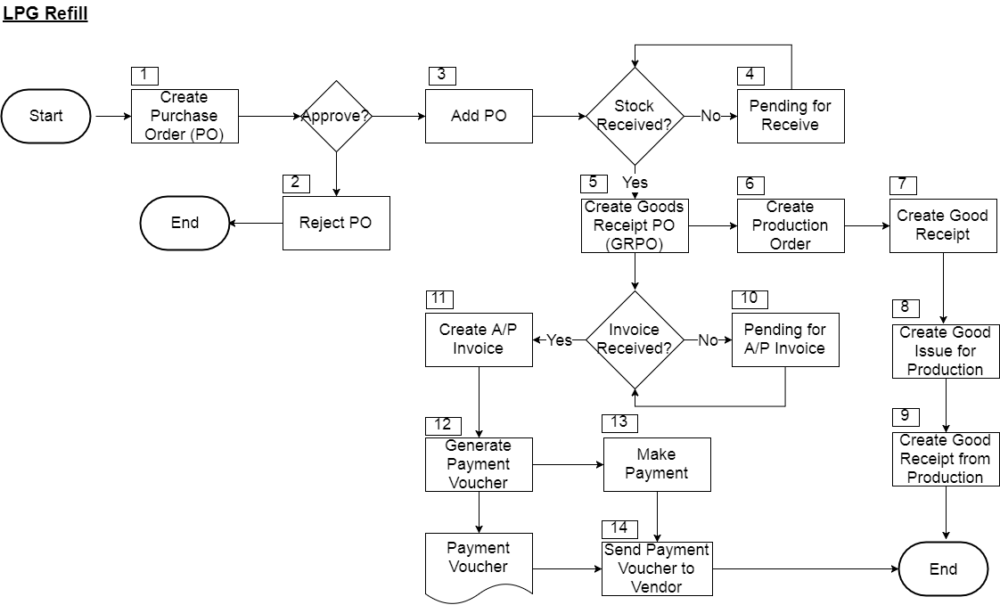

|  |  |  |  |
| --- | --- | --- | --- |
| **No.** | **Title** | **Description** | **Department/System** |
| 1 | Create Purchase Order (PO) | Create PO to purchase cylinder gas in SAP B1, it will automatically forward for approval. | BMD |
| 2 | Reject PO | Reject PO if it’s over budget or any other reason. The originator will receive notification in SAP B1. | Approver |
| 3 | Add PO | If PO is approved, originator will receive notification in SAP B1 as well, then he or she can now add the PO into system. | BMD |
| 4 | Pending for Receive | If the stock is yet to received, it will be pending in SAP B1 as open PO until it was fully received. | - |
| 5 | Create Goods Receipt PO (GRPO) | When the stock arrived, after physically received and checked, create Goods Receipt PO (GRPO) according to the PO and amend quantity where necessary by using copy to feature in SAP B1. | BMD |
| 6 | Create Production Order | Create Production Order in SAP B1 to refill the LPG. | BMD |
| 7 | Create Goods Receipt | Create Goods Receipt in SAP B1 to receive the empties cylinder for refill purpose. | BMD |
| 8 | Create Good Issue for Production | Create Goods Issue for Production in SAP B1 to assigned the material needed (empties cylinder & cylinder gas) for production order. | BMD |
| 9 | Create Good Receipt from Production | Upon finish filling the empties cylinder, create Good Receipt from Production in SAP B1 to increase the quantity of the filled cylinder in the system. | BMD |
| 10 | Pending for Invoice | Upon the stock fully received, GRPO will pending in open status if it hasn’t convert into A/P Invoice. | - |
| 11 | Create A/P Invoice | When received invoice from vendor, create A/P Invoice according to the GRPO by using copy to feature in SAP B1. | BMF |
| 12 | Generate Payment Voucher | Create Outgoing Payment in SAP B1 by selecting the A/P Invoice created in previous step. Then, print the payment voucher from the outgoing payment created. | BMF |
| 13 | Make Payment | Make payment to the vendor. | BMF |
| 14 | Send Payment Voucher to Vendor | Send payment voucher generated in step 12 to vendor via email. | BMF |

* 1. **Report**

There will be a list of purchase reports (yet to be finalized) in SAP B1 or BI360 as below:

1. Contract Listing Report
2. Purchase Listing Report
3. Open Purchase Orders
4. Open Goods Receipt PO
5. Importation Report
6. **Inventory**
   1. **Stock Adjustment (Stock Count)**

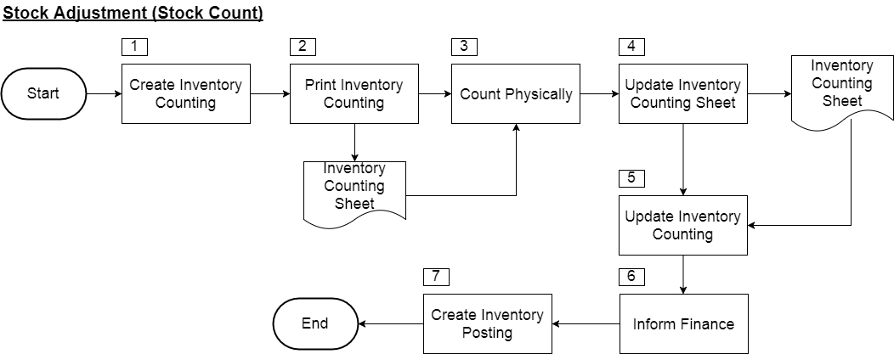

|  |  |  |  |
| --- | --- | --- | --- |
| **No.** | **Title** | **Description** | **Department/System** |
| 1 | Create Inventory Counting | Create Inventory Counting in SAP B1. | BMD |
| 2 | Print Inventory Counting | Print inventory counting document for operation staff. | BMD |
| 3 | Count Physically | Operation staff start to count the inventory physically at the warehouse. | BMD |
| 4 | Update Inventory Counting Sheet | Update the counted quantity of the inventory on the inventory counting document. | BMD |
| 5 | Update Inventory Counting | Once the physical count complete, the updated inventory counting document returned and update the counted quantity into SAP B1 inventory counting based on the inventory counting document. | BMD |
| 6 | Inform Finance | If there are variance between system and actual quantity in warehouse, need to inform finance for further action. | BMD |
| 7 | Create Inventory Posting | Create Inventory Posting based on Inventory Counting using copy to feature to adjust inventory quantity to be same as actual quantity in warehouse. This posting will impact inventory cost as well. | BMF |

* 1. **Stock Write-Off**

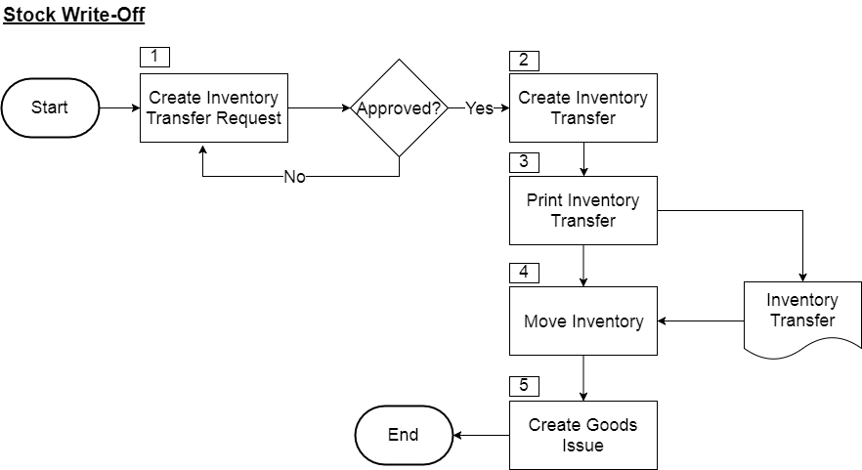

|  |  |  |  |
| --- | --- | --- | --- |
| **No.** | **Title** | **Description** | **Department/System** |
| 1 | Create Inventory Transfer Request | Create Inventory Transfer Request in SAP B1 by choosing the destination warehouse as damage warehouse. | BMD |
| 2 | Create Inventory Transfer | Create Inventory Transfer after Inventory Transfer Request approved using Copy To feature in SAP B1. | BMD |
| 3 | Print Inventory Transfer | Print out the inventory transfer document for the operation staff. | BMD |
| 4 | Move Inventory | Move the inventory physically to damage warehouse. | BMD |
| 5 | Create Goods Issue | Create Goods Issue in SAP B1 by selecting the damage inventory from damage warehouse to write-off the inventory. | BMF |

* 1. **Repacking**

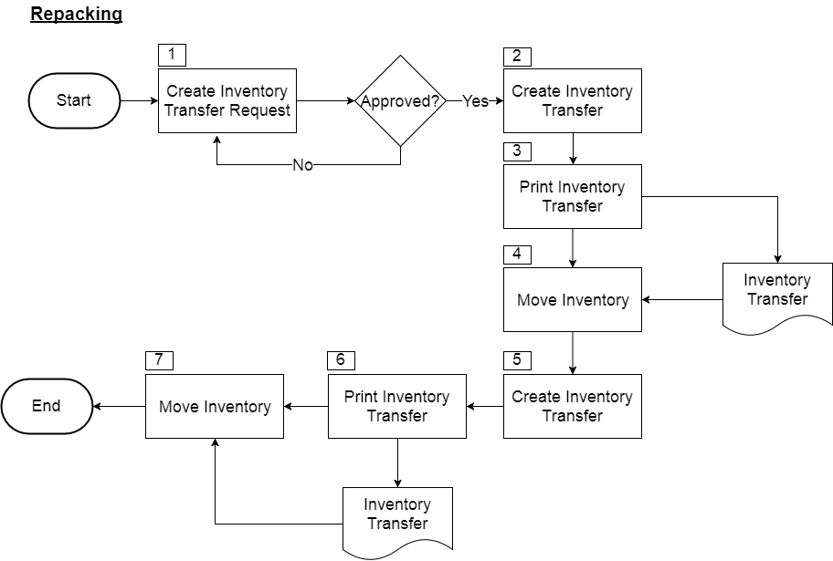

|  |  |  |  |
| --- | --- | --- | --- |
| **No.** | **Title** | **Description** | **Department/System** |
| 1 | Create Inventory Transfer Request | Create Inventory Transfer Request in SAP B1 by choosing the destination warehouse as repacking warehouse. | BMD |
| 2 | Create Inventory Transfer | Create Inventory Transfer after Inventory Transfer Request approved using Copy To feature in SAP B1. | BMD |
| 3 | Print Inventory Transfer | Print out the inventory transfer document for the operation staff. | BMD |
| 4 | Move Inventory | Move the inventory physically from sales warehouse to repacking warehouse to prevent CSC over commit the sales due to inaccurate in actual stock level based on the inventory transfer document. | BMD |
| 5 | Create Inventory Transfer | Once inventory repacked successfully, create another inventory transfer in SAP B1 to transfer the inventory from repacking warehouse back to sales warehouse. | BMD |
| 6 | Print Inventory Transfer | Print out the inventory transfer document for the operation staff. | BMD |
| 7 | Move Inventory | Move the inventory physically from repacking warehouse back to sales warehouse for sales based on the inventory transfer document. | BMD |

* 1. **Stock Count**

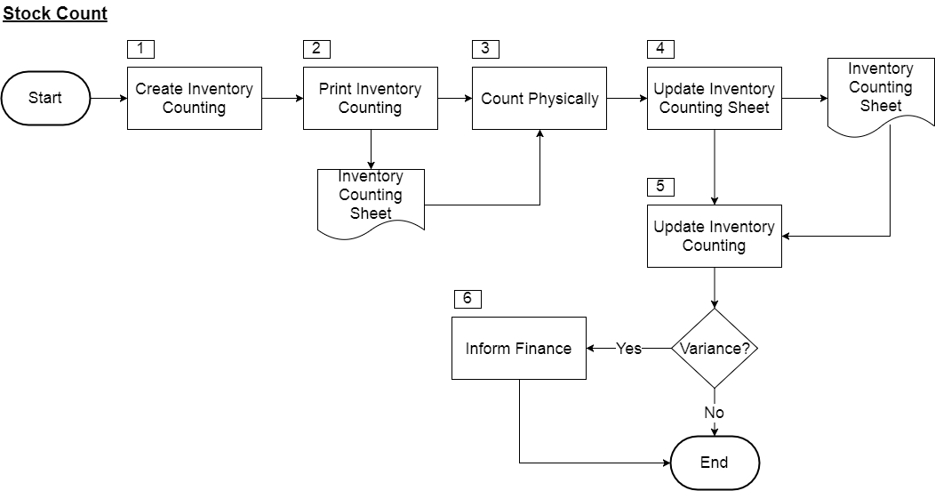

|  |  |  |  |
| --- | --- | --- | --- |
| **No.** | **Title** | **Description** | **Department/System** |
| 1 | Create Inventory Counting | Create Inventory Counting in SAP B1. | BMD |
| 2 | Print Inventory Counting | Print inventory counting document for operation staff. | BMD |
| 3 | Count Physically | Operation staff start to count the inventory physically at the warehouse. | BMD |
| 4 | Update Inventory Counting Sheet | Update the counted quantity of the inventory on the inventory counting document. | BMD |
| 5 | Update Inventory Counting | Once the physical count complete, the updated inventory counting document returned and update the counted quantity into SAP B1 inventory counting based on the inventory counting document. | BMD |
| 6 | Inform Finance | If there are variance between system and actual quantity in warehouse, need to inform finance for further action. | BMD |

* 1. **Report**

There will be a list of inventory reports (yet to be finalized) in SAP B1 or BI360 as below:

1. Log Report Sheet for Packed Products
2. Daily Activity Reports
3. Operation Reports
4. PMQA Template
5. Routing Sheet
6. Product Offtake Report
7. **Banking**
   1. **Incoming Payment Flow**
      1. **Incoming Payment (Normal)**

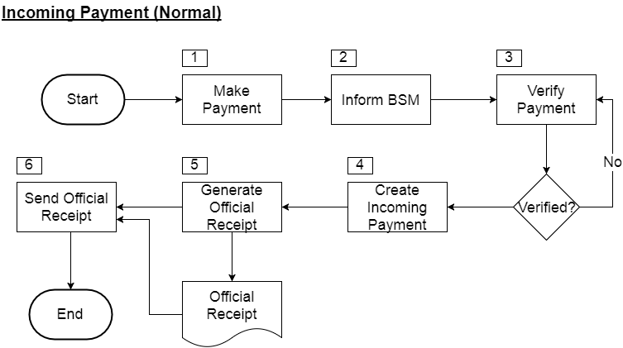

|  |  |  |  |
| --- | --- | --- | --- |
| **No.** | **Title** | **Description** | **Department/System** |
| 1 | Make Payment | Customer make payment using cheque, cash or bank transfer. | Customer |
| 2 | Inform BSM | Customer inform BSM on the payment details such as the amount they paid, payment method and apply to which invoice. | Customer |
| 3 | Verify Payment | Finance user need to verify the payment received from customer based on the payment details provided by customer. | BMF |
| 4 | Create Incoming Payment | Once verified, create incoming payment in SAP B1 by applying to the invoice that has been advised by the customer. | BMF |
| 5 | Generate Official Receipt | Upon creation of incoming payment successful in SAP B1, print out the Official Receipt. | BMF |
| 6 | Send Official Receipt | Send the official receipt to customer either via email portal (if applicable) or hand it over to customer physically. | BMF |

* + 1. **Incoming Payment (Direct Debit)**

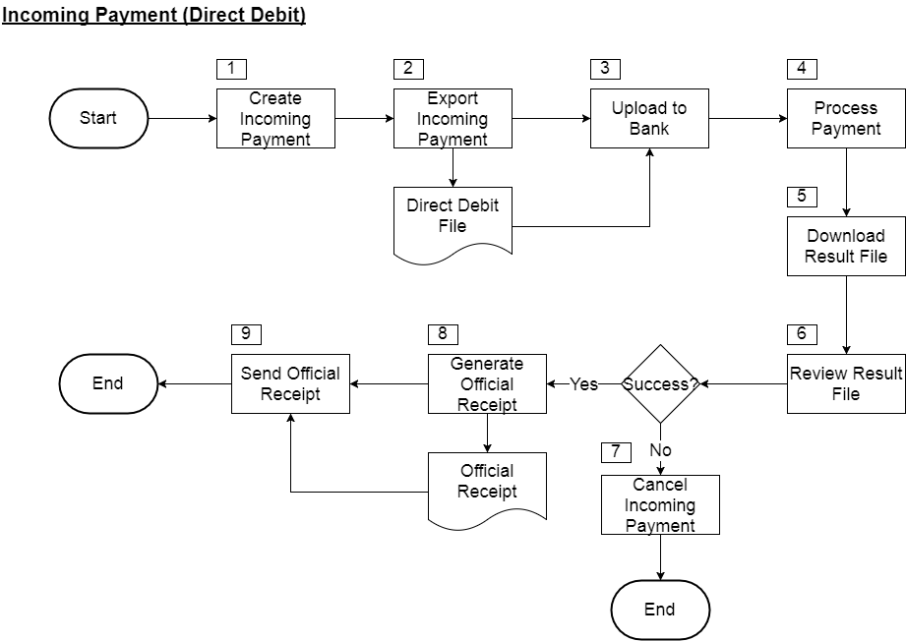

|  |  |  |  |
| --- | --- | --- | --- |
| **No.** | **Title** | **Description** | **Department/System** |
| 1 | Create Incoming Payment | Finance user create incoming payment in SAP B1 for the customer that agreed with the direct debit payment. | BMF |
| 2 | Export Incoming Payment | Upon finished creation of the incoming payment in SAP B1 for the day, export the incoming payment into the file format that required by bank using Bi360. | BMF |
| 3 | Upload to Bank | Upload exported file into the website that instructed by bank. | BMF |
| 4 | Process Payment | Bank will start to process the payment after upload successful. | Bank |
| 5 | Download Result File | Download the result file from the same website that upload the file. | BMF |
| 6 | Review Result File | Review the result file to check whether is there any unsuccessful transaction or not. | BMF |
| 7 | Cancel Incoming Payment | If the payment is rejected for certain reason according to the downloaded result file, finance user will cancel the incoming payment that created earlier in SAP B1. | BMF |
| 8 | Generate Official Receipt | If the payment is successful, finance user will print Official Receipt from incoming payment in SAP B1. | BMF |
| 9 | Send Official Receipt | Send the official receipt to customer either via email portal (if applicable) or hand it over to customer physically. | BMF |

* + 1. **Incoming Payment (Fleet Card)**

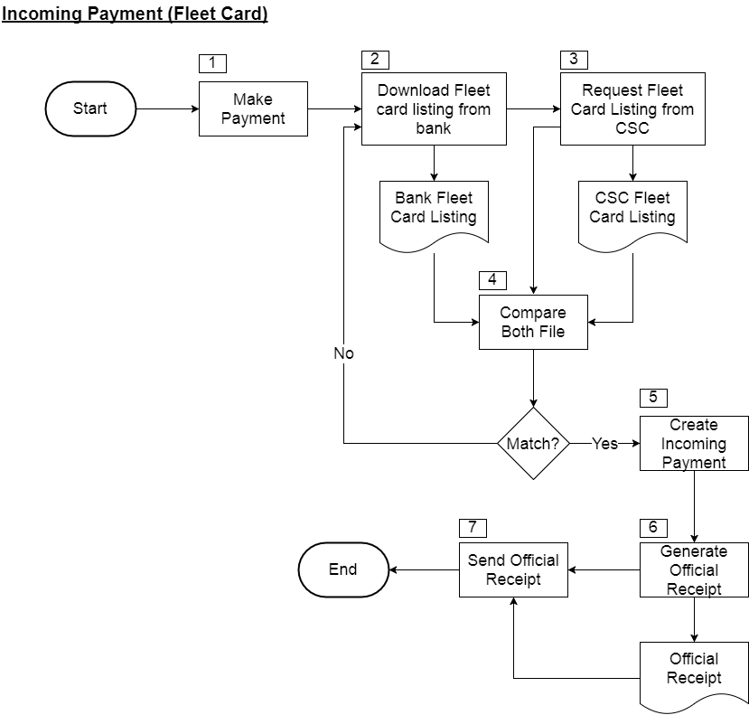

|  |  |  |  |
| --- | --- | --- | --- |
| **No.** | **Title** | **Description** | **Department/System** |
| 1 | Make Payment | Customer make payment using fleet card. | Customer |
| 2 | Download Fleet Card Listing from Bank | Finance user will download the fleet card listing from the bank website according to bank instruction. | BMF |
| 3 | Request Fleet Card Listing from CSC | Finance user request the fleet card listing from CSC as the listing from CSC contains the invoice/DO no. | BMF |
| 4 | Compare Both File | Compare fleet card listing from bank and flee card listing from CSC to find the matched transaction. | BMF |
| 5 | Create Incoming Payment | If there’s matched transaction, finance user need to create incoming payment in SAP B1. | BMF |
| 6 | Generate Official Receipt | Print Official Receipt from incoming payment in SAP B1. | BMF |
| 7 | Send Official Receipt | Send the official receipt to customer either via email portal (if applicable) or hand it over to customer physically. | BMF |

* 1. **Outgoing Payment Flow**
     1. **Outgoing Payment (Normal)**

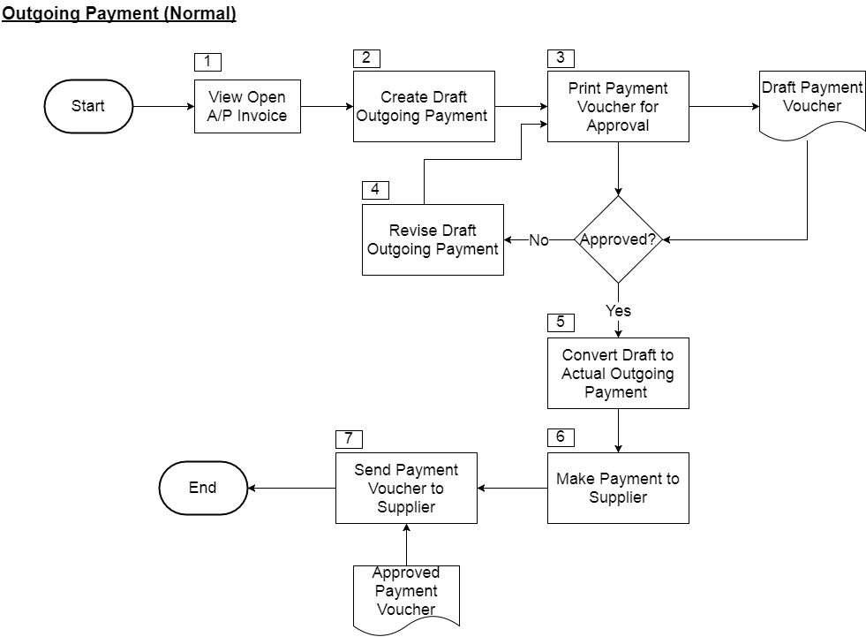

|  |  |  |  |
| --- | --- | --- | --- |
| **No.** | **Title** | **Description** | **Department/System** |
| 1 | View Open A/P Invoice | Finance user will view the open A/P Invoice that yet to be paid in SAP B1. | BMF |
| 2 | Create Draft Outgoing Payment | Create outgoing payment in SAP B1 and save as draft after decided which A/P Invoice to pay. | BMF |
| 3 | Print Payment Voucher for Approval | Print payment voucher from draft outgoing payment in SAP B1. | BMF |
| 4 | Revise Draft Outgoing Payment | If it’s rejected, revise again the created draft outgoing payment and amend where necessary, then go through the approval again. | BMF |
| 5 | Convert Draft to Actual Outgoing Payment | If it’s approved, convert the draft outgoing payment into actual in SAP B1. | BMF |
| 6 | Make Payment to Supplier | Make payment to supplier according to the approved payment voucher. | BMF |
| 7 | Send Payment Voucher to Supplier | Send the approved payment voucher via email to that particular supplier. | BMF |

This process can be applied to the outgoing payment created to pay for someone that doesn’t maintain as a vendor in SAP B1. This is because outgoing payment windows in SAP B1 having the 3 different options to pay for as below:

1. Vendor
2. Customer
3. Account
   * 1. **Outgoing Payment (Batch)**

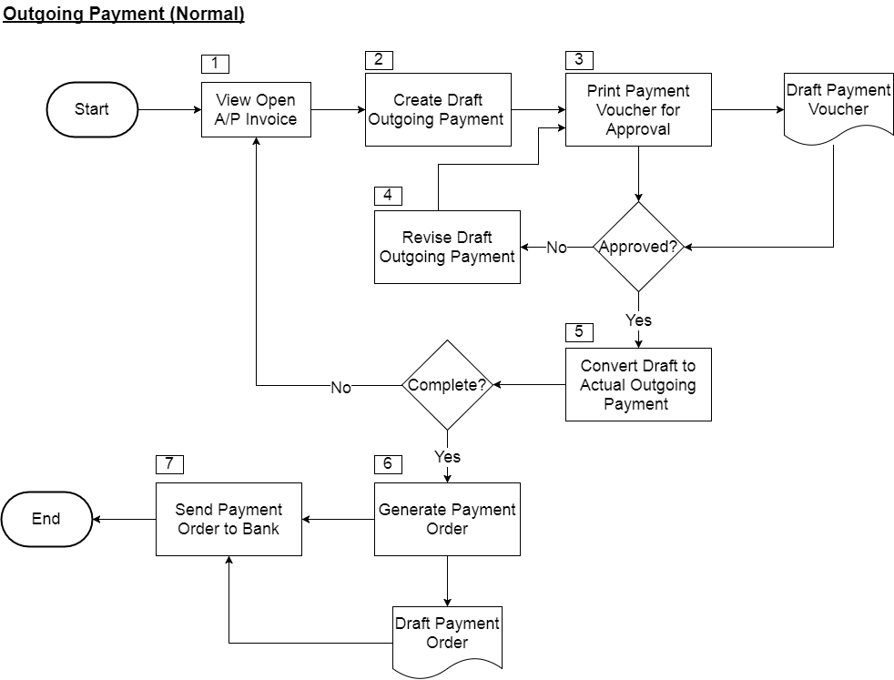

|  |  |  |  |
| --- | --- | --- | --- |
| **No.** | **Title** | **Description** | **Department/System** |
| 1 | View Open A/P Invoice | Finance user will view the open A/P Invoice that yet to be paid in SAP B1. | BMF |
| 2 | Create Draft Outgoing Payment | Create outgoing payment in SAP B1 and save as draft after decided which A/P Invoice to pay. | BMF |
| 3 | Print Payment Voucher for Approval | Print payment voucher from draft outgoing payment in SAP B1. | BMF |
| 4 | Revise Draft Outgoing Payment | If it’s rejected, revise again the created draft outgoing payment and amend where necessary, then go through the approval again. | BMF |
| 5 | Convert Draft to Actual Outgoing Payment | If it’s approved, convert the draft outgoing payment into actual in SAP B1. Repeat step 1 to 5 until all the outgoing payment finished for the day. | BMF |
| 6 | Generate Payment Order | Generate payment order after all the outgoing payment created and approved. | BMF |
| 7 | Send Payment Order to Bank | Send the generated payment order to bank to request bank to make payment in batch to the supplier on behalf of BSM. | BMF |

* 1. **Bank Statement & Reconciliation**

To verify the bank transactions recorded in SAP B1 against the balance received from the bank and create adjustments if required.

It able to reconcile as below:

• Outgoing clearance

• Incoming clearance

• Adjustment – bank interest, bank charges

It able to perform the task as below:

• Select multiple journal entries for mass posting

• View only un-reconcile transactions by date, cheque no, document no, amount and posting date either in ascending or descending order.

Please refer below for Bank Statement & Reconciliation window in SAP B1:

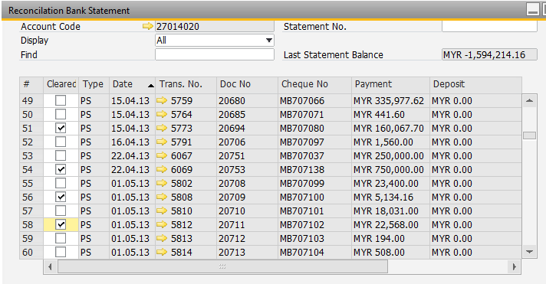

If user didn’t manage to finish the reconciliation, he or she can actually save it half way and continue the next day or later.

* 1. **Report**

There will be a list of banking report (yet to be finalized) in SAP B1 or BI360 as below:

1. Bank Reconciliation Statement
2. Daily Official Receipt Report
3. Payment Order Report
4. **Fixed Asset**
   1. **Report**

There will be a list of fixed asset report (yet to be finalized) in SAP B1, BI360 or Fixed Asset as below:

1. Fixed Asset Listing Report
2. Fixed Asset Schedule Report
3. **Asset Management**
   1. **Report**
4. **Add-On**
   1. **Email Portal**
   2. **Sales Portal**
   3. **Retail Portal**